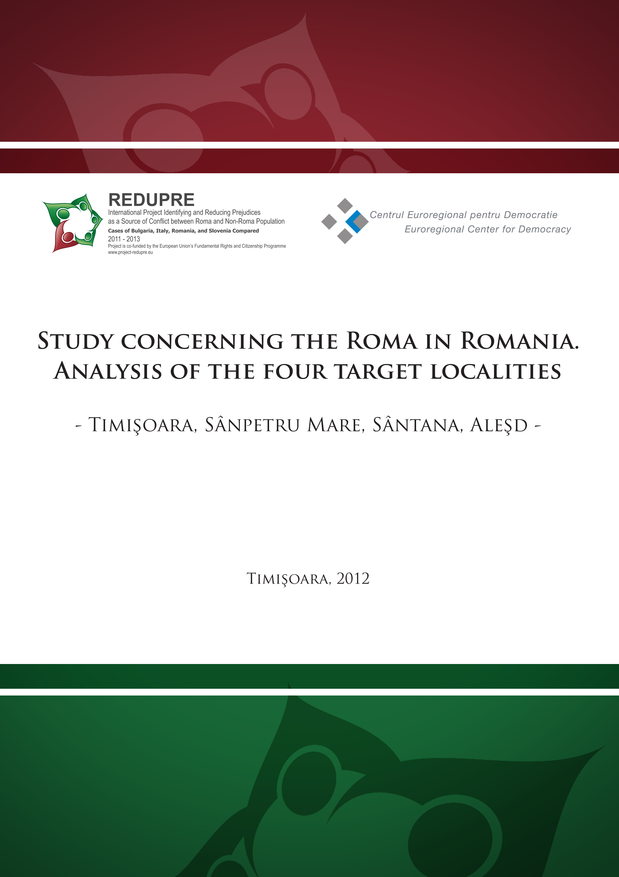
Contents

Foreword 4

Chapter I: An overview of the Roma in Romania 6
- History at a glance 6
  - The Roma make it to Europe 6
  - Romania: Roma’s next stop for the 14th century 7
  - A brand new carriage in exchange for 30 Gypsy slaves 8
  - Transylvania: the other side of the coin 10
  - “Will you ever dare to be among the civilized peoples as long as one
can read in one of your newspapers: Young Gypsy woman for sale?” 11
  - The Interwar wind of change 12
  - Antonescu’s policy and its communist follow-up 13
  - “So many of the Gypsy communities haven’t moved forward at all.
They are exactly where they were whether it’s 10 years ago, 20 years ago.” 16

2. Demographics 17
3. Indicators of social and economic status 22
3.1. Employment 22
3.2. Education 26
3.3. Healthcare 28
3.4. Housing 31
3.5. Conclusions 34

Chapter II: Laws and public policies impacting the Roma in Romania 36
1. International and European laws and public policies 36
2. National laws and public policies 41
3. Public participation of the Roma 50
4. Conclusions and recommendations 54

Chapter III: Stereotypes, prejudices and discrimination against the Roma 59
1. How Romanian language and literature relate to the Roma 59
2. The16 most common stereotypes about the Roma 60
3. National and European surveys and reports on discrimination against the Roma 62
4. The Roma versus the others: A glimpse of the self- and hetero-image
of the Roma and non-Roma groups 68
5. The image of the Roma in Romanian mass media 71
5.1. Media portrayals between 1990 and 2010 71
5.2. An up-to-date analysis of how large circulation newspapers portray the Roma 75
6. Conclusions 83

Chapter IV: Analysis of the four target localities in Romania 85
1. Timişoara 87
2. Sânpetru Mare 89
3. Sântana 92
4. Aleşd 95
5. Conclusions 97

Bibliography 99

Annex - Statistics concerning the Roma population in the West and
North-West Regions of Romania (Timiş, Arad, Bihor Counties) 108

Foreword

The present study draws upon a wide range of literary and statistical evidence in order to provide an objective outline of the Roma in Romania, away from both overly romantic and critical nuances.
If briefly reviewing the list of references, one can notice that the paper is almost an inventory of publications which either analyze the Roma directly or provide indirect clues for an accurate and complete profile.
To this end, the study embarks on a four-chapter tour.
The first chapter – An overview of the Roma in Romania – opens the way with a stroll down the history lane. The narrative thread checks off all the ‘hot spots’ from Roma’s arrival in Europe and Romania to contemporary facts and also lays emphasis on the slavery episode largely enigmatic to many Roma and non-Roma alike.
The following sub-chapters turn the history tide to Demographics and Indicators of social and economic status, piling up a notable amount of information for a snapshot of the four fields on whose shoulders the Roma’s precarious condition rests: employment, education, healthcare and housing.
The third chapter makes a thorough review of the international, European and domestic laws and policies displayed in the shape of an open-down parabola whose vertex is represented by the EU accession – the time when the measures taken are said to have reached the highest intensity. The review culminates in describing the participation of the Roma in public life and drawing a set of conclusions and recommendations.
“To traverse the world, men must have maps of the world” Lippmann said in his 1922 masterpiece – Public Opinion. His words pave the way for the fourth chapter – Stereotypes, prejudices and discrimination – which gradually goes through literature and statistics for catching a glimpse of the cognitive, affective and behavioral bias held about the ethnic group in question.
For such purpose, the chapter delves into Romanian words and idioms which relate to the Roma, summarizes national and EU reports on discrimination and also gauges the social distance between the Roma and the non-Roma by blending both the self- and the hetero-image into the analysis.
Given that many of the stories about the Roma are told by journalists in their daily news reports, the chapter dedicates an important slice to the 1990-2010 media portrayals and also looks at the articles in the four largest circulation daily newspapers in the quality press category, between 1 October and 31 November 2011.
The tour ends with an analysis of the four localities chosen as focal points for the research conducted in Romania, within the REDUPRE project – Timişoara, Sânpetru Mare, Sântana, Aleşd. The analysis delves into the main arguments which recommend these as edifying case studies in relation to the overall project goal by summarizing demographic, social, economic data and so forth.
As an additional note, it should be borne in mind that the word “Gypsy” appears only in quotations due to thus being employed by the authors and in the history chapter as an equivalent of the noun “ţigan” which used to flag the low rung to which the Roma were relegated during the slavery years.
In a nutshell, the paramount argument which recommends this study for lecture is the significant amount of sources reviewed for building a broad and objective portrait of the Roma and also the order in which the information unfolds. In other words, the study doesn’t jump to conclusions about the main issues the Roma are confronted with, but tries to draw a natural flow of data establishing a cause-effect relationship between history and modern-day challenges.
Chapter I: An overview of the Roma in Romania

1. History at a glance
"’Who are these people?’ asks the man behind the counter in the photo store in Southall, an area also known as London's Little India.
He is handing over my order: a hefty pile of colour photographs, of which a picture of two Roma women and their children (above) is the first.
"They look just like the Banjara in Rajasthan - that's where I come from," he says.
He points to a beautiful print on the wall, showing a glamorous group of female Banjara dancers.” (BBC News July 8, 2009)

1.1. The Roma make it to Europe
The question that the man behind the counter asks in the BBC series is the same question that scholars have asked for many years in their attempt to trace back the Roma’s origin. It took them a great deal of perseverance and hard work to make way through the stories and documents left behind by an ethnic group whose “collective memory has retained more of the legendary than of certainties” (Liégeois 1994). Actually, it was not until the 18th century that the certainties began to come to light due to H.M.G. Grellmann, the author of the first modern scientific paper having the Roma as centerpiece. The paper was published in 1783 and established that the not-so-new kid in town had Indian origins due to a comparative philology study which linked the language they spoke to Sanskrit (Achim 1998). The conclusion was that their language came from the North-West of the sub-continent and that the influx from India to Europe occurred between the 9th and 14th centuries in several waves (Liégeois 1994).
Gradually, the Roma arrived in the Byzantine Empire where they were named athingani. The collective name tag derived from the Greek word athinganos or athinganoy meaning pagan, untouchable, impure which pointed to a heretical sect whose adherents were known as soothsayers and magicians (Dumitrescu, Căpiţă and Manea 2008).
In his book – The Gypsies - Angus Fraser (1992) states that “the earliest reference to the presence of Gypsies in Constantinople comes, most probably, from a Georgian hagiographical text, The Life of Saint George the Athonite, composed at the monastery of Iberon on Mount Athos around 1068”. The text mentions Emperor Constantine Monomachus who asked for the help of the athingani, “descendants of Simon the Magician, notorious for soothsaying and sorcery” who were supposed to kill the wild animals in Philopation Park considered guilty of his disease.
The name athingani spread in a number of countries, resulting in the French Tsigans, German Zigeuner, Norwegian Sigöyner, Italian Zingari, Romanian Ţigani etc. (Liégeois 1994)
However, a recent study shows that the oldest and most certain reference to the Roma was found in a letter of Gregorios II Kyprios (the Patriarch of Constantinople, 1283-1289). Such theory implies that the word athingani in the earlier mentioned text pointed to the original heretical sect whose name was to stick later with the Roma people (Achim 1998).
Despite the two theories sharing the earliest reference spectrum, most works and authors embrace the first mentioned.

1.2. Romania: Roma’s next stop for the 14th century
The ground zero reference concerning the Roma in Romania is a deed from 1385 in which the Prince of Wallachia donates the possessions of Vodiţa Monastery to Tismana Monastery. Among these, 40 Gypsy families (sălaşe) are mentioned (Achim 1998).
In 1388, again in Wallachia, Mircea the Elder (Mircea cel Bătrân) donates 300 families to Cozia Monastery; in Moldavia, the Roma are first mentioned in 1428 when Alexander the Good (Alexandru cel Bun) donates 31 families to Bistriţa Monastery; in Transylvania, the earliest reference is a document (dated approximately between 1390 and 1406) stating that boyar Costea owns several villages as well as 17 ‘tent Gypsies’ (Ciganus tentoriatos) (Achim 1998).
In the 15th century, almost all monasteries and boyars had Roma slaves. Their number grew at a rapid pace thus making Dimitrie Cantemir state, at the beginning of the 18th century, that in Moldavia “…Gypsies were spread all over the country” and “There was almost no boyar who did not own several Gypsy families.” (Achim 1998, p.26).
Most researchers explain the arrival of the Roma by invoking two migration waves: one dating back to 1026 and heading for Damask, Egypt, Libya, Algeria, Morocco, Spain, France and another occurring in 1192 and heading for Dnieper, Don, Caucasus. The Gypsies from the second wave came across the Tatars and became their slaves. This encounter is believed to have set the ground for the arrival of the Gypsies in Romania (Dumitrescu, Căpiţă and Manea 2008).
In his book, Gypsies in Romanian history, Viorel Achim (1998) also argues in favor of the South-Danubian route, emphasizing as main strands in his argument: the use of the Greek word aţigani, which later became ţigani, the high number of Greek and Southern Slavic words in the Romany language as well as their Orthodox religion which was quite a paradox in Transylvania where Catholics and Protestants accounted for a significant slice of the religious makeup.
Even though the number of information sources concerning the Roma’s arrival is higher in Moldavia and Wallachia than in Transylvania, the last mentioned makes up for its lack of data at the end of the 15th century. Thus, in 1493, a group of Gypsies headed by Voivode Rajko is referred to in Cladova, Arad County, while the Gypsies in Timişoara are brought up by archival sources as cannon casters (1500) and torturers of György Dózsa (1514) (Achim 1998).
1.3. A brand new carriage in exchange for 30 Gypsy slaves

When the Roma entered Romania as Tatar slaves, slavery was already a fact. Later on, Tatars melted away and the only people on whose shoulders this social status continued to rest until the mid-19th century were the Roma. Given that the old Romanian language didn’t have a word to point to this status, the term ţigan was used as a synonym for slave. Afterwards, the nouns rob and sclav (slave) took the place of the word labeling one of the lowest steps of the social ladder (Dumitrescu, Căpiţă and Manea 2008).  According to Dumitrescu, Căpiţă and Manea (2008), “Ţigan didn’t belong to the social structure or to the human species; he was defined as an exchange object and asset somebody owned.” |   Fig.1. A poster announcing an auction  of Gypsy slaves  Source: Wikipedia
In order to set a background for the stories reflective of the Roma’s social condition in the Middle Ages, one has to take a closer look at the main categories of Roma slaves.
Depending on the owner, these fell into three categories: slaves owned by the Prince, by monasteries and by boyars. The first mentioned outnumbered the other two categories and encompassed both the Roma who worked at the princely court and the Roma who wandered the country and earned money from their crafts (Achim 1998).
Neagu Djuvara (2007) takes the above categorization even further and identifies, inside each group, two sub-groups: vătraşii (the settled) and lăieşii (the nomads) – the word derives from the Polish and Ukrainian noun laja meaning pack of dogs.
Vătraşii were used on the estates (in the kitchen, at the stables, in the fields etc.) while lăieşii wandered in small covered wagons, set their tents on the edge of the villages and made money crafting (they were blacksmiths, coppersmiths, woodworkers, bear tamers etc.).
Besides the two categories above, Djuvara also brings into the spotlight netoţii, i.e. small groups of Gypsies who were very poor, lived in the woods and had a savage look and behavior. Their name stands for incomplete and originates in the locals calling them people with incomplete minds.
Having a full table and a few chairs is an expression which describes in a nutshell the difference between the ‘welcome treat’ applied to the Roma in Romania and the one applied to those in Central and Western Europe. Namely, in Romania, the Roma managed to fill a gap through their crafts which addressed a specific market niche left uncovered mainly because of the agrarian profile Romania displayed at that time. Generally speaking, blacksmithing was not only the Roma’s favorite craft, but also a craft in high demand (Achim 1998).
I. St. Raicewich (cited in Achim 1998), a fine observer of the social and economic context in the two Romanian Principalities helps us gain a better understanding of the role that the Roma played: “All the mechanical crafts are in the hands of the Gypsies or of foreigners from neighbor countries”.
Moreover, a research carried out at the beginning of the 20th century showed that “…in the former Principalities there was not a single peasant farmstead that did not own pieces of ironwork produced by Gypsies”. In other words, Gypsy almost became a synonym for blacksmith in the Romanian villages (Achim 1998).
At the opposite pole, the Roma in Central and Western Europe didn’t have what gap to fill as craftsmen were already organized into guilds and the production was rather monopolistic. Additionally, unlike Romania which could cope with nomadism due to the sparseness of its population, this part of Europe didn’t have room for “the unsettled”. Hence, the Roma hit the wall of a pre-existent social and economic structure sound and rigid enough to reject the interference of the newcomers whose crafts and products were seen as rather rudimentary (Achim 1998)..
However, despite the “full table” of demand for Gypsy crafts and the few chairs around it filled by the Romanian craftsmen, the Roma were seen as “something that belonged to the owners who could use and re-use them without any fear” (Djuvara 2007).
A relevant example, in this regard, is a document from 1832 according to which Anica Manu got a brand new carriage from Vienna in exchange for 30 Gypsy nomads she had inherited. Also, in 1799, Emanoil Grădişteanu gave two young Gypsies as a fee for medical services (Djuvara 2007).
Mixed marriages were extremely rare given the peasants’ distrust of the nomads. Still, when such marriages took place, the woman who married a slave would embrace her husband’s status together with the offspring who were to come (Djuvara 2007).
When marriages between slaves owned by different boyars occurred, a compensatory exchange would take place. The receiving boyar either paid a price for the Roma who was to move to his land or gave his counterpart a slave which was worth the same value. If owners didn’t reach an agreement, they could break up the couple and even share their kids between them (Achim 1998).
To conclude with, the Roma slaves in the Romanian Principalities were at the very bottom of the social hierarchy. They were considered outcasts responsible for a consistent share of the country’s thefts. Seen from the outside, such treatment looked outrageous. An English traveler wrote at the end of the 19th century that: “Although the Gypsies form such an integral part of the community, they are regarded with the greatest disdain by the rest whose behavior towards them is scarcely better than towards animals; a man could more easily bear being called ‘thief’ or something similar than ‘Gypsy’”(Achim 1998, p.55).
The Austrian authorities in Chernovtsy (Bukovina region) joined the collective voice of those pointing a finger to the ill-treatment of the Roma and forbade the beating of the slaves in the street, a customary practice among the boyars from Moldavia. The owners were disturbed by the Austrian interference and fought to get an exemption from the general rule. Their efforts were not in vain as beating was allowed in the backyard of their houses (Djuvara 2007).

1.4. Transylvania: the other side of the coin
In Transylvania (the Romanian province which belonged to the Kingdom of Hungary and went under Habsburg rule in the 17th century), the Roma had a different faith.
First of all, the number of slaves was much lower as most of them were rather “royal serfs”. The latter status implied that they were directly subordinated to the King and their only duties came down to the taxes paid and works done for the state (Achim 1998).
Starting from 1688 and 1718, the Habsburg Empire engulfed Transylvania and Banat, respectively. This was the beginning of a new era for the Roma who became subject to the first coordinated effort aimed at coercing them into a sedentary life-style (Achim 1998).
In this respect, the two major cornerstones were the reigns of Maria Theresa (1740-1780) and Emperor Joseph II (1780-1790) who particularly tackled and touched upon the Gypsy problem. Maria Theresa issued four decrees which, briefly put, tied the Gypsies to a land, changed their name into Neubauer (new peasants) or újmagyarok (new Hungarians), abolished the jurisdiction of the Gypsy voivode and forbade the marriages between Gypsies. Emperor Joseph II extended the measures taken by his predecessor to Transylvania (Achim 1998).
Whatever the efforts made for assimilating the Roma, the Habsburg policy eventually failed. The main reasons were the relatively short period during which the measures were applied and the stage society underwent at that time. According to Achim (1998), another explanation for the debacle refers to the Roma’s distaste for discipline and agriculture, the new field they were supposed to embrace.
Yet, greater success of the sedentarization policy was attained in Banat. In 1784, the total number of Roma families in Timişoara amounted to 50 of which 30 were labeled as German. The only ones who were allowed to stick to their nomadic life-style to a certain degree were the gold washers. However, the beginning of the 19th century curtailed their wandering as this group also settled in the mountain villages in the South-East of the province (Achim 1998).
Therefore, one can conclude that the measures taken by the Habsburg Empire in the second half of the 18th century turned the page and carried the ‘unsettled’ Gypsies from Transylvania and Banat into a new chapter of their history for which ‘settled’ was the key word.

1.5. “Will you ever dare to be among the civilized peoples as long as one can read in one of your newspapers: Young Gypsy woman for sale?”
Fortunately, the answer to Kohly de Guggsberg’s question (cited in Achim 1998) was a categorical yes. The unequivocal answer came from the Romanian intellectuals who had studied abroad and returned home fascinated by the Western world and its new beliefs and ideals. Yet, their fascination hit against the contemporary certainties of their country which still preserved and took pride in its Gypsy slaves. Slavery soon turned into the “the country’s greatest shame, the darkest stain in the eyes of the foreigners” (Guggsberg cited in Achim 1998). This conclusion was reached in the context of the news avalanche concerning the abolition campaigns in the USA and the French and English colonies.
As a clue to the high sensitiveness Romanian society reached at that time, it should be borne in mind that the first American novel translated into Romanian was Harriet Beecker-Stowe’s Uncle Tom’s Cabin (Achim 1998).
Such sensitiveness was not only the result of the overly romantic views of the new intellectual wave, as many may think, but also of the accurate picture figures painted. Namely, between 1830 and 1860, the total number of Roma in Moldavia and Wallachia increased from roughly 200,000 to 250,000. According to most estimates, these accounted for almost one third of the total number of Roma in Europe (Achim 1998). Consequently, their social status wasn’t quite the ‘Guinness world record’ that intellectuals wished for in view of adhering to Western ideals.
Such conclusion led to the abolition of slavery which took the shape of a two-decade process. Its milestones, at a glance, were: the laws which set free the Gypsies belonging to the Metropolitanate, bishoprics and monasteries (1844 in Moldavia, 1843 in Wallachia) and the laws which set free the state-owned Gypsies (1844 Moldavia, 1847 Wallachia).
The final step towards complete abolition was taken in 1855 in Moldavia and 1856 in Wallachia when the privately owned slaves (the only ones remained) were liberated (Achim 1998).
The catapult responsible for launching the abolition process into its final stage is an apparently petty incident that took place in Moldavia. The incident represents one of the spiciest episodes in Djuvara’s book Between East and West (2007) and tells the story of a half-Gypsy boy on the Cantacuzino estate in Moldavia.
The boy is the illegitimate son of boyar Dimitrie Cantacuzino-Paşcani who had a love affair with a Gypsy servant. When the boyar passes away, his legitimate wife, Profira Cantacuzino, leaves to Paris together with little Dincă, the love child.
Dincă becomes an excellent cook due to the lessons taught by a renowned French chef paid by Mrs. Cantacuzino. However, because of a considerable decrease in her financial sources, the lady decides to return to Romania together with Dincă and Clémentine, the French chambermaid madly in love with the boy.
When the girl finds out that Dincă is a slave, she drops the initial marriage plan. Her husband-to-be asks for the help of Prince Grigore Ghica. The latter fails to persuade Mrs. Cantacuzino to set the boy free but promises Dincă he will do something about it. Dincă refuses to wait any longer and commits suicide after shooting his fiancée first. It is said that this tragedy made Prince Ghica order his ministers to stay in the Council Room all night long and draw up a project law for solving the issue. The law was promulgated a few days later and the Moldavian example was replicated by Wallachia, a little bit ashamed because its close neighbor was one step ahead.
The abolition of slavery in the Romanian Principalities gave rise to a transition period at the end of which the Roma were either peasants (mainly because of the 1864 land reform) or craftsmen still loyal to their traditional crafts. However, this episode is believed to have pushed the Roma to the edge of the Romanian society which entered the modern times with this “history relic” attached (Achim 1998).
Unlike in Moldavia and Wallachia, in Transylvania most Roma were already settled in the 19th century. According to the 1893 census, most nomads were in Caraş-Severin, Hunedoara and Timiş counties. Still, because of the sedentarization the Habsburg Empire began in the 18th century, the number of nomads became increasingly lower. Thus, the end of the 19th century witnessed the rise of a community integrated in the fabric of the majority after losing much of its cultural identity (Achim 1998).

1.6. The Interwar wind of change
The Interbellum set a completely different frame for the Roma in Romania. This time Romania didn’t refer to Moldavia and Wallachia only, but to Greater Romania also encompassing Bessarabia, Bukovina and Transylvania (with Banat, Crişana and Maramureş regions included). The new background also changed the ethnic make-up and the Roma’s position. More precisely, the latter were the sixth largest minority group after Hungarians, Germans, Jews, Ukrainians and Russians representing 1.5% of the total population (over 260,000 Roma). According to the same census from 1930, 15.5% Roma lived in the cities while a staggering 84.5% lived in the countryside (Achim 1998).
If one were to flag the landmarks in the history of the Roma during the Interbellum, he or she would definitely stress the major shift in the occupational structure and the emerging Roma elite.
Indeed, the 1918-1920 land reforms turned an important page. These transformed many of the Roma into land owners and alleviated their plight to a certain degree. Many families managed to have better houses and to climb the social ladder. Yet, there also existed an opposite pole represented by those who had to give up their traditional crafts and take up new jobs (Achim 1998).
On the other hand, as Crowe (1996) emphasizes: “The 1920s saw something of a Gypsy renaissance take root in Eastern Europe and Russia as some intellectuals struggled to carve out a niche for the Gypsies in the new nations.” In 1933, the “renaissance” took one step further and two Roma organizations were established – the General Association of the Gypsies in Romania and the General Union of the Roma in Romania. The latter was the most important organization by far due to its nationwide coverage (Achim 1998).
If taking a closer look at the crème de la crème of the interwar Roma, names as Zavaidoc, Grigoraş Dinicu or Fănică Luca cannot go unnoticed.
The first mentioned was one of the most famous fiddlers of his time because of his passionate and flawless performance. During WWII, he joined George Enescu in his attempt to lift the spirits of the Romanian troops through music and even sang to General Antonescu who ordered the deportation of the Gypsies to Transdniestria (Sandu 2005).
Grigoraş Dinicu was a prominent musician whose talent determined the Daily Chronicle in London to surname him “the king of the Gypsies” in 1928. It was the same ‘king’ who was invited to play at the reception held in honor of Sarah Roosevelt (the US president’s mother) at the International Exhibition from Paris in 1937 (Sandu 2005).
Fănică Luca was considered the greatest panpipe player in the world, during the interwar period and even after. He even played on the National Day of France and signed contracts with famous theaters like Chatellets and Paladium. (Sandu 2005).
This brief review of some of the interwar Roma emblems aims to highlight the great potential this ethnic community had and the emancipation path it started in 1918. Unfortunately, it remained a mere beginning as the road to emancipation was curtailed by WWII and the deportation episode which produced irreversible harm.

1.7. Antonescu’s policy and its communist follow-up

The same general who was fascinated by Zavaidoc’s exquisite performance in Odessa was the one who decided to deport the nomadic and the “dangerous and undesirable Gypsies” to Transdniestria in 1942. According to Achim (1998), approximately 25,000 people were deported and roughly half of them died on a land which was supposed to become their ‘new home’. In 1944, the Roma who survived came back to Romania and were allowed to return to their occupations even if many of them were unable to work anymore as a result of the ill-treatment during the deportation.
Despite this episode, Achim (1998) states that the Roma were not an issue until scholars (supporters of biopolitics) turned it into one. In their opinion, “…in Romania, there were minorities who represented a bioethnic danger. These were the so-called ‘minorities of extra-European origin’ or ‘ballast minorities’: the Gypsies, the Jews and others, who were distinct from the historical minorities, who did not constitute a danger of this kind”.
The end of WWII could have been the introduction to a better chapter in the Roma’s history but, as Crowe (1996) highlights in his book A History of the Gypsies of Eastern Europe and Russia, “Any dreams of postwar healing were dashed by the gradual Soviet takeover of Eastern Europe.”
In Romania, the only glimmer of hope was apparently induced by the Bloc of Democratic Parties (headed by the Communist Party) during the 1946 election campaign when the Roma voters were addressed as “Roma brothers and sisters”. However, this glimmer was short-lived and faded away in 1948 when communism fully took hold of Romania (Achim 1998).
In a nutshell, the communist approach towards the Roma was one which deliberately ignored their cultural identity and heritage (official documents didn’t even mention the Roma as a distinct ethnic group) and focused on the integration of this segment that led a “parasitic way of life” (Crowe 1996).
The Roma posed a serious threat to the communist theory which praised classless society based on common ownership and wished to reverse the social hierarchy having the proletariat at its top. The precarious living conditions, the nomadic life-style, the high illiteracy rate, all crumpled the much-desired impeccable look of the working class which was to prove its superiority over the bourgeoisie.
According to Achim (1998), it was this very theory that urged the communists to take measures for integrating the Roma and not the Roma problem itself which referred to an ethnic group placed on the edge of society. The result was a relatively significant number of Roma who climbed the social ladder by getting jobs in the militia, in the army etc., or even by becoming mayors in the villages. Consequently, during the 50s and 60s, the fact that the Roma belonged to “the poor” proved to be a catapult which launched them to higher positions. Still, a few years later, the Communist Party began to lose its enthusiasm and turned to people who had a certain education and competence.
From a housing perspective, many Roma benefited from better living conditions as they moved to flats or nationalized houses in the big cities. For instance, in Transylvania and Banat, some of them moved into the houses of the German ethnics (saşi) who had left to Germany (Achim 1998).
On the other hand, a major shift took place in the occupational structure. The Roma had to give up their traditional handicrafts and embrace new jobs in the fields of heavy or construction industry, agriculture etc. Some Roma continued to practice their crafts without being noticed by authorities (bucket makers, tinkers, small traders), others took up illicit trade and became protagonists of the black market (Achim 1998).
A chapter which placed the Roma far behind the other ethnic groups was education. The illiteracy rate and their underrepresentation in the country’s educational system above the primary grades were seen as major difficulties by the Gheorghiu Dej regime. Just to catch a glimpse of the situation, the 1966 census emphasized that only one Roma was officially enrolled at the university level (Crowe 1996).
Given the context above, communist policies urged Roma families to send their children to school. This measure reduced illiteracy and resulted in Roma students attending vocational schools. The other side of the coin, however, was the denial of their ethnic origin for not being discriminated and for getting higher ranks in the social structure (Center for Documentation and Information on the Minorities in Europe – Southeast Europe [CEDIME-SE]).
As David Crowe (1996) shows, the Helsinki Watch stated that “by the early 1970s, the official policy was simply to ignore the existence of the Gypsies, while in 1972 the Romanian government announced that the minorities question was resolved.”
Nevertheless, figures proved that the question was far from being resolved. The 1977 census revealed that the Roma represented 1.5% of the population (even though several government agencies estimated the accurate figure to approximately 2.5%). The picture was all the more concerning as the unemployment rate was extremely high (for Roma men it amounted to 32.7% while for Roma women it stood at 48%) (Crowe, 1996).
Such findings determined authorities to do more to integrate this segment but no notable results showed up. The last 10 years of the Communist regime were labeled as a period of social chaos and economic crises which progressively shifted the focus from the Roma issue. As a consequence, many of them lost their jobs and, inherently, the allowances for their children, the right to own a house or to retire. Such dramatic change pushed the Roma again to their prior condition of outcasts (CEDIME-SE).

1.8. “So many of the Gypsy communities haven’t moved forward at all. They are exactly where they were whether it’s 10 years ago, 20 years ago.”
This is what Kevin Hoy from the Smiles Foundation states in a CBN News story (2010) about the Roma in Romania, after several projects he has carried out.
His statement marks an important point on the itinerary followed by this community from 1989 to present day, an itinerary which experienced both ups and downs.
If beginning with the full half of the glass, one should mention the transition of the Roma whose specificity was almost erased during the Communist regime to a group that is aware, values and strives to put on the map its cultural identity. Edifying proofs are the leaders who have emerged in the public life in the new democratic system, the first Roma publications and TV shows broadcasted by the national television in 1990, the positive discrimination program dating back to 1992-1993 which fostered the access of the Roma to higher education etc. (Sandu 2005).
When looking at the empty half of the glass, one cannot ignore the ample research carried out by the University of Bucharest and the Research Institute for Quality of Life in 1992.
The research pinpointed that most Roma (79.4%) didn’t have any profession, while 16.1% had modern professions and 3.9% stuck to traditional crafts. The living standard (62.9% of the Roma were below the subsistence level) and the illiteracy rate (22% had no formal education) were additional concerns. Health was also a vulnerable chapter as Roma had the lowest life expectancy and the highest infant mortality (Achim 1998).
Despite the earlier mentioned findings, certain papers stress that many Roma started their own business or continued the trade they had begun during the communist regime, thus making considerable fortunes. Still, as Achim (1998) highlights in his book, this is only a niche that strongly contrasts the vast majority at the opposite pole and adds to the tension between the Roma and the non-Roma population.
The issues faced by the Roma community have been tackled and touched upon by the Romanian authorities through a series of laws and policies aimed at alleviating their plight and calibrating their status as a distinct ethnic group with distinct identity and cultural heritage.
One of the most recent proofs is the intensive media campaign which invited the Roma to declare their true ethnicity at the 2011 census for an accurate perspective on the country’s demographics.
However, going back to Kevin Hoy’s comment for a symmetrical closing of this chapter, the not-so-rosy picture that reality paints shows how many Roma communities haven’t made any progress at all being a history relic Romania has borne along from the slavery age to present day.

2. Demographics
According to the data made available by the Council of Europe (Roma and Travelers Division) in 2008 (quoted by SALTO Cultural Diversity Resource Centre), Romania ranks first in Europe with a total number of Roma which amounts to 1.85 million, representing 8.5% of the country’s population.
Fig. 2. Roma population by country
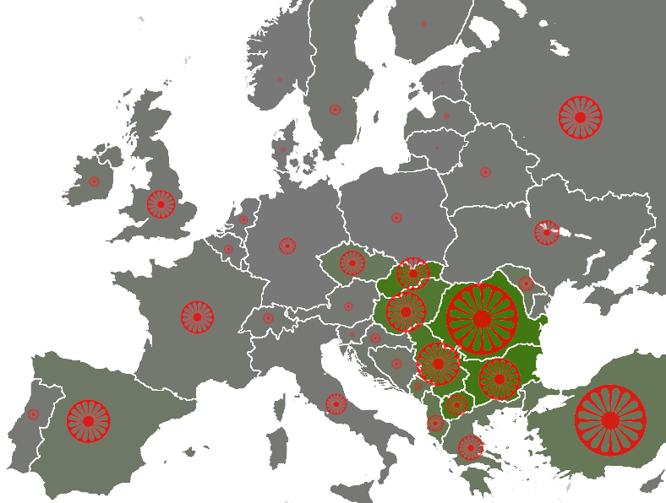
Source: Council of Europe
According to the 2002 census, the total population of Romania amounts to 21,680,974, of which the Hungarian ethnic group accounts for 6.6% (1,431,807), while the Roma ethnic group represents 2.47% (535,140). Consequently, the Roma are the second largest ethnic minority group in the country.
Fig. 3. The Roma ethnic group in Romania
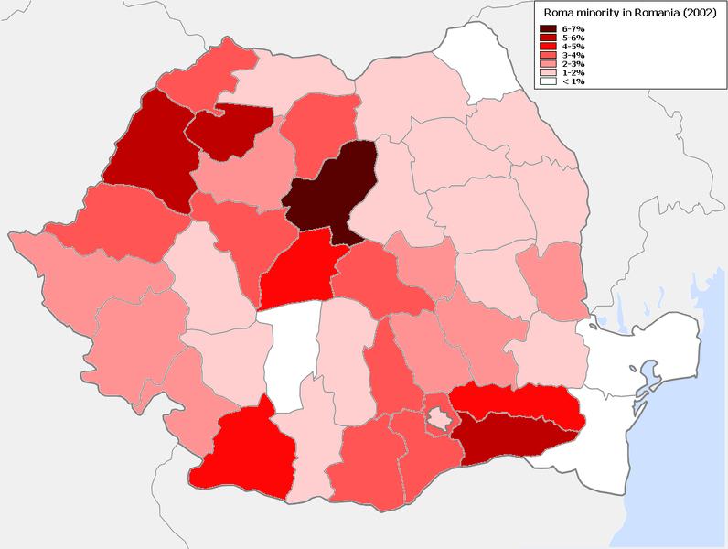
Source: Wikipedia
Despite the six-year period between the two estimates, the significant discrepancy between the two figures emphasizes that the accurate number of Roma people in Romania is subject to controversy given that most of them do not admit to their ethnic origins out of economic or social reasons.
As the Roma Inclusion Barometer emphasized (Bădescu et al. 2007), the experts and research institutes other than the National Institute of Statistics pointed to a higher percentage of Roma population. All the more interesting, according to the same barometer, the average estimates made by both Roma and non-Roma people concerning the amplitude of the Roma ethnic group in Romania were much higher than the official ones (almost 10 times).
Taking into account the 2002 census, the regions having a higher percentage of Roma population are: Center (3.96%), North-West (3.5%), South (2.91%) and South-West (2.58%).

Fig. 4. Roma population by region
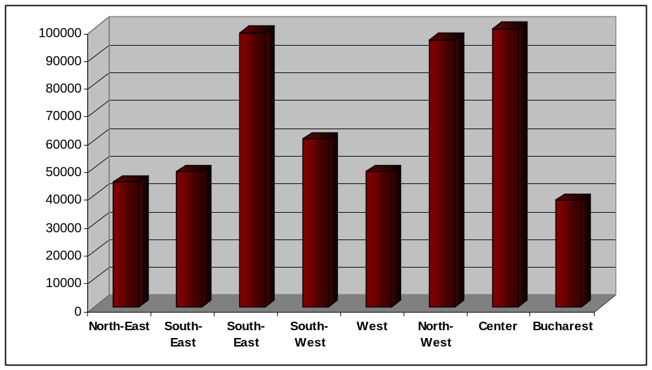
As far as the gender distribution is concerned, the 2002 census reveals a 2% gap between the Roma men (51%) and Roma women (49%). The gap reaches its maximum in the South-East (5.5%) and becomes extremely narrow in the West where the shares are almost equal (on the other hand, the West region is the only one where Roma women outnumber Roma men).
When taking a look at the Roma population by age, the highest density can be noticed in the 0-34 group. The climax is reached by the 0-4 group representing 12.8% of the total population and is closely followed by the 10-14 group accounting for 12.7%. If considering gender an additional variable in the age equation, the 2002 census highlights that men outnumber women between 0 and 44 years while women prevail in the group aged over 55. The two shares become similar between 45 and 54 years.

Fig. 4. Roma population by age and sex
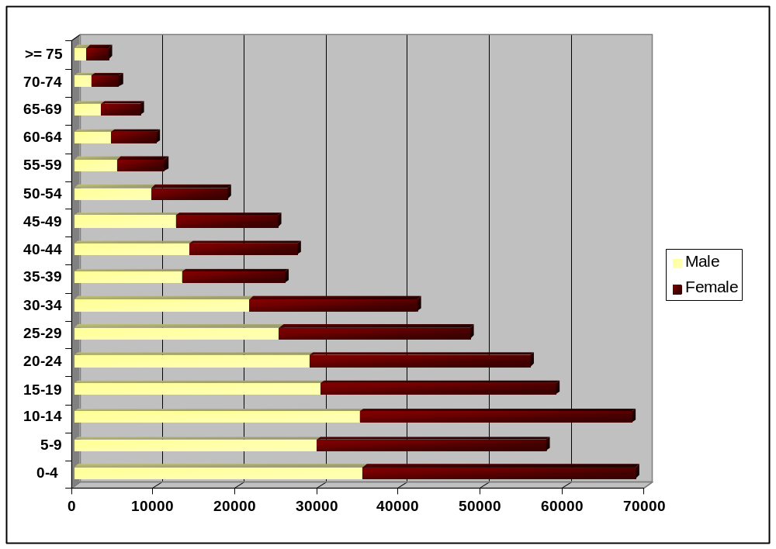

The religious makeup points to an overwhelming Orthodox majority (82%) followed at considerable distance by Pentecostals (6.4%), Roman Catholics (3.8%) and Reformed (3%).
If blending marital status into the demographic picture, one discovers that in 2002, 73% Roma were not married, 22% - married, 1% - divorced, 4% - widows/widowers. A significant share of the population (18%) was also held by those in a consensual union.
When drawing a parallel between the Roma women and men, the census reveals close figures for those married or in a consensual union and significant gaps for the other statuses. Namely, the not married men outnumber the women by 11%, while divorced women outnumber men by 63%. In the case of the widow/widower status, the number of women is approximately 3.5 times the number of men.

Fig. 5. Roma population by sex and marital status
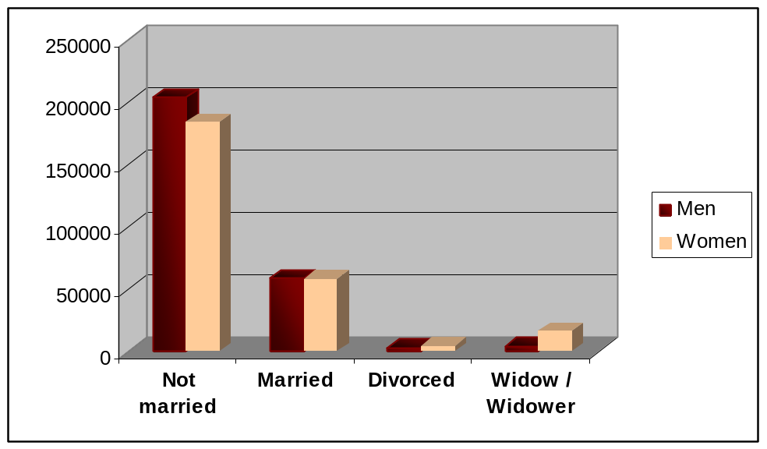
When adding age to the sex-marital status analysis, figures show that the number of women aged under 15 who are in a consensual union is almost 5 times the number of men belonging to the same group.
The number of married women aged between 15 and 19 is almost 4 times higher than that of men, while the number of widows is twice the number of widowers, for the same age group.
If we widen the perspective and relate to the majority, the findings show that the share of Roma people entering a consensual union at an early age is much higher than the share held by Romanians.
For instance, the Roma men aged under 15 who have a partner account for 0.14% while their Romanian counterparts stand at 0.0001%. Furthermore, the 15-19 age group reiterates the cleavage with 11% Roma men and 26% Roma women in a consensual union unlike 0.2% Romanian men and 3.5% Romanian women.
Another prominent discrepancy between the Roma and the rest of the population is the early motherhood and the number of children. If comparing the Roma and non-Roma women aged between 15 and 19 who gave birth to living babies, the former hold a 23% share while the latter stand at 4%. In other words, the share of Roma women (in the total Roma population) is almost 6 times higher than the one of the non-Roma.
Also, the number of living babies per 1000 Roma women aged 15 and over is approximately 2500 and tops the list. The second and third ranks are held by Csangos and Ukrainians, respectively, while the majority misses the tip of the ice berg by 800.
A deeper insight into the Roma population reveals that 55% have Romanian as mother tongue while 44% have Romany as mother tongue. The third language at the top of the hierarchy is Hungarian (4.5%) while all the other languages hold insignificant shares.
Fig. 6. Roma population by mother tongue and urban / rural residence
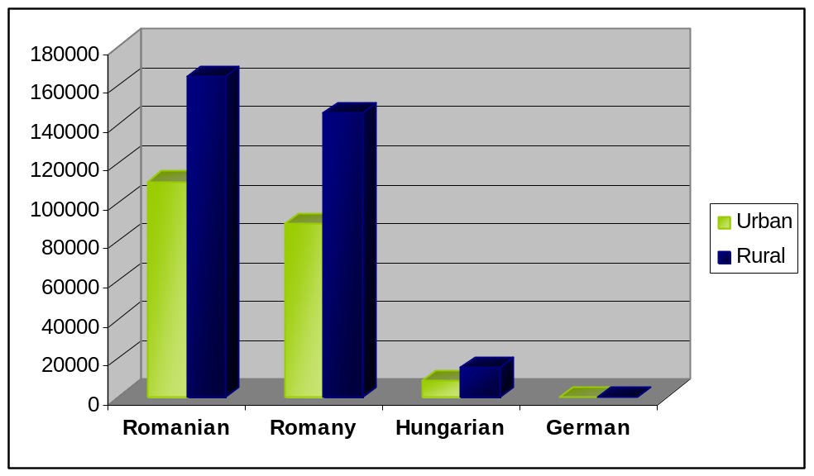

According to the distribution map drawn up by the Department for Interethnic Relations (Horváth, Raţ and Vitos 2006), out of the 41 counties in Romania, 13 include localities with over 20% people whose mother tongue is Romany.

Fig. 7. The population having Romany as mother tongue

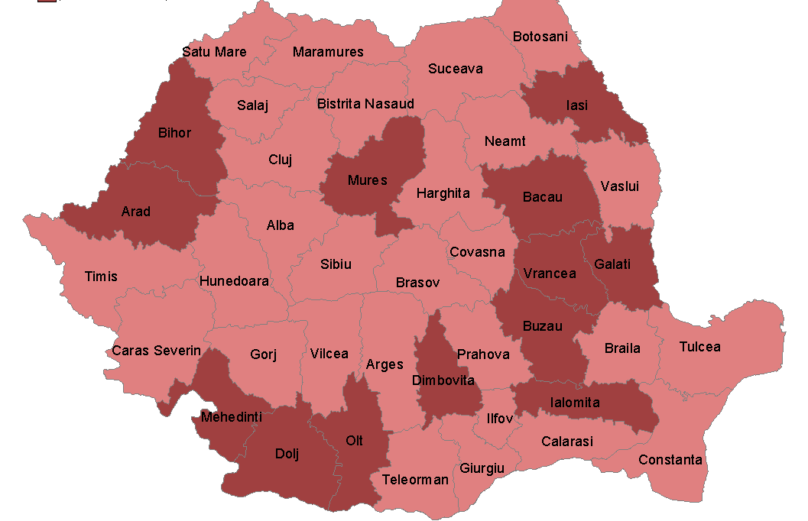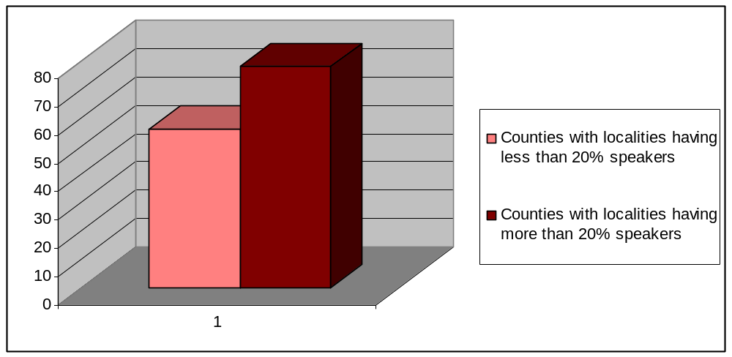

3. Indicators of social and economic status
In the 2007 Poverty Assessment Report published by the World Bank, the Roma came under scrutiny given the major discrepancies between them and the rest of the population. The report emphasized that of the three main ethnic minorities in Romania – Hungarian (5.9%), Roma (2.5%) and German (0.5%) – the Roma were the only group who had a standard of living much lower than the majority. The cleavage was highlighted by 2006 figures which showed that the share of poor Roma was likely to be four times the share of poor Romanians.
The main reasons which trigger the impoverished condition of the Roma are: high unemployment, improper housing, poor health and high illiteracy.
In other words, the four fields on whose shoulders their precarious condition rests are: employment, housing, healthcare and education.

3.1. Employment
In order to have an accurate perspective of the employment issues faced by the Roma, the starting point will be considered the 2002 census which shows that of the total Roma population (535,140), only 23% are economically active. If drawing a parallel and considering the 42% economically active Romanian population, the Roma score low.
The active Roma population consists of 71.5% employed and 28.5% unemployed people. The latter category encompasses more people looking for their first job (18.3%) and less people in search of a new job (10.2%).
The economically inactive population aged 10 and over holds a significant share in the Roma population (54%) mainly due to the large number of people engaged in family duties (32.7% of the inactive Roma) or retired (10.7%).
When getting a deeper insight into the labor market participation, one discovers the lack of professional training at the root of low employment. Namely, 70% of the Roma are unskilled or carry out activities that do not require formal professional trainings. Many Roma have never performed a legally accepted economic activity or had to cope with long-term unemployment (more than 50% were unemployed for more than 27 months). Consequently, the key words which best describe their income sources are “occasional” and “informal employment” (Sectoral Operational Programme Human Resources Development – POS DRU).
According to recent surveys, 16% of the Roma have social assistance as their only income source while the unemployment rate is 24% (POS DRU). If we compare the latter figure with the 2010 unemployment rate in Romania – 7.3%, the discrepancy is striking (The National Institute of Statistics 2011).
On the other hand, recent surveys continue to point to a considerable gender gap in labor market participation with Roma women accounting for less than a third of the total number of employed Roma (POS-DRU).
A relevant update of the figures concerning the integration into the labor market is the study drawn up by the Research Institute for the Quality of Life (ICCV) in 2010. Despite the 8-year distance between the official census and the study, the coordinates which continue to provide an accurate overview of the Roma are high informal employment, poor formal qualification or non-formal qualification based on experience and tradition.
Building on the findings, ICCV establishes seven categories of working Roma:
- Roma who perform unskilled work in the informal labor market;
- Extremely poor Roma who collect waste materials;
- Roma who perform household duties and other informal occasional activities;
- Roma who carry out traditional activities;
- Roma who are employed in the formal labor market;
- Roma who have their own businesses (e.g. real estate, recycling waste materials, trade etc.)
- Roma who work abroad.
As shown by the authors, most Roma belong to the first two categories.
The study also pays particular attention to the traditional activities carried out by a notable share of the working population. These are said to have evolved from iconic practices or crafts like fortunetelling, blacksmithing and healing to niche activities like scrap metal collection, handmade bricks etc.
The appetite for traditional activities is explained by the high percentage of unskilled workers. In this regard, the study emphasizes that 43.6% of the employed Roma state they have no qualification. The percentage is even higher (73.7%) when a closer look is taken at the educational attainment of the interviewees.
Also, findings reiterate the gender gap in labor market participation by stating that most Roma who have never had jobs are women aged under 34. The gap is once again made obvious by the high percentage of women who didn’t look for a job during the last year because of family duties unlike men who mainly invoke the general economic background. The latter is held responsible for the failure on the labor market by most interviewees while individual factors like lack of education, ethnic origin or age come second.
When being asked about the main fields they would embrace, most respondents do not have a particular option while the second largest share would choose agriculture, constructions and cleaning. If looking from a gender angle, women tend to choose especially agriculture, cleaning, trade and services, while men’s favorites are construction, agriculture, industry and transport.
The study also provides a snapshot of the efficiency of the employment policies by revealing that only 29% of those looking for a job resort to county / local employment offices whereas most of them go directly to employers or ask for the help of their friends, relatives, acquaintances.
A more recent perspective on the Roma population is provided by a knowledge brief issued by the World Bank in April 2011 (De Laat and Bodewig 2011). The analysis focuses on four countries – Bulgaria, Czech Republic, Romania and Serbia – known for their ethnic makeups with consistent Roma shares.
The brief pinpoints that the integration of this group into the labor market is extremely important considering the fast pace at which it is growing (in Romania, almost one fifth of the new entrants are Roma) and the proportion of Roma and non-Roma people aged between 0 and 15 - 29.8% and 12.4% respectively. In other words, the Roma youth enter the market at 2-2.5 times higher rates than the majority.
The analysis sounds a warning by stating that labor market integration continues to be poor despite the programs and strategies touching upon the issue.
In order to argue their statement, the authors resort to four main strands.
First, they state that the Roma are less likely to be working than the non-Roma and illustrate this tendency by pointing to a 13% employment gap in Romania.
Second, the Roma earn less than the non-Roma and the 61% wage gap in Romania is one edifying proof which can be invoked in this regard.
Third, the analysis contradicts the general public perception about the Roma’s dislike of work by emphasizing the efforts they make for finding jobs. However, most efforts do not culminate in becoming formally employed even if their willingness to work is clearly outlined by the 84% labor participation rate of the Roma men which outnumbers the 75% rate corresponding to their non-Roma counterparts.
Yet, the proportion changes when it comes to the Roma women who participate in the labor market to a lesser extent.
Despite their wish to work, the analysis shows that across the four countries, 39% of the Roma women looking for jobs remain unemployed while 20% of the Roma men having the same goal fail to achieve it.
Another argument which remaps the position of this ethnic group refers to the 12% Roma who receive guaranteed minimum income social assistance, a relatively low percentage if considering their generally low level of income.
A different perception of the Roma’s attitudes to labor is also given by the values these hold in relation to the topic in question. As shown by the ICCV study (2010), work comes second after health when respondents are asked to identify the main ingredients which ensure success. Also, when being asked to draw a hierarchy of these ingredients depending on their importance, 59% of the interviewees state that work is very important. Hence, labor heads the list together with a beautiful family, happy children, health and personal safety.
The central role which labor plays is also highlighted by the significant percentage of Roma choosing full time over part time jobs and open-ended over fixed term contracts.
The perspective induced by employment is also underpinned by Roma’s incomes.
According to the Roma Inclusion Barometer (Bădescu et al. 2007), in October 2006 the average income of the Roma was less than half the one of the non-Roma. During the same month, 43% of the interviewees didn’t have any income at all whereas only 19% non-Roma stated the same. The extremely low standard of living also impacted the Roma children of which 11% lived in households with no income compared with 2% non-Roma.
In the rural area, the difference between the Roma and the rest was even higher and was also reflected by the 80% Roma versus 35% non-Roma who used goods produced in their own households.
The low or lack of income also entailed higher debts. The study pinpointed that the indebted Roma outnumbered the non-Roma (38% versus 20%) and established a link between the debts and the incomes. In October 2006 the average ratio between the two variables was found to be higher than 1 for the Roma unlike the non-Roma ratio which stood below 1.
Consequently, not only the number of indebted Roma was higher but also the value of their debts related to their earnings.
The ICCV research (2010) brings the above findings up to date by drawing a comparison between 1998 and 2010 earnings.
The parallel begins with per capita income which accounts for 15% of the net average salary in 1998. Twelve years later the ratio drops by 3% thus suggesting an almost insignificant change also highlighted by the share of those having no income in the last month - approximately 4% in 1998 and 2010.
The chronological perspective goes even further and emphasizes a steady growth of those claiming that their incomes ensure only a bare subsistence between 1992 and 2010.
As expected, the evaluation highly depends on the interviewees’ occupational status. Those who state they make a decent living are either entrepreneurs or employees in the formal labor market. Most of those who state the contrary are economically inactive or perform traditional activities.
When taking a closer look at the main sources, children-related incomes lead the list (alimonies, maternal benefits, state allocations for children, indemnity for raising children and other social benefits) and are followed by occasional incomes and social assistance (guaranteed minimum income).
To conclude with, work is considered to be a natural centerpiece of the work-life balance in close relation to family and the need to have a constant source of income. Work is seen less from the perspective of high professional competence and top management positions and more as an inherent part of day-to-day life.
Yet, despite their work-related values and beliefs, the situation of the Roma on the labor market continues to be highly volatile. Occasional jobs, informal employment, low wages, skills unable to meet the current labor demand are only a few examples which explain their vulnerability and also point to another problematic chapter- education.

3.2. Education
The knowledge brief published by the World Bank (De Laat and Bodewig 2011) emphasizes that the public perception of Roma’s poor education perfectly matches reality. The analysis shows that, in the four countries addressed, most Roma do not have secondary or higher education and the percentage of those who have completed secondary education is less than 20%. The gap between the Roma and non-Roma is once again striking considering that the latter hold a 75% share at the same chapter.
In Romania, 12% of the Roma take further steps after completing primary education compared with 75% non-Roma. In other words, the share of those who continue their studies is approximately 6 times lower than the majority.
The discrepancy is also confirmed by the 2002 census and recent national researches.
The census reveals that of 408,842 Roma aged 10 and over, 25.6% are illiterate.
The environment has a significant impact on the illiteracy rate. The conclusion can be drawn given that the Roma in the urban area account for 39% of the total while those in the rural area stand at 61%.
The research carried out by ICCV in 2010 also provides a conclusive outline. In brief, it highlights that 25% Roma cannot read or write, 50% have completed primary school and only 33% “ventured” into secondary school.
When getting to the three fundamentals for success in life, the respondents omit education and point to health, work and luck. In other words, education is not seen as a must-have of any individual wishing to achieve a high position in the social hierarchy.
The study also pays particular attention to the correlation between the parents’ and respondents’ education and concludes that the level of education is more likely to be higher if the interviewee has a proper family background which encourages study and professional competence.
However, despite the major role family plays, the large number of children which is characteristic of the Roma poses a serious barrier to their education. Two major reasons are the scarce financial resources and the shift of parental responsibilities to the elder children who take care of their younger siblings. Moreover, Roma children start working in their household or in the informal labor market at an early age and do not have time to attend school.
The research carried out by Surdu, Vincze and Wamsiedel (2011) in 2009-2010 digs even further into the Roma’s low educational attainment by correlating pre-school education with school dropout rate.
The link established between the two shows that those who go to nursery school or kindergarten are more likely to have higher school graduation rates.
A progressive parallel between the Roma children who attend pre-school education and the national average emphasizes that the participation rate of the former is 12 times lower than the latter at the age of 3, 7 times lower at the age of 4 and 5 times lower at the age of 5, and partially explains why 44% of the children aged between 7 and 11 and 65% of the children aged between 12-16 drop school.
When delving into the main reasons which trigger such impressive rates, the low income tops the list both for the Roma who leave school (42%) and for those who were never enrolled (55.8%).
Other reasons stated by interviewees are the lack of transport means (mentioned in the rural area only) or the uselessness of school mainly referred to in the urban area.
Contrary to public perception, marriage at an early age is not a major reason for dropping school. Yet, the percentage becomes significant from a gender perspective as all the persons who abandoned school for such reason are girls.
Another chapter of the research touches upon the expectations parents have when enrolling their children. In this regard, an overwhelming majority state that they simply wish their children to learn, while lower shares justify their pro-school attitude by invoking the need to learn a trade or to have a better standard of living.
Even if most parents are in favor of education, the family background and low income often discourage such attempts. The research shows that most children don’t even have a table where to study at home and can’t benefit from the help of their parents when doing their homework.
The precarious condition is a stigma which is often perceived as a starting point for discrimination. Thus, 38% of the parents state they are not satisfied with the teaching staff and frequently point to their insensitiveness towards the “humiliation and embarrassment” children undergo given their financial background.
When it comes to segregation, almost half of the interviewees say that both Roma and non-Roma children are treated equally while a smaller percentage state the contrary. If drawing a profile of the interviewees in the first half, one discovers that these belong to families where all children attend school unlike the other share who also have dropouts.
Segregation is highly influenced by the environment and the level of education attended. The research suggests that such phenomenon is more likely to arise in the primary school (where 65% of the Roma people learn in segregated classrooms unlike 53% in the secondary school) and in the rural area (where their share amounts to almost 70%).
The topic in question is also addressed by the National Report on Roma Inclusion in Children’s Early Development Services (Bennett 2010) which highlights that the schools where most pupils are Roma rank low because of less trained teaching staff and inappropriate infrastructure. Some examples refer to the lack of a school library, laboratories, gymnasium and teaching materials.
Moreover, the report states that Roma children are often considered children with special needs. According to 2001 statistics, 70% of the pupils in special schools were Roma, while the 2007 EU Monitoring and Advocacy Program (EUMAP) pinpointed that many Roma children were deliberately directed towards separate classrooms and special schools for the mentally-disabled.
To sum up, if reviewing the researches on education, all findings converge to the same conclusion: the education attainment of the Roma is poor. Most frequently, the key syntagms revolving around this sentence are the high illiteracy rate, the lack of secondary or higher education and the low income as a major drawback which explains the high dropout rates or not attending formal education at all. If delving deeper into the background researches set, education appears to be valued by the Roma community who wishes (but not necessarily affords) a better life for their children. However, it is not considered a side of the “success in life” triangle which lays stronger emphasis on health, work and luck.

3.3. Healthcare
Another chapter which is closely related to work and education and which paints an equally worrying picture of the Roma population is healthcare.
A brief inventory reveals that the major problems faced by this ethnic group stem from the scarce financial resources which hinder them from going to the doctor in the first place, the lack of ID papers and health insurance, the poor medical infrastructure to which Roma have access given that they usually live on the outskirts, difficulties in buying the drugs prescribed in the rural areas, the lack of transport means to reach the medical care centres, legal issues concerning their place of residence, discriminatory behavior and attitudes of the medical staff (Chiriac et al. 2007).
When referring to the health problems per se, the report lays a great emphasis on Roma’s diet which is considered to be lacking in both quality and quantity. Thus, if drawing a food consumption ranking, vegetables top the list while dairy and meat products climb down to the lowest step of the hierarchy (Chiriac et al. 2007).
The imbalanced nutrition is also central to the 2009 report - Health and the Roma community (Wamsiedel et al. 2009) - which reveals that cereals, pasta and rice account for a consistent share in Roma’s everyday meals, unlike fish, eggs or meat.
Both studies emphasize the immediate consequences of such inadequate diet and most frequently mention overweighing and obesity (also determined by insufficient physical activities), avitaminosis, malnutrition, anemia, dystrophy and rickets.
Besides imbalanced nutrition, a considerable share of the Roma population doesn’t properly preserve the food and wash the fruits, vegetables etc. or uses products beyond their past expiration date. Such behavior leads to enterocolitis for many of those who disobey the rules.
On the other hand, tap and drinking water are rather scarce in the Roma communities used to poor quality water and home hygiene. Such weak point is correlated with the occurrence of blood poisoning and infectious diseases.
Aside from the nutrition and hygiene-related problems, the report also points to cardiovascular diseases as one of the adults’ most common health problems and to respiratory disorders (throat troubles, cough, cold or flu) in the case of children.
When shifting to the main reasons which generate the health problems mentioned above, consistent shares go to the lack of health education and information. An edifying example is the National Immunization Program which has failed to achieve its goals related to the Roma community mainly because of not providing enough information on the role of vaccination, the period for completing it and the free of charge status of mandatory vaccines. The result was that almost half of the children included in the sample didn’t receive all the required vaccines.
The very same lack of health education together with the perception originating in the Roma culture lead to a relatively positive self-evaluation of the health condition. Almost 80% of the respondents state their health is either good or very good and only 5% have a gloomier perspective on their condition described as bad or very bad.
The percentage of those belonging to the positive self-assessment group decreases to 60% in the 2010 research conducted by ICCV but still stands at a considerable level. A 10% gap appears between the Roma women and men mainly because of the large number of children which negatively impacts the former’s state of health.
Wamsiedel et al. (2009) explain the tendency to overestimate the state of health by quoting the findings of a report published in Spain according to which “a large percentage of Roma conceive health as the absence of disease, and disease as an incapacitating phenomenon linked to death”.
The cleavage between this perception and the approach of the World Health Organization - “Health is a state of complete physical, mental and social well-being and not merely the absence of disease or infirmity.” – is huge.
Consequently, self-assessment cannot be considered a yardstick when touching upon this issue and one edifying example is the fact that despite the good and very good health of the majority, many people had disabilities, chronic diseases, cavities, were overweight or obese.
Another strand which gives a clue to the condition of the Roma is their preoccupation with health which has been inferred, among others, on the basis of drug use and frequency of visits to the doctor and dentist.
The research (Wamsiedel et al. 2009) shows that self-medication is widely spread among Roma and tends to increase with age. From a gender perspective, women are found to use drugs without prescription to a higher extent (75%) than men (50%).
When touching upon the frequency of visits to medical care centers, most interviewees claim they make at least one visit to the doctor a year and almost half state they have never been to the dentist. Consequently, dental care is not a priority especially for those Roma living on the outskirts and having an overall bad health.
The access and use of healthcare services and facilities is another topic researches touch upon.
At this chapter, the 2010 ICCV study paints a rather optimistic picture by stating that 90% of the interviewed Roma have a family doctor. Even if the share is slightly lower than the national average (95%), it gives a positive outlook on their preoccupation with health.
Still, a further note is made on the number of Roma pensioners who claim there is a family doctor in their town / village. Taking into account that this is higher than the average in the sample, the authors draw attention to either a possible confusion with other types of doctors or a severe lack of knowledge concerning the existence of family doctors.
When being asked to evaluate the national healthcare system, most respondents label it as very unsatisfactory or unsatisfactory (60%). Possible reasons are the lack of financial resources, the lack of medical insurance and even transportation means to the medical care centers.
Yet, the low income heads the top and the information provided by the Health and the Roma community report (Wamsiedel et al. 2009) – 20% respondents didn’t go to the doctor in the year preceding the interview because they couldn’t afford it, almost half of them did not have insurance or the insurance couldn’t cover the services needed, 10% of the parents didn’t vaccinate their children because of lacking financial resources – are only a few examples.
However, the health problems faced by the Roma emerge not only from the reasons above described, but also from the poor or lack of communication between them and the medical staff. It is this very lack of communication which has led to the health mediation program set up by Romani CRISS Organization. If making a brief review of its history, the initiative took a prominent shape in 1996-1998 when Romani CRISS together with Comitè Catholique contre la Faim et pour le Dèveloppement trained 30 Roma women who afterwards returned to their communities in order to facilitate the relationship between the medical staff and the Roma. The program later gained national coverage and culminated in including the health mediator profession in the Registry of Occupations in 2001 (Chiriac et al. 2007).
If one were to draw a quick profile of a health mediator, the result would be a Roma woman who completed secondary school and is highly respected and valued by the community, whose communication skills are strong enough to smoothen the relationship between Roma people, local authorities and medical staff, who understands and is sympathetic to the problems of the Roma in her community and, last but not least, who keeps off politics.
The activities in a health mediator’s job description fall into two categories: social and medical.
The former mainly consists of helping the Roma to obtain ID papers, medical insurance and unemployment benefits, if the case.
The latter essentially refers to acting as an intermediary between the Roma and the medical staff and implies, among others, explaining basic notions of child medical care, promoting a healthy diet and home and public-space hygiene, explaining the role of prescribed medication and monitoring the administration of medication, alerting medical staff to special situations (communicable diseases, water safety issues etc.) (Chiriac et al. 2007).
The initiative was highly praised for its results but went on a downward slope given the decentralization process which implied the transfer of health mediators to local public authorities not properly prepared to cope with this change.
However, constant efforts should be made for this intermediary link to work properly especially that in the overall image describing the health condition of the Roma, the low income and the lack of health education and information continue to have the upper hand.

3.4. Housing
Taking into account the national public policies, strategies and researches addressing the condition of the Roma, housing can be labeled as the fourth ingredient which ads to employment, education and healthcare and gives a final touch to the overall picture.
If considering the previous chapters which stressed the high unemployment or informal employment, lack of education and poor health of the Roma, housing becomes highly predictable.
A relevant introduction to its analysis is provided by the ICCV research (2010) which mentions living on the outskirts, poor infrastructure, limited access to utilities, ghettoes and even landfill as key words in describing Roma’s dwellings.
Furthermore, a comprehensive analysis which can be considered a yardstick when touching upon the houses inhabited by this ethnic group is the 2007 Roma Inclusion Barometer (Bădescu et al. 2007).
The research provides a two-fold perspective as it analyzes both the area where Roma live and their access to different services, on the one hand, and the house itself, access to utilities, legal status, household goods owned, on the other.
Before delving into these two perspectives, an important introductory note is made on Roma’s satisfaction with the locality, area and residence they inhabit. According to the research findings, the Roma tend to be less satisfied than the non-Roma when assessing the three variables. The lower satisfaction mainly derives from evaluating the area they live in and their dwelling while higher contentment is related to the locality. Still, answers must be correlated with the interviewees’ expectations and perceptions of optimal housing which may significantly differ from those of the non-Roma.
In order to remove any doubts, the authors begin by taking a snapshot of the areas they usually inhabit. Thus, the Roma are found especially on the outskirts of cities or villages unlike the non-Roma who live less in such areas. However, the Roma residing in the urban areas are more likely to live in the center than those in the rural area. The explanation rests on the high number of old buildings (dated approximately 1886) in the town centre which were rented by the state.
The mainly peripheral and isolated position gives rise to a major issue – access to services. And one of the first indicators reflective of this drawback are the roads labeled as “poor or extremely poor” by more than 60% of the Roma unlike roughly 40% of the non-Roma who state the same.
Higher figures can be also noticed when referring to the means of transport and services available in the community. Thus, most Roma negatively assess the former by stating these do not exist or are in a poor working condition and point to the lack of shops, schools or kindergartens in their areas.
The inner circle of the analysis begins with the dwellings Roma inhabit. These are described as less resistant than those of the non-Roma as only 55% of the Roma live in houses made of stone, brick etc. compared to 90% of the rest. The high vulnerability of the dwellings is also characteristic of the flats inhabited by this ethnic group who have low comfort levels.
To conclude with, even if most rural and urban Roma live in houses, the feature which makes the difference is the quality of dwellings which is much poorer than the one corresponding to the rest of the population.
The discrepancy becomes all the more worrying when taking a look at the percentage held by the Roma people living in shanties or abandoned buildings (3% in the rural area and 8% in the urban area). The number of non-Roma people having similar housing is statistically irrelevant and, therefore, entails that improvised dwellings made of scrap materials are almost a perquisite of the Roma.
Utilities are another chapter which widens the gap between the Roma and the non-Roma analyzed. Even if the cleavage is less visible in the rural area, the urban area makes it prominent due to the 70% of the Roma households which are not connected to water, gas and sewerage systems, unlike other similar households which amount to 20%. The lack of electricity tops the list given the 13% of the Roma who don’t have such connection and ads to the lack of heating or heating based on waste materials which is characteristic of 12% of the Roma households.
Overcrowding is also referred to as one of the major issues considering that the average number of Roma persons per room is more than double the non-Roma average. The area per person is closely related and is found to be much lower in the Roma households (8 versus 19.5 square meters per person for the Roma and non-Roma, respectively).
When shifting to household goods, the ownership of highly durable assets establishes an impressive cleavage between the Roma and the rest of the population mainly because of the refrigerators (owned by 37% of the Roma compared with 88% of the non-Roma), color TV sets and telephones (landline or mobile) owned by 32% of the Roma compared with more than 73% of other ethnic groups.
However, one of the most serious issues is the lack of legal documents certifying ownership or rental. According to the survey, only 66% of the Roma have contracts for their dwellings whereas the percentage of non-Roma is 82.
The remaining 34% either do not have a valid contract or do not have any contract at all.
Of those having a contract, 67% own the place, 22% live in a house owned by their parents, 2% are tenants in a house owned by a company or a person, while 7% are tenants in a state-owned house. The last mentioned status applies almost exclusively to the Roma, if we consider the irrelevant percentage of non-Roma undergoing a similar situation.
The findings of the Roma Inclusion Barometer have been recently reiterated by the ICCV research (2010).
Most of the shares indicated by the two studies are similar. Higher differences are displayed by the percentage of those living in state-owned houses (which is almost double the percentage from the Barometer) and on the outskirts of cities and villages (83% compared with 68% in the Barometer). Differences may be either the result of the 3-year distance between the two surveys or the consequence of the research methodology used. However, these do not impact the overall picture described by the two studies which point to comparable trends.
In addition to all the features considered so far, housing can be also approached as a status symbol. One edifying example is the “Come closer” study (Fleck and Rughinis 2008) which analyzes housing as a conflict and competition generator given the main connotations it relates to - space, visibility, access and welfare - and lays the topic in a bivalent frame. Thus, on the one hand, it presents testimonials which emphasize the poor living conditions, the ramshackle cabins Roma live in and the efforts made for obtaining social housing. At the opposite side of the spectrum, the study places the heavily-ornamented houses owned by the rich Roma which often contradict the local architectural style. The survey states that these are labeled as kitsch or inaesthetic while the Roma and non-Roma interviewees in the respective localities consider them to be symbols of diligence and welfare. When such clashes of social representation arise, tensions between opponent ethnic groups are likely to emerge.
However, the so-called Roma palaces represent only an insignificant niche when compared to the overwhelming majority having a standard of living well below the average.
In a nutshell, most Roma live in the rural areas, on the outskirts and have poor access to services given the inappropriate infrastructure. When shifting to the dwellings per se, these are made of non-resistant materials or even waste materials, are not in line with non-Roma dwellings in terms of connection to utilities, durable household goods and area per person. As regards the legal documents proving ownership or rental, the Roma rank low as a considerable share don’t have valid contracts or any contracts at all.
Despite all these, the Roma are moderately content with the localities, areas and dwellings they inhabit (even if less content than the non-Roma) but such positive assessment originates in considerably different cultural background and expectations.

3.5. Conclusions
If making a brief review of the statistical information presented in this chapter, the Roma appear to be one of the most vulnerable groups given the significant share they hold in the total population as well as their high growth and poverty rates.
Even if Romania’s ethnic makeup owes its diversity to different groups, no group deviates more from the majority axis than the Roma. Such deviation can be noticed when analyzing the four main fields which give a clue to the Roma’s standard of living – employment, housing, health and education.
If merging all the findings, the major traits in the Roma’s portrait are: high unemployment and informal employment, lack of skills and, subsequently, an impressive gap between the current labor demand and supply, low and occasional incomes, low educational attainment, non-resistant houses built in isolated areas with poor or no access to utilities and community services, poor health condition often overestimated because of lacking basic health education.
If adding the lack of ID papers and property deeds for the lands or houses Roma use, the perspective becomes even gloomier and highly justifies a through analysis of these topics within the frame of the national laws and policies reviewed in the next chapter.

Chapter II: Laws and public policies impacting the Roma in Romania

The present chapter provides an overview of the laws and policies which impact the Roma in Romania. The chapter begins by reviewing the international, European and national framework and sets the ball rolling for a deeper insight into the public participation of the ethnic group in question.
The international and European documents placed under scrutiny are: The Universal Declaration of Human Rights; The International Convention on the Elimination of All Forms of Racial Discrimination; The Framework Convention for the Protection of the National Minorities; The European Union Charter of Fundamental Rights; The Millennium Development Goals; The Decade of Roma Inclusion 2005-2015; The Europe 2020 strategy; The Integrated European Platform for Roma Inclusion.
The national laws and policies in the second part of the chapter revolve around: the Constitution of Romania, Local Public Administration Law no. 215/2001, Government Decision no. 834/2003 on the establishment of the National Centre for Roma Culture, Government Decision no. 881/1998 for the proclamation of December 18 National Minorities Day in Romania, Government Decision no. 137/2000 on preventing and punishing all forms of discrimination, Government Strategy for Improving the Condition of the Roma 2001-2010, National Plan for Combating Poverty and Promoting Social Inclusion 2002-2012, Joint Inclusion Memorandum (2005), National Development Plan 2007-2013, National Strategic Reference Framework 2007-2013, Government Program 2009-2012, 2011 Employment Programme, Strategic Plan of the Ministry for Public Health 2008-2010, Strategic Plan of the Ministry of Education, Research, Youth and Sport (2007-2009), the Housing Law no. 114/1996, Pilot Programme – Social Housing for Roma Communities (2008).

1. International and European laws and public policies
Given its amplitude, role and length in time, the document chosen for opening the international suite is the Universal Declaration of Human Rights, adopted by the United Nations General Assembly in 1948 and signed by Romania in 1955.
The document emphasizes the freedom and equality in dignity and rights of all human beings from its very first article and establishes that all the rights and freedoms mentioned in the Declaration apply to everyone “without distinction of any kind such as race, color, sex, language, religion, political or other opinion, national or social origin, property, birth or other states” (Article 2).
The chronological trip on the realm of international policies and laws leads to the next milestone – the International Convention on the Elimination of All Forms of Racial Discrimination which was adopted by the UN General Assembly in 1965 and was accessed by Romania in 1970. According to this document, all states parties condemn racial discrimination defined as “any distinction, exclusion, restriction or preference based on race, colour, descent, or national or ethnic origin” and commit to pursue a policy of eliminating it and to take measures for ensuring “the adequate development and protection of certain racial groups or individuals belonging to them for the purpose of guaranteeing them the full and equal enjoyment of human rights and fundamental freedoms” (Article 2).
On 21 March 2003, Romania recognized the competence of the Committee on the Elimination of Racial Discrimination to receive complaints from persons claiming that their rights stipulated in the Convention were infringed and highlighted that according to domestic law, the competent body to receive and examine communications and complaints in Romania was the National Council for Combating Discrimination.
The most comprehensive multilateral treaty addressing minority rights is The Framework Convention for the Protection of the National Minorities, adopted under the auspices of the Council of Europe in 1995 and signed and ratified by Romania during the same year.
According to Article 1, the Convention is “an integral part of the international protection of human rights” and, therefore, must be supported with other existing human rights instruments.
The document defines the fundamental principles of non-discrimination and equality and emphasizes that its aim – the protection of the national minorities – is to be achieved not only by the states’ mere abstention from discrimination but also by their affirmative action (The Human Rights Project 2007).
Among the most important courses of action on which signatory states agree, one could mention: helping minorities to preserve and develop their culture and identity, fostering tolerance, mutual respect and understanding, recognizing the right to use a minority language in private and in public, recognizing the rights of minorities to set up and manage their own educational establishments and learn their own language etc. (The Human Rights Project 2007).
When shifting to the 21st century, one of the first notable documents to be mentioned is the European Union Charter of Fundamental Rights signed and proclaimed in Nice on 7 December 2000 (Charter of Fundamental Rights).
The Charter represents a premiere due to encompassing the civil, political, economic and social rights of the European citizens in a single document comprising of six chapters: dignity, freedoms, equality, solidarity, citizens’ rights, justice.
Non-discrimination is the centerpiece of Article 21 which states that “Any discrimination based on any ground such as…race, color, ethnic or social origin…membership of a national minority…shall be prohibited” (Charter of Fundamental Rights).
The beginning of the century can be also considered a landmark due to the Millennium Development Goals (MDGs) tagged as “the only global development agenda on which there is a high level agreement among most of the world’s states” (United Nations Information Center in Romania).
The MDGs were the result of the Millennium Declaration adopted in 2000 by 192 UN member states (including Romania). The Declaration set 8 goals with 21 targets and measurable indicators which UN member states agreed to achieve by 2015. These goals are: eradicating extreme poverty and hunger; achieving universal primary education; promoting gender equality and empowering women; reducing child mortality rates; improving maternal health; combating HIV/AIDS malaria, and other diseases; ensuring environmental sustainability; developing a global partnership for development (United Nations Development Programme Romania).
As regards Romania and the impact of the MDGs on the Roma population, the 2010 national report relates to the latter within the frame of Goal no. 2 – Increase compulsory education graduation rate by 2012, Target 2 – Increase literacy of the Roma population. The status of this goal reads: “significant progress with challenges remaining”. Furthermore, the report paints a fairly positive picture of the fight against discrimination, also facilitated by the “opportunities created for disadvantaged minorities such as the Roma in schools to express their own values and culture” (The United Nations and Government of Romania 2010).
Another international commitment that Romania made and that exclusively addresses the Roma issues is the Decade of Roma Inclusion 2005-2015, an idea which originated in the regional conference “Roma in an Expanding Europe: Challenges for the Future”, held in Budapest in 2003.
In 2005, the Declaration of the Decade was signed by eight states, all having significant Roma communities that underwent severe social and economic problems.
The Decade was considered an unprecedented effort made by the European countries to enhance the status and social inclusion of the Roma. However, this enhancement was not supposed to occur without the Roma’s participation which is clearly highlighted by the vision and values statement: ”Nothing about us without us: Roma participation will make or break the Decade. Roma representatives and civil society organizations are involved in every stage of the Decade. Roma shaped and defined the vision from the very outset. Roma civil society groups and experts identified policy priorities and played a key role in defining Decade goals and targets. Roma participation will be central to regular oversight and monitoring of the process over the next ten years.” (Decade of Roma Inclusion 2005-2015).
The core areas the Decade addresses are: education, employment, health and housing. All the signatory countries established their goals and indicators for these four priority areas and developed action plans in order to touch upon them.
In Romania which held the Decade presidency between July 1, 2005, and June 30, 2006, the action plan proposed is still being publicly debated according to Government Decision no. 755/2005, even if the other member countries have already passed to its revision (Decade of Roma Inclusion 2005-2015).
In broad lines, the goals established for each priority area of the Decade are:
Education
1. Increasing the participation of the Roma children in pre-school education
2. Increasing the participation of the Roma children and youth in the compulsory education (grades 1-10) and upper secondary education (grades 11-12)
3. Increasing the participation of the Roma in higher education
4. Developing an inclusive educational climate
5. Valuing and preserving the Roma cultural heritage
Employment
1. Increasing the number of Roma who are officially employed or have their own businesses.
Healthcare
1. Strengthening the role of the national and local public authorities in the development and implementation of public healthcare programs which meet community specific needs.
2. Promoting intercultural education in the national healthcare system
3. Increasing the Roma’s access to public healthcare services by including them into the healthcare insurance system (particular focus is set on women and children).
Housing
1. Improving housing conditions for disadvantaged Roma families (Decade of Roma Inclusion 2005-2015).
Five years after signing the Declaration of the Decade, Romania became part of the Europe 2020 strategy aimed at converting the EU into “a smart, sustainable and inclusive economy”.
The strategy addresses five core fields – employment, innovation, education, social inclusion and climate, energy – which set the ground for the national targets each member state had to establish.
In Romania, the Europe 2020 targets are: employment; research, development and innovation; reducing greenhouse gas emissions; renewable energy sources; energy efficiency; education; social inclusion (Europe 2020).
The key document which builds upon these targets is the National Reform Programme 2011-2013 that particularly mentions the Roma ethnic group at the Education and Social inclusion / Poverty reduction chapters.
The former relates to the Roma youth within the frame of reducing the early school leaving rate. Among the measures taken for spurring school attendance, the programme invokes “Increasing participation to education for Roma children and youth by teaching Romany language and Roma history and traditions at all levels, introducing a chapter on Roma history in the curriculum…, allocating special places for admission of Roma in high-schools and higher education, creating school inspector positions for Roma children etc.”
The document also mentions the PHARE programmes “Access to education for disadvantaged groups”, implemented between 2001 and 2010 in order to “support the concepts of inclusive education, combating discrimination and segregation”.
In the field of social inclusion, Romania’s target consists of reducing by 580,000 the number of people at risk of poverty and social exclusion. At this chapter, the Roma are mentioned by two key actions: Reform of the social assistance system and Active social inclusion.
Among others, the first mentioned revolves around the need to increase the quality of life for persons belonging to vulnerable groups. The document quotes the Romanian Government Strategy on Roma Inclusion 2011-2020 which aims to enhance the socio-economic inclusion of the Roma by putting specific measures on the agenda of central and local public authorities.
Moreover, in order to prevent the school dropout among children belonging to disadvantaged groups, the Ministry of Labor, Family and Social Protection together with the Ministry of Education, Research, Youth and Sport have developed a project which is said to result in “setting up 32 school training centers; financial support granted to 7,680 children aged between 6 and 16 who belong to disadvantaged communities or Roma ethnics to be sent to kindergarten and / or to school.”
The Active social inclusion key action addresses the Roma in the context of the programmes aimed at facilitating the access to and participation in the labor market for the persons belonging to vulnerable groups.
On the other hand, their social (re)integration is reiterated by the flagship initiative “The European Platform against Poverty and Social Exclusion: European framework for social and territorial cohesion”. The platform lays emphasis on citizens’ involvement in combating poverty and states that it is the very lack of active participation which tops the major drawbacks of the Romanian system (National Reform Programme 2011-2013).
An equally important initiative in view of the know-how transfer it fosters is the Integrated European Platform for Roma Inclusion. The Platform emerged after the first EU Roma Summit held in Brussels in 2008 as well as a consequence of the conclusions formulated during the December 2008 European Council. The structure brings together civil society, governments of member states, EU institutions and international organizations and has as an overall goal the harmonization of the Roma policies within the EU (Equinet-European network of equality bodies). In order to achieve it, the major functions assigned to the Platform are: to foster the exchange of good practice and experience in the field of Roma inclusion, to provide analytical support and to encourage cooperation between all the parties interested in Roma-related issues.
The main broad themes addressed are education, housing, health and employment and the key issues inside each theme range from early school leaving and academic failure to securing access to healthcare and adult vocational training (Integrated European Platform for Roma Inclusion Road Map (30 June 2010)).

2. National laws and public policies
The Romanian legislative framework on national minorities has been long considered an example by many neighbor countries.
The main pillar responsible for establishing the much hailed rule of law is the Constitution of Romania which dates back to1991 and was revised in 2003.
The titles that specifically deal with national minorities are: Title I – General Principles, Title II - Fundamental right and freedoms, Title III – Public authorities.
The ground is laid by Article 4 which states that “Romania is the common and indivisible homeland of all its citizens, without any discrimination on account of race, nationality, ethnic origin, language, religion, sex, opinion, political adherence, property or social origin.”
Furthermore, Article 6 points to the ethnic, cultural, linguistic and religious identity whose preservation, development and expression are guaranteed and recognized by the Romanian state.
When touching upon the fundamental rights, freedoms and duties, the Constitution clearly states that “all citizens are equal before the law and public authorities, without any privilege or discrimination” (Article 16).
The right to education (Article 32) particularly focuses on national minorities who are guaranteed the right to learn their mother tongue as well as to be educated in their language.
The third title Public authorities establishes that a national minority (which can be represented by one organization only) has the right to one Deputy seat if it fails to get the number of votes necessary for representation in Parliament (Article 62). The same title which regulates the relationship between citizens and public authorities gives national minorities the right to use their language before the courts of law (article 128).
The Constitutional provisions which outline the equality of citizens before the law and public authorities gave rise to several organic laws which pay special attention to the use of mother tongue by national minorities.
One edifying example is the Local Public Administration Law no. 215/2001 which sets several rights starting from a minimum 20% share held by national minorities in the total number of inhabitants from an administrative-territorial unit.
The rights to which national minorities are entitled if holding a share above the minimum threshold are:
- the right to be informed in their language about the agenda of the Local Council and Local County meetings;
- the right to be informed in their language about the decisions taken by the local public administration (LPA);
- the right to use their language when communicating with LPA representatives and to receive answers in both Romanian and their language (in this regard, the Public Relations Departments must have employees who speak the language of the respective minorities);
- the right to have public announcements and the name of the localities and public institutions translated into their language and displayed as such.
A different share is established for the local councils whose representatives belong to national minorities. Namely, if at least one third of the total number of councilors belong to a national minority, their language can be used during the meetings on condition that the mayor ensures the translation into Romanian.
The Local Public Administration Law was later followed by the Government Decision no. 1206/2001 on approving the application of the provisions concerning the right of citizens belonging to national minorities to use their mother tongue in local administration.
The right to preserve, develop and express cultural and ethnic identity, guaranteed by the Romanian Constitution, led to the Government Decision no. 834/2003 on the establishment of the National Centre for Roma Culture, a public institution with legal personality, subordinated to the Ministry of Culture and National Heritage.
The main objectives of the Centre are emphasized by Law no. 430/2001 concerning the Strategy for Improving the Condition of the Roma and comprise of setting up a theatre, a Roma museum and a musical and choreographic ensemble as well as of preserving the traditions and crafts of the Roma.
In order to catch a glimpse of the Centre’s activity, one can consider its major contribution to the program “Sibiu – European Capital of Culture” where more than 100 artists (painters, craftsmen, dancers etc.) covered a significant part of the 2004-2008 agenda (Romani Kher).
Government Decision no. 881/1998 additionally fuels the development and expression of cultural identity by establishing the National Minorities Day on 18 December as a special occasion on which cultural activities, round tables and other similar actions take place.
Besides the legislation which sets the general framework for national minority rights, an important module comprises of the legislation on discrimination.
At this chapter, the landmark is considered the Government Ordinance no. 137/2000 on preventing and punishing all forms of discrimination (amended by Law 324/2006, Law 48/2002, Government Ordinance no. 77/2003) which defines discrimination as “any distinction, exclusion, restriction or preference based on race, nationality, ethnicity, language, religion, social category, belief, sex, sexual orientation, age, disability, non-contagious chronic disease, HIV infection, belonging to a disadvantaged category, and any other criterion that has as purpose or effect the restriction, removal of recognition, use or exercise, on an equal footing, of the human rights and fundamental freedoms or rights recognized by law, in the political, economic, social, cultural or any other field of public life.”
The following chapter “Special provisions” delves into the contraventions concerning: economic activity, employment and profession; access to public administrative, legal and health services; access to education; freedom of movement; the right to freedom of choice of residence and access to public places; the right to personal dignity.
The sixth section of the Ordinance plays a crucial role as it sets the state authority in the field of discrimination – the National Council for Combating Discrimination (CNCD). The Council is independent, reports to the Parliament and is responsible for applying the anti-discrimination domestic laws and international documents to which Romania is a party.
Article 19 provides an outline of the Council’s responsibilities which mainly consist of preventing, mediating, investigating, ascertaining, sanctioning and monitoring discriminatory actions as well as of providing specialized assistance to the victims.
Despite the above legal provisions, CNCD was effectively established in August 2002. Its functions were set out by several Government Decisions (1194/2001, 1514/2002, 1279/2003) and consist of: proposing certain actions for the protection of disadvantaged persons and groups, proposing draft legal regulations, co-operating with the relevant public authorities, receiving petitions and complaints regarding violations of the legal provisions, co-operating with NGOs active in the field of human rights protection, ascertaining and sanctioning the contraventions mentioned by Government Ordinance no. 137/2000, carrying out programmes and national campaigns in order to fulfill its tasks etc. (Council of Europe. National Council for Combating Discrimination Romania).
According to the 2006 revision of the Ordinance no. 137/2000, an individual or legal entity can bring forward a case of discrimination within one year after the discriminatory action occurs. CNCD has the obligation to establish whether anti-discrimination laws were breached within 90 days. The Council can issue a fine or a warning. If the victim of the discriminatory action is an individual, fines range from 400 to 4000 lei. If the victim is a group of people or a community, fines range from 600 to 8000 lei (Law no. 324/2006).
Among the most notable rulings of CNCD, one can mention:
a) sanctioning the mayor’s office in Miercurea Ciuc in 2004 (fined 4000 lei) for the forced eviction of 140 Roma families and their relocation to a hazardous area close to a wastewater treatment facility (2005 Country Reports on Human Rights Practice);
b) sanctioning the newspaper “Anunţul telefonic” (fined 700 lei) for publishing a classified advertisement that explicitly excluded the Roma; the advertisement read: “…I take in lodgers - two girls or a family. Gypsies excluded.” (Gilbea Vasile et al. 2008)
c) sanctioning of Adrasim company (fined 2000 lei) and website www.e-jobs.ro (fined 400 lei) for posting two job openings that clearly discriminated against Roma applicants; the advertisements read: “Hiring experienced mechanics, aged between 30 and 40 (Roma excluded)” and “seamstresses, Roma excluded” (Report on the Implementation of the Race Directive 2003-2010).
The CNCD is also referred to by Law no. 612/2002 which designates it as “the competent body to receive and consider complaints (communications) in Romania”, in accordance with the International Convention on Elimination of All Forms of Racial Discrimination.

The first public policy which addressed the Roma in Romania was the Government Strategy for Improving the Condition of the Roma 2001-2010.
The strategy was approved by Government Decision no. 430/2001 and was the result of a close cooperation between the Government and Roma NGOs assisted by the EU institutions.
The strategy was drawn up in order to meet the Copenhagen criteria for joining the EU. The 2001 Regular Report on Romania’s Progress Towards Accession pinpointed that the strategy was one of the major initiatives which touched upon the problems faced by the Roma ethnic group and described it as “a comprehensive and high quality document”.
The strategy took into account both discrimination and poverty, the two dimensions which outlined the most severe problems faced by the Roma, and covered 10 sectoral fields: community development and administration, housing, social security, healthcare, economy, justice and public order, child welfare, education, culture and denominations, communication and civic involvement.
The strategy’s main target groups were the Roma ethnics, political leaders, local and central public administration, mass media and public opinion.
Some of its most notable objectives were the transfer of responsibilities to the central and local authorities for improving the condition of the Roma, fostering the creation of a Roma intellectual and economic elite, removing the stereotypes and prejudices that civil servants and public opinion held about the Roma, ensuring decent living conditions and stimulating Roma participation in all aspects of civil society (Public policies for Roma in Romania, 2000-2005: legislative framework, institutions, programmes, achievements and expectations).
The strategy was especially praised for its decentralized nature and for the great emphasis on the participation of the Roma in the implementation process. In this regard, each county had to establish an office including 3-4 experts of which one had to be Roma. Besides the County Offices, other organizational structures set up within the frame of the strategy were: the National Agency for Roma (established by Government Decision no. 78/2004 as a specialized body of central public administration, with legal personality; it is subordinated to the Government and coordinated by the General Secretariat of the Government), the Joint Committee of Implementation and Monitoring (JCIM) which acted as a coordinating mechanism, Ministerial Commissions for Roma responsible for implementing those strategy modules which corresponded to their fields of activity (Focus Consultancy Ltd. 2005).
The National Agency for Roma (ANR) proved its sustainability by drawing up the draft of the Government Strategy for the Inclusion of the Romanian Citizens belonging to the Roma Minority.
The new document builds upon the conclusions drawn by the 2001-2010 strategy assessment report, namely on the need to take further action in the education field (education is seen as the main pillar capable of driving the change of mentalities) as well as on the labor market (the lack/low level of income is one of the most severe problems faced by the Roma). Therefore, the objectives of the 2011-2020 strategy are: increasing the education level of the Roma, increasing the employment rate, reducing poverty, social exclusion and discrimination.
The six sectoral fields representing the core of the strategy are: education, employment, healthcare, housing and small-scale infrastructure, culture, social infrastructure.
According to the information on ANR’s web site, the project is still being debated.
Another document which proves to be a landmark if considering discrimination and poverty as main coordinates of the Roma condition is the National Plan for Combating Poverty and Promoting Social Inclusion 2002-2012 (PNAinc).
The plan originated in the templates established by the European Council in 2000 and was adopted by Government Decision no. 829/2002. The document focuses on the Roma community in Chapter 14 which sets eight strategic objectives: providing the Roma with identity papers, ensuring access to medical care, increasing the participation of the Roma in compulsory and upper secondary education, fostering the employment of the Roma with a special focus on youth, solving the issues related to houses or lands for which the Roma don’t have property deeds, combating any discrimination against the Roma and promoting a supportive collective attitude, improving the self-esteem and the public image of the Roma community.
PNAinc is coordinated by the Committee against Poverty and for Promoting Social Inclusion (CASPIS) while the National Agency for Roma is responsible for implementing and coordinating the measures in the Plan (Decade Watch Romania Report 2010: Mid Term Evaluation of the Decade of Roma Inclusion (2010)).
Another touchstone in the field of Roma policies is the Joint Inclusion Memorandum. Even if the document dates back to 2005, it has surely set the ball rolling for the programmatic documents which followed.
JIM was drawn up by the Government of Romania and the European Commission in accordance with the provisions of the Accession Partnership. Its overall goal was to prepare Romania for the Social Open Method of Coordination (OMC) upon accession (The Research Institute for Quality of Life 2010).
In brief, JIM took a snapshot of the social problems faced by the Roma community (employment, poverty, healthcare, education, housing) and identified several priority areas, thus establishing the coordinates of the pre-and post-accession social inclusion policies.
The EU membership led to Romania’s full participation in the OMC thus compelling it to submit national strategic reports on social inclusion and protection.
The two reports submitted by Romania for 2006-2008 and 2008-2010 were analyzed by the European Commission and the Council of the National Reports on Strategies for Social Protection and Social Inclusion (The Research Institute for Quality of Life 2010).
Of particular concern were the comments made on objective 3 – Improving the condition of the Roma and the measures to be taken for achieving it. More precisely, the 2009 joint report states that: “…there is certain confusion between the objectives and the measures established...A positive element is the commitment to set up a system for monitoring and assessing the political programs for the Roma …However the lack of measurable goals continues to be a weak point” (Romania – Joint report on social protection and inclusion - 2009). In an overall assessment of objective 3, the authors of the report conclude: “both targets and measures appear realistic and correspond to the needs, however, in the absence of any quantifiable objectives, there is a great risk for them to remain mere declarations of good will at a rather general level that cannot be adequately subjected to assessment” (The Research Institute for Quality of Life 2010).
If taking further steps in the chronological review of the Roma public policies in Romania, two more documents come into the spotlight: the National Development Plan 2007-2013 and the National Strategic Reference Framework 2007-2013.
The former provides a comprehensive analysis of the current situation of disadvantaged groups on the labor market and delves into the problems of the Roma population with a special emphasis on employment and education.
The Roma are once again mentioned by the National Development Priority no. 4 – “HR Development, promoting employment and social inclusion and strengthening the administrative capacity” which originates in the following rationale: “Insufficient integration of the Roma population and of other vulnerable groups in education on the formal labor market.”
The National Strategic Framework 2007-2013 derives from the priority areas established by the National Development Plan and is considered to be a tool which sets out the investment priorities for the regional and sectoral programmes to be supported by the EU.
The Human Capital chapter tackles Roma issues like poor education facilities, lack of skills, lack of housing and identity cards, poor participation in the formal economy etc. and puts the Roma on a list of social groups at risk of social marginalization.
The document reiterates their belonging to vulnerable groups at point 4.5 – Sectoral Operational Programme Human Resources – which is said to promote and develop all the social economy forms as a means to ensure social inclusion.
The general framework of public policies for Roma is provided by the 2009-2012 Government Program which dedicates an important share of its objectives and measures to this ethnic group.
Chapter 5 – Education addresses issues such as: equal access to education, providing the necessary conditions for learning both Romanian and the minorities’ language, promoting multiculturalism while Chapter 6 – Healthcare promises to increase the quality of the healthcare system through Roma sanitary mediators and community assistants.
Chapter 9 – Family, child protection and equal opportunities – specifically mentions the Roma community by setting a course of action which aims to increase the efficiency of the institutional structures and human resources in charge of solving the Roma issues and update the Government strategy in this regard.
Chapter 20 – Public order and security – stipulates that the national and local police will have employees who speak the languages of national minorities (at a local level, this measure applies to those administrative-territorial units where national minorities hold a significant share).
As stated by Chapter 21 – Foreign Policy, the Government commits to protect the rights of Romania’s national minorities in neighbor countries, while according to Chapter 22 – Culture and national heritage, it commits to promote their culture.
Chapter 24 – European Affairs takes the initiative even further by advocating for a European Roma inclusion strategy aimed at removing their “second-hand citizens” status as well as a European agency that can be hosted by Romania.
Chapter 25 – Policies in the field of inter-ethnic relations explicitly mentions the Roma community as well as the need to improve its condition and reduce the gap between this ethnic group and the overall society.
The same chapter states that Roma-related issues are a distinct field which implies both domestic efforts and correlation with the European framework. In view of a substantial improvement, the national strategy and corresponding programs should: consolidate the local structures in charge of implementing the national strategy, establish a viable partnership between public administration and Roma communities, solve the ownership issues related to the houses and lands of the Roma, increase the efficiency of those measures touching upon sectoral issues.
When delving into the public policies addressing the Roma, notable attention should be also paid to the documents corresponding to the four priority fields: employment, healthcare, education and housing.
In the employment field, the background is set by the National Employment Plan (which was last updated for 2006-2008), the National Employment Strategy 2005-2010 and the Short and Medium Term Strategy for Professional Training 2005-2010 (The Research Institute for Quality of Life 2010).
Despite the guiding lines established, these documents haven’t been brought up to date.
However, the need to insert the Roma into the labor market, highlighted by the National Employment Plan is up-to-date and continues to fuel significant parts of the employment programmes developed by the National Agency for Employment.
A recent example is the 2011 Employment Programme which targets those persons who have difficulties in finding jobs. The highest share is held by the Roma people (the programme aims to provide employment for 6676 persons of whom 5760 are Roma ethnics).
Considering that the employment of this group is one of the Agency’s top priorities, a special program has been devised for those communities having a high number of Roma (Programme 145).
The initiative is intended to result in the employment of 2250 Roma (39% of the overall target set for this ethnic group) by the end of 2011. The main tools underpinning the achievement are the employment caravans, job fairs and extended cooperation with Roma representatives, with a special focus on work mediation and career counseling.
According to the half-yearly assessment report (Progress in implementing the Employment Programme of the National Agency for Employment, in the first half of 2011), 665 Roma benefited from information and career counseling services.
Programme 145 resulted in the employment of 1412 Roma (62.75 % of the 2011 target) mainly due to work mediation (1209) and information and counseling services (163).
On the other hand, the job fairs organized in two localities from two counties having significant Roma communities have led to the employment of 59 Roma.
A complementary initiative which sounds promising is the 2011 Employment Program for the Socially Marginalized Persons. However, despite its title, the program focuses on the youth who face professional exclusion without paying particular attention to the Roma.
The healthcare sectoral policies paint an even less rosy picture. The most recent document is the Strategic Plan of the Ministry for Public Health 2008-2010 which mainly refers to the extension of the health mediators’ network established by JIM in 2005 (The Research Institute of Quality of Life 2010).
Among the most important measures to be taken, the plan suggests: hiring 50 Roma health mediators per year, training community assistants and mediators in public healthcare and health education, drawing up the necessary information materials, developing a system of evaluation indicators, evaluating, monitoring and extending the project (The Research Institute of Quality of Life 2010).
The Government Ordinance no.162/2008 regarding the transfer of responsibilities and competences from the Ministry of Public Health to the local public administration has resulted in the decentralization of the services provided by the Roma mediators.
Still, according to the study Legal and equal on the labor market for the Roma communities (The Research Institute for Quality of Life 2010), the 2009 and 2010 programmes don’t mention the Roma mediators unlike the 2008 programmes which included specific targets and indicators for evaluating their achievement. The main reason which is believed to have triggered such omission is the financial crisis.
In the education field, the document which sets the frame for Roma people is the Strategic Plan 2007-2009, drawn up by the Ministry of Education, Research, Youth and Sport (MECTS).
The plan aims at ensuring the necessary conditions for the education of national minorities, in general, but also includes explicit measures to be taken for improving the Roma children’s access to education. Among these, the most significant are: increasing the share of Roma children in preschool education for encouraging their social and educational development; preventing and reducing the dropout rate, providing new opportunities for those who haven’t attended compulsory school, setting up a Roma inspector position in each county; training and hiring school mediators; allocating special places for the admission of the Roma youth to high schools and schools of arts and crafts.
The Roma children are also given as an example when touching upon the disadvantaged groups whose access to pre-school education should be top priority.
The guiding lines set by the 2007-2009 Plan haven’t been brought up to date. However, the 2009-2012 Government Program includes structural reforms such as the decentralization of the education system which also impact the Roma. Additionally, MECTS continues to carry out social programs such as the one providing school supplies for children whose families have low income but these do not target Roma students in an explicit manner (The Research Institute for Quality of Life 2010).
The housing field revolves around Law no. 114 / 1996 (the Housing Law) which includes the Program for Building Social Houses, implemented by the Ministry of Regional Development and Tourism. The program targets those persons who can’t afford to buy or rent a house given their low level of income (The Research Institute for Quality of Life 2010).
As stated by the above mentioned Law, the local councils distribute the social houses considering the recommendations made by the social committees. The Program addresses those families and persons having a net average monthly income below the average net monthly salary in Romania. The rent can’t exceed 10% of the net monthly income per family. The houses can’t be sold and may consist of new or renovated buildings (The Research Institute for Quality of Life 2010).
Another reference point is the Pilot Programme – Social Housing for Roma Communities – approved by Government Decision no. 1237/2008. The initiative emerged as an experiment tailored to the Government Strategy for Improving the Condition of the Roma and aimed to build no more than 300 social houses for the Roma families having low income (The Roma Civic Alliance of Romania 2010).
However, the Mid Term Evaluation of the Decade of Roma Inclusion emphasizes two major drawbacks of the programme. On the one hand, it emphasizes that the criteria for selecting the beneficiaries are not clearly stated and, on the other hand, it shows that the project implementation ignores the recommendations made by Roma organizations which stress the need to involve the Roma in the building process.

3. Public participation of the Roma
According to the Study concerning the political participation of the Roma in Romania (cited in Chiriac and Constantinescu 2007), the civic involvement rate among the Roma is low as two thirds of the interviewees state they cannot influence the decisions taken on a local or county level.
The perspective becomes gloomier when also considering the findings of the survey conducted within the frame of the Decade of Roma Inclusion (The Roma Civic Alliance of Romania 2010). Namely, public policy practitioners consider that the consultations between the Government and the Roma representatives have low or very low efficacy whereas participation in the policy making process scores low/very low to average. However, when being asked about the role of Roma organizations in the implementation process, most professionals rate it high and very high (43%).
Studies emphasize that, in Romania, civic engagement is dissatisfactory as people lack both citizenship education and trust in public institutions. Yet, the percentage of Roma who have little confidence in public authorities is higher.
The Roma Inclusion Barometer (Bădescu et al. 2007) is one of the main researches which argue this trend. According to it, only 38% of the Roma trust the city hall (unlike the national average which stands at 50%), 34% have confidence in the police (44% - national average) and 20% credit NGOs (27% - national average). The only exceptions which reverse the ratio between the Roma and the overall population are the Government and the Parliament which score better according to the former.
Also relevant for how the Roma relate to authorities and get involved in solving community issues is the poll conducted by the Research Institute for Quality of Life (2010). Among others, the poll asks Roma interviewees where they would seek help if they had a problem or wished to make a proposal. The answer pattern points to a mix of formal and informal figures. The most prominent are the mayor /deputy mayor, the city hall’s expert on Roma affairs and the neighbors. Still, a significant share mention they have no one to go to for solving their problems.
On a national level, the Roma are guaranteed political representation by the Constitution which provides that each recognized national minority is entitled to a set-aside seat in the Parliament. The number of reserved seats is the same for all ethnic groups regardless of their size (National Democratic Institute for International Affairs - NDI 2009).
Moreover, the Constitution establishes that each minority can be represented by one organization only. In the case of the Roma, this status is held by the Roma Party which entered the Parliament in 1992. Its current leader, Nicolae Paun, also chairs the Committee for Human Rights and Minorities.
Despite being guaranteed political representation, the Roma are rather skeptical about their representatives who are rated ineffective by 59% of the respondents in the NDI’s poll (NDI 2009).
Additionally, Roma organizations are relatively unknown to the public they address. According to the Roma Inclusion Barometer (cited in Chiriac and Constantinescu 2007), 30% of the Roma had never heard of the Roma Party in 2006, while other entities like the Roma Civic Alliance of Romania, the Alliance for Roma Unity etc. scored even lower.
NGOs are also entitled to take part in the elections either if they have at least 20,000 members or are “officially recognized minority organizations” and members of the National Council for Minorities. The latter comprises of NGOs which have elected representatives in the Parliament. Such provision is considered to limit competition and is made responsible for the ‘monopoly’ the Roma Party has held since 1992 (NDI 2009).
On a county / local level, the main structures which act as intermediaries between authorities and Roma communities are the county offices for Roma, the local experts on Roma affairs, the health and education mediators as well as the local council members (NDI 2009).
According to the NDI’s poll, most Roma have never heard of or resorted to the county offices. However, those who have are prone to positively evaluate their experience due to being assisted in finding jobs, proper housing and obtaining ID cards.
The NDI team have also concluded that very often these structures don’t have clear job descriptions for their employees, action plans or time frames and, in several counties, the offices are not even functional. Moreover, these have funds for the salaries of their staff but have no budget for addressing the issues the Roma in the respective counties are confronted with. Such outline makes researchers conclude that the offices have not managed to engage and assist the Roma communities as established in the original plan.
Other two major links which facilitate the relationship between public officials and Roma communities are the local councilors and the experts on Roma affairs.
Unfortunately, the severe lack of statistical evidence doesn’t allow for an accurate tracking of the number of Roma councilors. Yet, the NDI report (2009) emphasizes that most of the times their voices go unheard due to being outnumbered by non-Roma representatives who tend to overlook their concerns or proposals. Sometimes, they are not even informed about the agenda of the meeting and are not given time to prepare for arguing their requests.
The local expert on Roma affairs is appointed by the mayor on the basis of the community’s request. Even though he/she is supposed to act as a facilitator and develop projects for solving the problems of the Roma, many times he/she fails to do so due to being elected in a non-transparent manner. Actually, the NDI survey pinpoints that in some localities the expert has been turned into a sort of gatekeeper of the mayor, used for marginalizing the issues of the Roma.
Two other intermediaries which prove increased efficiency are the health and education mediators. These are Roma themselves and have higher credibility due to not being political figures. Their contribution is greatly valued as they manage to tackle and touch upon issues that wouldn’t reach the authorities otherwise. Yet, their visibility among community members is dissatisfactory.
The conclusion was drawn by the Research Institute for Quality of Life (2010) which found that roughly 20% of the Roma interviewees had heard of the mediators and local Roma expert. The main factor which triggered the significant non-response rate was the lack of education. Hence, those having higher education were better informed and also tended to positively assess the job done by the mediators.
In other words, those who most need the intermediaries are those who less know about their existence.
Even if not being officially acknowledged, informal leaders have their say too. The Come closer survey (Gábor and Rughinis 2008) emphasizes that their role is two-fold as, on the one hand, they help authorities manage the problems of the Roma community and, on the other hand, they gain significant power due to regularly interacting with public officials. Such power is said to be sometimes used against the interests of the community members.
One of the respondents in Sfantu Gheorghe (Covasna county) even suggests that because of informal leaders, Roma people never contact the authorities directly. Therefore, when failures occur, the Roma blame officials without knowing the factors which led to the debacle (Gábor and Rughinis 2008).
Even when they talk to authorities directly, most Roma lack the know-how for approaching these encounters. For instance, the NDI report (2009) mentions the case of a member of Parliament which received complaints from his Roma constituents for not having electricity.
The problem originated in the lack of building permits which also triggered the absence of the respective households from the records of the electricity supplier. Still, the petitioners thought that the public institutions were the ones which refused to treat them fairly.
Civil society has an important contribution to the civic engagement of the Roma. Some prominent examples which have gained awareness due to successfully implementing projects addressing Roma issues are the Resource Center for Public Participation, ProDemocracy and Romani CRISS. However, the NDI report shows that very often Roma NGOs devote their time to raising funds in order to secure the cost-share most grants require. Also, many of them focus on building awareness and service provision rather than lobbying to change the laws and do not tap fully into the potential that volunteers are willing to invest. The NDI poll emphasizes that, even if the number of those participating in an action for the benefit of their community is extremely low, the overwhelming majority states it would volunteer for different programs if asked (NDI 2009).
This entails that NGOs do not completely reach their target group as over 50% of the Roma don’t know how to describe an NGO and 90% have had rare or very rare contacts with an NGO as underlined by the NDI poll.
From a cultural point of view, the Roma are visible mainly due to the National Centre for Roma Culture – Romano Kher. The Centre was established in 2003, but it was reorganized in 2009 (Government Decision no. 609/2009).
The Center is subordinated to the Ministry of Culture and National Heritage and the activities it carries out mainly consist of the projects developed by its management team. The core part of its actions comprise of providing information and on-going education as well as of implementing programs aimed at promoting the Roma culture.
According to the law, the Center organizes at least one call for proposals every year and is compelled to include a distinct chapter in its annual budget for such grants (The National Center for Roma Culture - Romano Kher).

4. Conclusions and recommendations
The trajectory followed by the public policies for the Roma in Romania resembles to a high degree an open-down parabola whose vertex is represented by the EU accession.
The 2001 Accession Partnership and the need to comply with the Copenhagen criteria were the two drivers which led to opening a new chapter that looked at the Roma community from a brand new angle. This fresh perspective resulted in the Government Strategy for Improving the Condition of the Roma and, afterwards, in the Joint Inclusion Memorandum (The Research Institute for Quality of Life 2010).
However, once the vertex reached, the laudable pre-accession efforts began to lose intensity.
One of the reasons was the fact that the EU membership resulted in myriad programmes addressing the Roma. These programmes were not necessarily correlated and included measures which were inappropriately or never put into practice.
A second factor responsible for the decreasing curve was the world economic crisis which public policies failed to touch upon. Many strategies hailed for their objectives and suggested courses of action were not brought up to date and lost their vigor in the new financial context. The perspective becomes all the more worrying as those categories facing a high poverty risk before the crisis are prone to lead the way during the economic downturn also (The Research Institute for Quality of Life 2010).
The third factor which had an overwhelming contribution to the curve’s changing direction was the lack of a solid monitoring and evaluation framework based on measurable indicators. As the 2009 Joint Report of the European Commission and the Council of the National Reports emphasizes, the thin line between objectives and measures can often lead to mistaking one category for the other. Additionally, many objectives are too broad, not time bound and difficult to measure. Such pitfalls lead to unrealistic conclusions which, in turn, fail to lay a solid and accurate ground for public policies and, implicitly, for future improvements (The Research Institute for Quality of Life 2010).
The factor which closes the quartet is the poor cooperation between different political levels, on the one hand, and between public authorities and civil society, on the other. According to the Mid Term Evaluation of the Decade of Roma Inclusion (The Roma Civic Alliance of Romania 2010), Romania uses a top-to-bottom approach which doesn’t always correspond to local realities given the severe lack of dialogue between the parties involved.
The high impact of the above factors can be spotted in every major field addressed by the public policies for Roma.
As poverty is among the coordinates which best describe the condition of this ethnic group, the chapter which tops the failure list is employment.
According to the representatives of the national and county agencies for employment, interviewed for the study “Legal and equal on the labor market for the Roma communities” (The Research Institute for Quality of Life 2010), the measures for integrating the Roma into the labor market are not efficient. Such conclusion derives from several findings.
First, the Roma are not motivated to shift from informal to formal employment given the lower income that the latter would bring.
Second, the lack of identity papers turns formal employment into an impossible dream while the poor education makes the Roma non-eligible for qualification programmes.
Third, there is a major gap between the labor demand and the requirements employers have, on the one hand, and the Roma’s offer, on the other. It is this very gap that the job fairs or employment caravans, organized by the national and local agencies, fail to bridge. Add to all these the lack of information or time which applies especially to those who are single providers for their families and you will get a complete perspective on the reasons which trigger the debacle.
As the Decadewatch Romania Report puts it, it is true that there are many projects implemented with the financial support of the EU, but it is also true that many of them focus on raising-awareness campaigns and training programmes rather than on finding jobs for the Roma or encouraging their entrepreneurial spirit (The Roma Civic Alliance of Romania 2010).
The decentralization process and the uncorrelated public policies also take their toll in the healthcare field. An example is the transfer of the health mediators to the local public authorities completely unprepared for the wind of change. The Mid Term Evaluation of the Decade of Roma Inclusion (The Roma Civic Alliance of Romania 2010) emphasizes that there were local authorities who didn’t hire the mediators or, if they did, a significant change occurred in their role and responsibilities. The picture is once again completed by the lack of identity papers, a prerequisite for having access to medical care, and by the stereotypes and prejudices the medical staff has against the Roma.
Housing doesn’t pay a fairly rosy picture either given the weaknesses of the current programs, the limited institutional capacity of the National Agency for Roma, the lack of cooperation between the Government and civil society or the lack of property titles for the lands and houses Roma live in (The Roma Civic Alliance of Romania 2010).
Education adds to the list the segregation of Roma children (the Order of the MECTS 1540/2007 on prohibiting school segregation of Roma children and approving the methodology for the prevention and elimination of school segregation of Roma children is not properly disseminated, applied or monitored and doesn’t specify the sanctions applied to those school principals who fail to comply with its provisions) and the poor training of the teaching staff on Roma culture (The Roma Civic Alliance of Romania 2010).
After taking a snapshot of the major issues faced by the Roma, a set of basic recommendations naturally follows.
The first recommendation refers to the evaluation of the already implemented strategies and programmes. An honest and solid diagnosis of their strengths, weaknesses and outcomes can be extremely useful as a ground for future policies (The Research Institute for Quality of Life 2010).
Secondly, strategies should be brought up to date in order to address the Roma issues in the new context of the world financial crisis. Vulnerable groups are the most impacted by the scarce financial resources and therefore must be paid particular attention (The Research Institute for Quality of Life 2010).
Third, there is a prominent need for an integrated approach to Roma policies. In order to achieve such goal, any overlaps or contradictions should be removed and the cooperation between different political levels as well as the one between central / local authorities and civil society should be strengthened. The Decade Watch Report (The Roma Civic Alliance of Romania 2010) invokes several successful examples of EU countries which started from the bottom in order to reach the top. In other words, prior to implementing large-scale programs, the Government began with pilot programs applied on a local level with the active support and input of project beneficiaries and civil society. Consequently, in order for the national programs to meet the real needs of the Roma community, cooperation with NGOs and pre-testing of the suggested courses of action could be extremely useful.
Fourth, the employment field should be differently approached. In order to encourage the Roma to take part in the training and re-training programmes, a certain subsidy / allowance should be paid in order to compensate for the income they would have gained if working instead of attending the course. Subsidies should be also used to encourage employers to hire Roma and should be coupled with intensive information campaigns (The Research Institute for Quality of Life 2010).
Moreover, the assessment reports of the national and county employment agencies shouldn’t focus only on figures (how many Roma were employed, how many fields were addressed etc.), but also on the reasons which triggered the nonaccomplishment. Aditionally, projects which have as an overall goal the insertion into the labor market shouldn’t settle for the training and re-training courses but should also take the trainees to the next step: meeting the entrepreneurs and finding jobs.
Fifth, there are two issues which pose serious barriers to any strategy or program devised for the Roma – the lack of ID papers and property titles. These are the basic bricks upon which public policies build and, therefore, should be addressed by special programs (The Roma Civic Alliance of Romania 2010).
Sixth, particular attention should be paid to the staff who interact with Roma communities on a regular basis. The medical and teaching staff frequently fail to act according to the national public policies because of the stereotypes and prejudices they hold about this ethnic group. Consequently, there is an impetuous need for trainings which can help the staff in the healthcare and education system understand and grow accustomed to the Roma culture (The Roma Civic Alliance of Romania 2010).
Last but not least, an extremely important recommendation on which the success of all the others depends is the setting up of a rigorous monitoring and evaluation framework based on measurable indicators. The practice of elaborating public policies becomes useless if “the moment of truth” never comes, namely the moment when the outcomes are measured and compared with the objectives proposed. Many of the public policies which have been devised so far seem to be more preoccupied with the means than with the ends, even though red-carpet treatment should be given to both.
As far as public participation is concerned, despite lacking official statistical evidence, the isolated polls carried out by different institutes have led researchers to the same conclusion: the civic involvement rate among the Roma is extremely low. The two main drivers are poverty and the lack of education, additionally spiced by a “legacy of distrust” which followed the centuries of slavery in their history (NDI 2009).
Such findings draw the need for changing mentalities, a time- and also effort-consuming process which must be shared by public authorities and civil society alike.
One of the top priorities is the development of civic education programmes to teach the Roma about the responsibilities, but also about the rights they have. The programmes should take the shape of both formal and non-formal activities which promote practice over theory.
In this regard, NGOs must pay more attention to potential volunteers who are willing to contribute to solving the problems of their communities. Additionally, if projects equally involve Roma and non-Roma members, this will benefit both sides by reducing the social distance between them and revealing the unknown next to them (NDI 2009).
Moreover, NGOs should facilitate direct interactions between the community and local public administration by helping community members set the agenda and participate in the debates.
The National Agency for Roma should have a closer cooperation with the local Roma experts and should also collect and learn from their good practice examples. As a matter of fact, the lack of an organized collection of successful initiatives that can be accessed nationwide is a major pitfall as many exceptional small scale initiatives could be translated to a larger scale (NDI 2009).
NDI also suggests that NGOs should propose reforms to the electoral law for reinvigorating the competition among minority organizations and increasing their political participation.
In close relationship with increased competition, new generations of leaders must be trained for negotiation, advocacy, lobby and policy making.
To conclude with, all these recommendations point to teaching the Roma that policy- and decision-making are shared processes which value and can even originate in their input. Once they get to know about the tools that can be used for reaching the authorities and influencing their decisions, an important slice of the problems they are confronted with is likely to be solved.

Chapter III: Stereotypes, prejudices and discrimination against the Roma in Romania

“For the real environment is altogether too big, too complex, and too fleeting for direct acquaintance. We are not equipped to deal with so much subtlety, so much variety, so many permutations and combinations. And although we have to act in that environment, we have to reconstruct it on a simpler model before we can manage with it. To traverse the world men must have maps of the world.”
(Lippmann [1922] 1997)

1. How Romanian language and literature relate to the Roma
Very often, the maps in Lippmann’s description take the shape of stereotypes which according to the Cambridge Dictionary consist of fixed ideas “that people have about what someone or something is like, especially ideas that are wrong.” Stereotypes can easily lead to the next level – prejudices – “unfair and unreasonable opinions or feelings, especially when formed without enough thought or knowledge” which, in turn, can culminate in discrimination – “treating a person or particular group of people differently, especially in a worse way from the way in which you treat other people, because of their skin color, religion, sex etc.”
In other words, stereotypes, prejudices and discrimination are the cognitive, affective and behavioral facets of bias.
When analyzing the cognitive pattern applied to the Roma in Romania, the first landmark can be considered the definition of the word ţigan (Gypsy) in the Explanatory Dictionary of the Romanian Language – DEX (the second edition, 2009): “1. Person who is part of a population originating in India and spread to almost all European countries, that still has a semi-nomadic life style in some areas. 2. Epithet given to a brunette person. 3. Epithet given to a person with bad manners”.
In September 2011, a group of 16 organizations lobbied for the change of this definition into one that would not fuel existent stereotypes and prejudices. The main adjustment referred to mentioning the pejorative sense of the word ţigan which discriminated against the Roma community and was used as an erroneous alternative to the politically correct noun Roma. Moreover, the petition suggested that the pejorative nuance should be also highlighted when the word was used as an epithet for a bad-mannered person.
Pursuant to the campaign, the Romanian Academy announced to make all the necessary changes in the next edition of the DEX (2014).
As Delia Grigore emphasizes in “The history of the national minorities in Romania” (2008), the definition attached to the noun ţigan is a reminiscence of the slavery episode in the history of the Roma when the word used to flag their social status. The examples which build upon this theory are the many proverbs, idioms and roles assigned to the Roma in the traditional Romanian fairy tales.
A quick inventory of the Romanian folklore reveals adages and idioms like: “to beg like a Gypsy”,”to quarrel like Gypsies”, “Every Gypsy praises his hammer” (used for those who boast of their belongings), “Somebody is used to something as a Gypsy is used to his hammer” (for those who are used to their needs), “to move like a Gypsy with his tent” (to move very often), “to drown at the shore like a Gypsy” (to fail little before completing an action), “Only the devil has seen a Gypsy priest and a wedding on Wednesday”(refers to something impossible) and so forth.
Additionally, in Romanian fairy tales, the Roma do not get the red carpet treatment as they usually represent the antiheroes. They are portrayed as traitors, unfaithful servants of the negative character, being a yardstick which highlights even more the positive aura of the hero. The same template applies to the Roma women who most often prove to be perfidious, make the pact with the devil and are severely punished in the end for having inappropriate conduct and values.
At the other side of the stereotype spectrum, one can discover the overly romantic literature of abolitionists like Leon Negruzzi - The Gypsy woman, Ghorghe Asaschi - The Gypsies, Cezar Bolliac -The boyar’s daughter and the sold Gypsy etc. These authors plead for liberating the Gypsy slaves and draw a completely different outline of the Roma seen as innately intelligent, having a remarkable sense of humor, wishing to overcome their condition. Roma women are also portrayed as incredibly beautiful, innocent, often in love with non-Roma protagonists acclaiming abolitionism.
The chronological inventory of the stereotypes goes even further and stops at the socialist regime which completely erased the specific ethnic background of the Roma in order to forcibly blend this group into the majority population. The literature corresponding to this milestone fueled an esoteric image of the Roma due to invoking centuries-old magical practice and secrets to which the savage beauty of their women holders was an added value (e.g. Vasile Voiculescu – Sakuntala, Mircea Eliade – La Tiganci, Eugen Barbu – Groapa).
Even if embracing the positive end of the spectrum, such literature was equally damaging for the image of the Roma whose real traits, needs and cultural background were ignored.

2. The 16 most common stereotypes about the Roma
The tags attached to the Roma are also central to the Dosta! awareness raising campaign launched by the Council of Europe in 2006 and implemented in 13 countries. Among others, the campaign aims to counteract overgeneralized beliefs by making a brief inventory of the 16 most frequent stereotypes held about this ethnic group (Is this a stereotype? A tools for fighting stereotypes towards the Roma n.d.).
The first stereotype is labeled “’Gypsies’ are just ‘Gypsies’!” and refers to the oversimplified perception of the non-Roma who treat Roma as a homogenous lump which fits into a clear, unequivocal pattern that applies to each and every individual. Even if exceptions to the general rule are often quoted in the public speeches, they are a sort of footnotes which reinforce even more the stereotypes about the overwhelming majority.
The second stereotype refers to nomadism – an outdated feature which is still assigned to the Roma even though the nomads account for only 20% of the European Roma (almost exclusively found in Western Europe). The author of the toolkit suggests as possible reasons for such life-style the poor income which urged them to keep moving for making a better living and the various political regimes which often forbade them to settle down in specific places or persecuted them.
Stereotypes no. 3 and 4 revolve around music and dancing, and fortunetelling, respectively. These are said to fuel the exotic part of the oversimplified portrait even though music was many times a “survival strategy” and fortunetelling was used for the benefit of the gadje and not for cursing or stealing their valuables.
Stereotype no. 5 focuses on traditional crafts (blacksmithing, sieve making, gold washing, spoon making etc.). These are said to have filled a gap in the labor market when such skills were unknown to the majority population (like in the Romanian Principalities). However, nowadays normal job opportunities are looked for depending upon the current labor demand.
Roma customs and clothes generate two other patterns in which colorful long skirts, golden jewelry, long and braided hair are salient features. Yet, these are rather maintained by traditional communities or invoked to reconnect the Roma with their ethnic roots but are no longer seen to be descriptive of the 21st-century Roma.
The Roma “allergic to soap, afraid of water, representing a source of disease” is another stereotype which originates in the poor income and standard of living most Roma have, despite the highly-valued cleanliness and purity characteristic of Roma traditions.
Religion is most often in line with that of the majority population, contrary to the general perception of Roma having no religion at all.
The Roma women are seen either as exotic and seductive or as fortune tellers who curse those refusing to give them money, while Roma children are portrayed as dirty beggars or pick pockets, exploited by family members. The campaign shows that, contrary to such beliefs, family is a central value to the Roma ethnic group and that the filthy image must be linked with the severe poverty most of them undergo and not with their ethnic background.
Severe poverty is also stereotypically connected with the unwillingness to work as Roma are said to prefer social welfare to having a job. The other side of the coin is represented by the rich Roma who are usually associated with illegal businesses.
The lack of formal education which partially explains the incapability of meeting the current labor demand is also seen as a mere characteristic of the Roma and not as a result of the low level of income which narrows education options.
The same influence applies to housing which is considered inappropriate not because of the lack of financial resources but because of Roma’s taste for improvised, temporary dwellings.
The stereotype which closes the suite refers to the Roma’s unwillingness to integrate into the mainstream society which doesn’t take into account that self-marginalization was often a survival strategy and not a free choice and that sometimes it was the natural reply to the perspective of denying and losing the Roma culture.

3. National and European surveys and reports on discrimination against the Roma
As shown in the introduction of this chapter, stereotypes and prejudices are the cognitive and affective steps preceding discrimination. The extent to which these apply to the Roma in Romania has been highlighted by resorting to literature rather than figures given that they refer to opinions and feelings instead of concrete behaviors.
Discrimination translates thoughts and feelings into specific conducts against a group and, therefore, statistics can provide a relatively accurate snapshot of the extent such phenomenon reaches.
An edifying example, in this regard, is the European Union Minorities and Discrimination Survey - EU-MIDIS (2009) which took a fresh look at the unequal treatment this group experienced in everyday life.
The Roma were chosen as a front page subject due to reporting the highest level of discrimination of all the groups surveyed (North Africans, Sub-Saharan Africans, Turkish, former Yugoslavians, people from Central and Eastern European countries, Russians) in seven EU countries: Bulgaria, the Czech Republic, Greece, Hungary, Poland, Romania and Slovakia.
The research ground which led to such conclusion comprised of: the experiences of discrimination in the five years prior to the survey (2004-2008); the reporting of these experiences; Roma’s awareness of their rights and complaints mechanisms; the perception of discrimination; the racially motivated crimes against them and the reporting of these crimes; the encounters with law enforcement, customs and border control.
An overall introductory picture was given by the percentage of those discriminated against solely on ethnic grounds. In the case of the Romanian Roma, this amounted to 17%, a figure which placed them at the bottom of the seven-country hierarchy.
The survey delved even further and established nine areas reflective of the unfair treatment Roma underwent: when looking for work; at work; when looking for a house or an apartment to rent or buy; by healthcare personnel; by social service personnel; by school personnel; at a café, restaurant or bar; when entering or in a shop; when trying to open a bank account or get a loan.
Across the nine areas, 65% of the Roma in Romania claimed they hadn’t been discriminated against in the previous five years. If taking a closer look at each variable considered, the areas reporting the highest levels of discrimination were when looking for work (40%), by healthcare personnel (20%), when at work (19%). The fourth area also identified as a source of discriminatory treatment was At a café, restaurant or bar which held a 13% share.
In close relation to the latter, the survey asked if respondents tended to avoid certain shops or cafes (public spaces) because of possible unfavorable treatment. Unlike the other countries, Romania had the lowest avoidance rate (11%), a figure which was explained by the segregation between the Roma and the non-Roma rather than by the positive, natural relations between the two groups.
When being asked if they reported the discriminatory incidents experienced in the 12 months prior to the survey, approximately 81% of the Roma in Romania gave a negative answer. The highest non-reporting shares were held by the respondents looking for a job (93%) or entering / in a café, restaurant or bar (98%).
The survey went on to ask respondents why they didn’t report the most recent incident, in the previous 12 months, in any of the nine domains. In Romania (similarly to the other six countries), the reason which topped the list was the fact that nothing would happen or change if reporting (66%). Important shares were also held by those who were not sure where and how to report (45%) as well as by the interviewees concerned about the negative consequences of making a complaint (32%). Additionally, 27% of the respondents considered incidents to be trivial occurrences, inherent to everyday life, while 22% stated that reporting such incidents would have taken too much trouble or time.
After taking a snapshot of the main discriminatory incidents occurred in the five years prior to the survey, the research provided an overview of the rights awareness and perceptions of discrimination.
The introductory question to this chapter asked if discrimination based on ethnic / immigrant origin was widespread in the respondent’s country. In Romania, 42% stated it was very or fairly widespread, 36% considered it was very or fairly rare, while 12% mentioned it was non-existent. Compared with the other six countries in the survey, Romania ranked fifth judging by the percentage of those who considered ethnic discrimination to be prominent.
The research went even further and asked respondents if they were aware of anti-discrimination laws on various grounds. In Romania, those who gave a positive answer accounted for roughly 25%. Higher shares went to those aware of such laws when applying for a job and lower shares were held by respondents aware of the legal tools forbidding discrimination when entering or in a shop, restaurant or club and when renting or buying a flat.
When shifting to the European framework on discrimination, the Charter of Fundamental Rights sounded familiar to 26% of the Roma in Romania. However, the percentage of those who knew what the Charter was about ranged between one third and one fifth of this share.
The survey complemented the law awareness module with further questions on anti-discrimination bodies. Hence, it concluded that 89% of the Roma in Romania didn’t know of any organization which offered support or advice to people who had been discriminated against, whereas only 24% of them had heard of the National Council for Combating Discrimination.
Crime victimization was another chapter on which the EU-MIDIS survey focused. The approach took into account five crime areas: theft of or from a vehicle; burglary or attempted burglary; theft of personal property not involving force or threat; assault and threat; harassment of a serious nature (the last two mentioned were also jointly labeled in-person crime).
In Romania, 19% of the Roma interviewed were victims of a crime in the 12 months before the survey while 34% reported the same for the five-year time span preceding the research.
When getting to the role their ethnic background played in the respective incidents, most of the Roma victims in Romania and Bulgaria tended not to attribute a racist motivation unlike in the other five EU states where respondents saw a strong cause-effect relationship between ethnicity and crime.
The overall perspective was broken down into the five crime areas in question.
Thus, the survey pinpointed that theft of and from vehicles as well as burglary / attempted burglary were not serious problems among the Roma in Romania (the share was 9% in each of the two areas analyzed).
Of the total number of burglary victims, approximately 21% considered that the crime was racially motivated.
The theft of personal property not involving force or threat also scored low as only 4% of the Roma in Romania reported being victims of such incidents in the previous 12 months.
Low percentages were also reported when touching upon in-person crimes. Thus, only 13% of the Roma stated they were victims of assault or threat in the previous five years (31% considered the incidents to be racially motivated), while 16% pointed to serious harassment (48% attributed ethnic motivation).
Even though the findings most often placed Romania at the bottom of the hierarchy, the proportion changed in the case of assaults or threats involving physical violence. Force was used in 55% of the incidents, thus placing Romania second to Bulgaria and on equal footing with the Czech Republic.
When trying to draw a line between the perpetrators from the Roma ethnic group and those belonging to other ethnic groups or to the majority population, the survey revealed unexpected findings. More precisely, unlike the respondents in all the other Member States who mainly pointed to the majority, in Romania, approximately 56% of those who experienced assault / threat and serious harassment stated the crimes were committed by fellow-Roma.
As far as reporting to the police was concerned, only 34% of the victims of assaults or threats reported the incidents. In the case of serious harassment, the percentage was even lower (18%).
The main reason for not reporting was the lack of confidence in the police. Fear of intimidation came second for assaults and threats while triviality followed the top for harassment.
Corruption was another ‘hot spot’ addressed by the survey. At this chapter, Romanian Roma scored high as 12% of the respondents mentioned that a public official expected them to pay a bribe in the five-year time span (thus coming second to Greece which topped the list). Inside this category, the healthcare personnel were most frequently referred to.
Compared with the other EU countries in the survey, Romanian Roma had relatively satisfactory interactions with the police.
63% of the respondents said they hadn’t experienced any contact at all in the 12 months before the survey, 17% were stopped by the police and 17% contacted the police themselves. The main activities carried out by police officers during the stops were checking documents and asking a few questions. Yet, 26% of the stops resulted in a fine.
When being asked to evaluate the police conduct during stops, 59% of the interviewees claimed that they were very or fairly respectful (most recent stop in the 12 months preceding the survey) while 23% put the stops in the previous year on account of their ethnic background.
The perspective became even more optimistic in the case of police conduct in contacts other than stops, as the share of those pointing to at least fairly respectful behavior amounted to 76% (most recent contact in the previous 12 months).
Border control also established a positive record as only 6% of the Romanian Roma considered that the stop was ethnically motivated, unlike the other EU states which reported higher scores.
To sum up, of the seven EU countries addressed by the EU-MIDIS survey, Romania (together with Bulgaria) painted a fairly rosy picture in terms of discrimination against the Roma. Except for corruption and in-person crimes involving physical violence, which placed Romania close to the top, all the other areas analyzed scored low.
Even though, at first glance, these results imply lower discrimination rates, the survey makes a cautious note which tempers potential enthusiasm. More exactly, the Roma in Romania and Bulgaria are said to be exposed to higher levels of spatial segregation. This entails two main assumptions: the lack of interactions between the Roma and the mainstream society and potentially higher discrimination rates than the ones reported in the survey. Whatever the assumption, the overall conclusion is the same: authentic discrimination rates could be more prominent if the Roma had regularized contacts with the majority and the other ethnic groups.

Extremely relevant information on the discrimination against the Roma, also conclusive for the awareness of anti-discrimination laws and bodies, is the report drawn up by the National Council for Combating Discrimination (CNCD) concerning the implementation of the EU Race Directive in Romania, between 2003 and 2010.
According to the statistics, the total number of complaints, in the years analyzed, amounted to 823, while the findings stood at 129 (103 – discrimination because of ethnicity, 22 - nationality, 2 – ethnicity and nationality, 2 – racial discrimination).
When taking a snapshot of the criteria at the root of discrimination, the Roma ethnic origin was by far the most frequent (70% of the findings referred to the unfair treatment of the Roma).
The report also looked at the types of discrimination encountered during the eight-year time span.
At this chapter, direct discrimination came first whereas unfavorable active or passive behavior and harassment came second and third, respectively.
The main fields on the black list, given the high levels of discrimination reported, were personal dignity, private services - cafés, pubs, employment and education.
The sanctions applied by CNCD broke down into warnings, fines, recommendations and mere findings. The highest shares went to the first three mentioned.
If making a brief review of the Council’s rulings between 2002 and 2010, discrimination was mostly linked to: statements made by public authorities and journalists in newspaper articles, access to private services (especially cafés, clubs), classified ads in newspapers or job search web sites, school segregation.
One of the most notable rulings which ended with a 2000-lei fine was the very first case in 2003. The sanction was applied to the President of the County Council of Prahova whose statements in a press conference included syntagms like: “specific dirt”, “the efforts of their leaders should focus on them, to put water, soap, books as basic tools for their education and move to the civilized world”, “He is either Gypsy or Romanian”.
Another ruling which culminated in a fine (1000 lei) occurred in 2005 when the National Agriculture Museum made a complaint about a newspaper article whose author belittled Roma’s knowledge and experience in the agriculture field – “as if the Gypsy has ever known what agriculture is”, “Well, if the Gypsy has come to teach us agriculture…”
Discriminatory statements were also sanctioned during sports competitions. For instance, Steaua Bucuresti (a Romanian football club) was fined 4000 lei for the slogans shouted by its fans during a game in 2005, while the coach was fined 2000 lei for the statements he made about his counterpart from the opposing team.
Job openings added to the unfair treatment the Roma had to cope with. One edifying example was the sanction applied to the company S.C. Adrasim S.A. which in 2005 published an announcement that read: “Hiring experienced mechanics, aged between 30 and 40 (Roma excluded)” and “seamstresses, Roma excluded”. The company was fined 2000 lei whereas the site on which the announcement was uploaded was fined 400 lei.
Access to private services was also frequently quoted.
For instance, a club in Roman (Neamţ county) received a warning as a result of the statements made by the security guards: “The owner ordered not to leave crows in” (2003).
Another case reported in the same year referred to a café in Botoşani which posted the following messages at the entrance: “We reserve the right to choose our customers”, “We do not serve Roma people”.
The issue was also touched upon by Romani CRISS (NGO) in a press release which stated that 9 of 10 clubs in the large cities in Romania denied access to Roma youth. The conclusion was drawn after testing 10 clubs in Bucharest, Craiova, Cluj-Napoca and Dorohoi on the 5th of March 2011 (Romani CRISS 2011).
Education was also brought into the spot light by those complaints which pointed to school segregation. In 2008, as a result of a complaint filed by Romani CRISS according to which most of the pupils in the schools for children with special needs were Roma because of their ethnic background rather than medical reasons, the Council recommended that the Ministry of Education take all the necessary measures for ensuring equal opportunities.
Examples could go on in each of the fields quoted, pointing to the Roma ethnic origin as a central pillar to most of the discrimination cases handled by the Council. The number of complaints, however, is relatively low compared with the frequency of incidents mentioned by other surveys. If briefly reviewing the CNCD report, it is highly noticeable that the overwhelming majority of discrimination cases were either reported by NGOs (Romani CRISS most often, Liga Pro Europa etc.) or ascertained by the Council itself. Such conclusion reinforces the EU-MIDIS findings which draw attention to the low awareness of anti-discrimination laws and bodies among the members of the Roma ethnic group.

4. The Roma versus the others: A glimpse of the self- and hetero-image of the Roma and non-Roma groups
The surveys presented so far have touched upon the discrimination against the Roma mainly considering the opinions expressed by the members of this ethnic group. Yet, in order to have an integrated approach, one must also consider the dynamics of the relationships between the Roma and the non-Roma.
An important study which brings the others into the equation is the Barometer of Ethnic Relations (2002) summarized in Aurora Liiceanu’s article “Ethnic alterity and collective imagery” (Bădescu, Kivu, Robotin 2005).
The first outline of the interactions between the Roma and the majority population is drawn by the views on Romanians’ religiousness, honesty, hard work, intelligence, hospitality, hypocrisy and cleanliness.
The first trait is looked at from different angles as the Roma consider Romanians to be less religious than they consider themselves (11.8 vs. 18.6%).
When referring to honesty, the Roma state that this is a characteristic of Romanians (19.9%) to a higher extent than the Romanians themselves (13.2%).
The optimistic proportion changes when hard work enters the stage. Thus, 47% of Romanians consider themselves diligent whereas less Roma (37%) state the same.
Intelligence is seen almost similarly by both groups (27% Romanians vs. 23% Roma), while hospitality widens the gap as 60% of the Romanians claim they have a welcoming attitude unlike only 36% of the Roma who make the same assessment.
Hypocrisy is not a characteristic of Romanians according to the majority population. Yet, the percentage of the Roma who state the contrary is four times higher.
Cleanliness is highlighted by 4% of Romanians and 9% of the Roma. In other words, the Roma consider Romanians to be cleaner than the Romanians consider themselves.
To sum up, the self-portrait of Romanians includes lack of hypocrisy, hospitality, diligence and intelligence among the most important positive features and leaves cleanliness, honesty and religiousness for the negative side of the spectrum.
The Roma hold different opinions especially on hospitality and lack of hypocrisy, which are less prominent features attributed to Romanians.
The cleavage between self-image and hetero-image is much wider in the case of the Roma.
The first feature which mirrors the discrepancy is cleanliness seen as a characteristic of the Roma only by half of the Romanian and Hungarian respondents.
The second negative attribute is primitiveness highlighted by Romanians and especially Hungarians. The negative perceptions go on as half of the Romanians interviewed consider that Roma are thieves unlike 9% of the Roma themselves.
Laziness and hospitality are again put on the black list by both Romanians and Hungarians even though the Roma consider themselves diligent and welcoming.
In a nutshell, the self-image of the Roma showcases cleanliness, openness to progress, honesty, hard work, hospitality and kindness, whereas the hetero-image painted by Romanians and Hungarians emphasizes the contrary.
Another chapter which adds to the gap earlier described is the perception of the relationship between the Roma and Romanians.
The former consider this is based on cooperation (71%) rather than conflicts (16%) or mutual ignorance (17%) whereas the latter emphasize conflicts (40%) rather than cooperation (31%).
In order to improve interethnic relations, both the Roma and the Romanians agree upon forbidding the broadcasts which promote and incite to hatred, encouraging mixed marriages, non-segregated education, and severe sanctions for lowering the crime rate. Hungarians approve of these approaches but lay less emphasis on non-segregated education.
The social distance between the Roma and the non-Roma is not only reflected by the images they hold about each other, but also by the opinions they have on the same issues.
In this regard, the Come closer survey (Fleck, Rughinis 2008) provides useful information on how education is perceived by the two groups in relation to better interethnic relations.
The survey asked three main questions: if Roma children should learn Romany language in schools; if all children should learn about the history and culture of the Roma in schools; if a certain number of places should be allotted to the Roma in the high school admission exam.
Two thirds of the Roma respondents gave positive answers. However, the non-Roma tended to be more in favor of teaching Romany language to Roma students (49%) and allotting special places in the admission exam (47%) rather than encouraging all children to catch a glimpse of the Roma culture (33%). These findings made the author conclude that the Roma were seen as poverty icons instead of representatives of a different culture.
Another clue to the social distance between the Roma and the non-Roma was the percentage of those who would accept a member with a different ethnic background in their families. The research showed that 54% of the Roma would welcome Romanians and 28% would accept Hungarians whereas only 18% of the non-Roma would do the same for the Roma.
The Roma also proved to be more open when it came to having a friend with a different ethnic background. Thus, 90% would welcome Romanians, 45% - Hungarians. On the other hand, less than half of the non-Roma coped with the idea of having a Roma friend.
The shares subscribed to the same pattern for Roma and non-Roma neighbors, colleagues, citizens and tourists.
When being asked about those whom they would rather expel from the country, 0.5% of the Roma pointed to Romanians and 7.1% named the Hungarians. The percentage of the non-Roma who would prefer the Roma out of the country was much higher (15.6%).
The answers of the Roma respondents were significantly influenced by their mother tongue. The survey concluded that those whose first language was Romany tended to be less open to interactions with the non-Roma while those having a different mother tongue were prone to accept the other ethnic groups much easier. Yet, the latter had a more reticent attitude towards fellow-Roma.
The level of income was also decisive for the acceptance rate. The survey showed that 60% of the Roma displaying a decent or more than decent standard of living had non-Roma family members unlike 30% who lacked financial resources.
Additionally, employment and family history had their say, too. Those Roma who worked in organizations or already had non-Roma relatives were more accustomed to the idea of welcoming new members with a different ethnic background.
The answers provided by non-Roma respondents were correlated with the ethnic profile of the area they lived in. If this was mainly inhabited by Roma people, the non-Roma tended to have a much friendlier attitude.
A greater likelihood to shorten the social distance towards the Roma was also determined by the size of the locality. The bigger the city or village inhabited by the non-Roma, the higher their tolerance towards the Roma. At this chapter, Bucharest appeared to be a city of striking contrasts as it ranked first due to both its acceptance and rejection rates (40% of its dwellers said they would welcome a Roma family member, 20% would keep the Roma out of the country).
When shifting to a map of regions, the shortest distance between the two groups was found in the Bucharest-Ilfov area, followed by the Western region. The other side of the coin was represented by the North East region where almost a quarter of the non-Roma would banish the Roma from the country.
The Roma Inclusion Barometer (Bădescu et al. 2007) signals the same attitude gap between the two groups. Thus, when asking if Romanians and Roma should share the same neighborhoods, get married to each other, learn in the same classrooms and play together, the Roma were much more prone to give positive answers than the non-Roma.
To conclude with, the social distance between the Roma and the non-Roma is viewed differently by the two groups. The former are open to a shorter interactive and affective distance and also tend to draw a favorable outline of the latter. Yet, statistics emphasize that their openness concerns Romanians to a greater extent than Hungarians.
On the other hand, the non-Roma prove to be more reticent towards the Roma whose portrait is rather made up of negative features.
Consequently, the distance between the self-image and hetero-image widens in the case of the Roma but becomes much narrower in the case of the non-Roma.

5. The image of the Roma in Romanian mass media

5.1. Media portrayals between 1990 and 2010

In his article “Gypsies, travelers and the media: Press regulation and racism in the UK”, Rachel Morris (2000) starts his plea for objectivity by stating that in industrial societies, most information is received at second hand. In other words, mass media act as an intermediary between us and others and shape our perceptions of those things or people we cannot have access to directly.
Under such circumstances, objectivity becomes a must for an accurate image, especially that most people consider mass media to be trustworthy.
A pertinent up-to-date research which manages to catch a glimpse of the trust people have in the media and the influence they exert on their attitudes is “Stereotypes about the Roma. The perception of the Roma ethnicity. The role of the media. Identifying alternatives for improvement” (2011).
The survey sets the ground by asking if the Romanian media are objective or not and reveals that more than half of the respondents (55%) consider they are unbiased. When compared to 2010 figures, one discovers a 3% increase which points to a higher level of confidence (the prominent role of mass media is also highlighted by a 2002 opinion poll which shows that respondents place them on the third rank after the church and the army) (Popescu 2002).
Having established the rather notable confidence in Romanian journalism, the 2011 survey goes on to identify people’s perceptions of the Roma by presenting two messages – a positive and a negative one. The positive message consists of a news story about a Roma who found a bag with 42,000 EUR and turned it in to the police. The negative side of the coin refers to the same news only this time it highlights that the Roma kept the bag.
When asked if such incidents should be reported more often in the media, those who read the positive message agree to a higher extent than those who read the negative text.
The survey takes one step further and asks if the Roma are an issue in Romania. Results emphasize that those respondents introduced to the negative message tend to consider this ethnic group a delicate subject to a greater extent than those exposed to the positive message.
The attitude gap is once again underlined by a question which asks if the rather unfavorable image of the Roma is fuelled by how media report the facts. Findings show that the interviewees who read the negative message are less prone to blame journalists for the gloomy picture of this ethnic group.
Another statement which widens the gap is “Most Roma are law breakers and should be sent to jail”. In this regard, those who read the negative message tend to agree more with the high crime rate attributed to the Roma.
When touching upon the EU strategy concerning this ethnic group, the interviewees exposed to the positive message show more confidence than those familiarized with the negative news who consider it to be less capable of solving the issues of the Roma people.
To conclude with, the respondents who are exposed to negative messages are much more likely to view the Roma as conflict generators, to draw a stronger link between ethnicity and crime rate and to be skeptical about the potential outcomes of public policies.

The findings are all the more worrying if one examines the Report on the Implementation of the Race Directive 2003-2010 drawn up by CNCD.
In a nutshell, the analysis emphasizes that the media have fuelled the already existent negative patterns about the Roma through opinion articles, classified ads, statements made by public authorities, on-line forums or advertisements.
If taking a look at the figures, the climax is reached by 2004 which reports two discriminatory newspaper articles of five findings concerning the unequal treatment applied to the Roma.
If delving into the contents, 2003 opens the suite with two articles which refer to Roma’s behavior abroad and a series of negative stereotypes attributed to them (thieves, bribers, aggressive, swindlers etc.) Both findings ended up with a 200-lei fine.
2004 brings into the spotlight two newspaper articles which discriminate against the Roma because of referring to skin color, crime rate, poor hygiene, specific music. The suite is completed by a statement on ethnic origin showcased by the sports media. All the findings culminated in a warning.
In 2005, the main themes are Roma’s behavior abroad criticized in a TV broadcast and a newspaper article, the poor hygiene of a Roma group attending a meeting at a town hall, the lack of knowledge and experience in the agriculture field, negative traits like laziness, loose morals, felonies etc. seen as characteristic of the Roma.
Discriminatory statements made by politicians, articles posted on the web site of the organization Noua Dreaptă as well as inappropriate lyrics made public by print and broadcast media are the main themes around which unfavorable treatment revolves in 2006.
2007 joins the list with a highly offensive opinion article in a local newspaper and several discriminatory comments on the online forums of two large circulation newspapers, while 2008 focuses on the offensive statements in local print media which portray the Roma as illiterate, alcoholic, law breakers and which suggest violence as a valid solution to these problems.
2009 reiterates the link between the Roma and law breaking and reveals other offensive statements in two newspaper articles, but also brings on a premiere – a discriminatory advertisement in a magazine that reads ”’If you don’t buy a BMW’ because ‘all Gypsies have one’, it means that ‘the Gypsies won’”.
2010 closes the series with two recommendations issued for two articles which fuel stereotypes like poor education, stealing preferred to working, and which instigate to discrimination, racism and xenophobia against the Roma.

Bearing in mind the background set by the CNCD report for the eight-year time span, a brief chronological review of the media portrayals of the Roma can be made if analyzing the surveys addressing the issue in question.
The first piece which goes into the puzzle is the 1997 research – Image and Issues – which takes a look at the key words in the newspaper articles about the Roma and finds that “skin color” and “crime” rank first in the print media from Timişoara, while “Roma ethnics” and “crimes” top the list in the local newspapers from Bucharest and Constanta (Tarnovschi 2002).
Another research dating back to 1998 provides an insight into the headlines in two of the most circulated newspapers – Adevărul and Ziua: “Fane Capatana’s trial – Confrontation between Gypsy mafia clans (Adevărul, 24 iunie 1998), The Gypsies from Cazanesti fight over stolen aluminum (Adevărul, 13 iulie 1998), Two Gypsy gangs armed with baseball bats fought in the Strandul Tineretului area (Ziua, 29 iulie 1998)” (Tarnovschi 2002).
The study pinpoints that the image of the Roma in the media is mainly negative, especially because of the crimes referred to in the respective articles and also because of using police jargon like unemployed Gypsy, with or without criminal records, with or without stable residence, known criminal etc.
A 2000 content analysis of five national newspapers and one local newspaper from Bucharest finds that more than half of the articles involving Roma are conflict-related. Most of these point to crimes or economic reasons as main generators of the disputes. The grim results are additionally fuelled by Roma’s actions which are negative in 71% of the cases, the journalists’ mainly hostile attitudes towards the Roma (32% of the cases) and the number of unfavorable stereotypes (11 of 14) which most frequently point to “criminal Gypsies” and “violent Gypsies” (Tarnovschi 2002).
As one can easily infer from the CNCD report, the Roma are often held responsible for the country’s image abroad. A relevant study, in this regard, is the one carried out by the Press Monitoring Agency in 2002 (Popescu 2002). The research addresses illegal migration and reviewes 12 daily newspapers in order to take a snapshot of the media portrayals built upon the incidents occurred outside Romania.
Before summarizing the findings, it should be mentioned that the background in which the articles originated were the over 300 illegal migrants expelled from Switzerland and Spain in October 2002 as well as the steps taken by France and the Netherlands to reintroduce visas for Romanian citizens.
The study emphasizes that in 60% of the articles analyzed, the authors’ attitude towards the Roma is negative. Also, the events involving Roma protagonists are conflict-related (60%), but contrary to what might have been anticipated, the Roma are victims or have a neutral behavior in 70% of the cases. Furthermore, the report shows that over half of the actions having Roma protagonists are negative and over 70% of the articles mention the Roma ethnic origin of those expelled even though citizenship is the only relevant parameter to be officially taken into account.

The broadcast media don’t paint a rosy picture either. A relevant proof is the analysis The Television and the “Gypsies” (ActiveWatch-Press Monitoring Agency 2003) which monitored approximately 70 news broadcasts aired between 23 June and 11 July 2003 by four national TV channels. The main reference points considered for drawing an outline of the stories told about the Roma were the context in which they were presented, biased versus unbiased comments and images, the use of the word Roma or Gypsy, the behavior of the actors involved, the main themes touched upon and the relevance of the Roma ethnic origin mentioned in the news.
The findings pinpointed that of the 44.5 minutes (19 news stories) monitored, 80% revolved around conflicts. Most stories included biased comments and images (shabby houses, filthy children, landfills, beggars etc.) and half of them used the word Gypsy instead of Roma.
Given that most stories in the respective period dealt with the illegal camp established by Romanian citizens (of Roma ethnic origin) in Naples, Italy, the perpetrators were the police, while the victims were the Roma people.
The subjects touched upon were in close relation to the context mentioned above as the two most frequent themes were illegal migration and police raids.
Again, mentioning the ethnic origin was considered irrelevant in 70% of the cases monitored, but evocative enough to add to the five most prominent stereotypes fuelled by the news reporting: criminals, migrants, beggars, dirty and poor.
A more recent perspective on media objectivity is provided by a 2006 report (ActiveWatch - Press Monitoring Agency 2006) which looks at both national and local print media. Besides the length of the monitoring period (six month and a half) which is considerably higher than in the previous studies, the report brings forward a new comparative approach which looks at the media portrayals of several minorities: Roma and other ethnic groups, mentally and physically disabled people, sexual minorities, institutionalized children, HIV-positive people, juvenile delinquents.
Both national and local analyses show that the most visible minority by far are the Roma. The ethnic group also ranks first due to the high number of negative portrayals generated by criticism, negative stereotypes or irrelevant mentions concerning the ethnic origin in articles about crimes.
However, unlike in the case of other minorities, journalists take a higher interest in the issues the Roma are confronted with. In this regard, access to education, discrimination and social inclusion are among their favorites.
The subjects which most frequently point to the Roma are crimes and their relationship with public authorities and majority population. When drawing a parallel between the portrayals of the Roma and of other ethnic groups in local media, the contrast is striking as most articles referring to the latter revolve around cultural identity.
To conclude with, after having a brief tour of several media monitoring reports, the Roma are framed by negative, conflict-related actions, very often backed up by images which reinforce existing stereotypes and breed discrimination. The essential ingredient which fosters prejudice and social distance is the ethnic origin mentioned in most of the articles or news reports dealing with crimes. As Orhan Gajus put it at an OSCE side event (cited in the Report on Anti-Gypsyism in European Media 2005), “How come whenever a Roma steals a bike that’s news? I’ve never seen an Italian, Spanish, Romanian, Bulgarian or Hungarian newspaper reporting a stolen bike by a member of the majority population.”

5.2. An up-to-date analysis of how large circulation newspapers portray the Roma
In order to have an up-to-date perspective on the portrayals of the Roma, the REDUPRE team monitored the online versions of the first four large circulation daily newspapers in the quality press category: Adevărul, România Liberă, Jurnalul Naţional and Evenimentul Zilei (The Audit Bureau of Circulations in Romania, 2011).
The methodology used for screening the articles published between 1 October and 31 November 2011 consisted of typing the words rom / romi (Rom / Roma), ţigan / ţigani (Gypsy / Gypsies) into the search engine of each online newspaper. As Table 1 emphasizes, the first rank is held by Evenimentul Zilei while the fourth goes to Adevărul. In other words, the hierarchy dictated by the attention paid to the Roma is the reverse of the hierarchy by circulation.

Table 1. Newspapers ranked by the number of articles including the words rom / romi / ţigan / ţigani (1 October – 31 November 2011)

No. | Newspaper | Words searched | Number of relevant articles | Total
1. | Evenimentul zilei | rom / romi | 30 | 62
1. | Evenimentul zilei | ţigan / ţigani | 32 | 62
2. | Jurnalul Naţional | rom / romi | 24 | 34
2. | Jurnalul Naţional | ţigan / ţigani | 10 | 34
3. | România Liberă | rom / romi | 26 | 34
3. | România Liberă | ţigan / ţigani | 8 | 34
4. | Adevărul | rom / romi | 9 | 21
4. | Adevărul | ţigan / ţigani | 12 | 21
Total |  |  |  | 151

If drawing a map of the subjects touched upon (Table 2), the articles about the crimes committed in Romania and abroad top the list.
The so-called Gypsy palaces, police raids and illicit fortunes linked to these palaces miss the top by only one point but still can’t go unnoticed because of the high score.
Begging comes third due to the stories focused on the Roma who thus make a living in Norway, Ireland and England. The ‘hottest’ articles in this category refer to the investigation carried out by the Irish police who confiscated thousands of euros from the Romanian Roma begging in Dublin as well as to the documentary made by BBC Panorama about the Romanian Roma children who are street beggars in London.
All newspapers (except for Jurnalul Naţional) quote Inspector Patrick McMenamin who describes a barefoot beggar in Grafton Street that has “more runners…than the Footlocker (shop)” due to manipulating the people who feel pity for him.
The fourth position is held by: the 2011 census, the situation of the Roma in France and the discriminatory statements against Romanians in TV and radio broadcasts from France and Italy, respectively.

Table 2. The main subjects covered (1 October – 31 November 2011)

No. | Subjects | Adevărul | România Liberă | Jurnalul Naţional | Evenimentul zilei | Total  score
1. | Crimes committed by the Roma:  - in Romania  - illegal deforestation  - policeman killed  - aggression against the journalists from TVT89 channel  - utilities not paid for 20 years  - thefts of metal from railway lines  - traveling by train without buying tickets  - prostitution  - counterfeiting Nokia phones  - abroad  - thefts in Ireland, aggressions in Italy  - thefts of metal from railway lines in UK  - fights between Roma clans in Finland  - squatters occupying a house in France | 3 | 2 | 5 | 5 | 15
2. | “Gypsy palaces”, police raids, illicit fortunes linked to such palaces, heavily ornamented chapels in cemeteries (especially Banat region) | 2 | 5 | 7 | - | 14
3. | Begging – beggars in Norway and Ireland, the BBC documentary – The secret lives of Britain's Child Beggars, Mark Deans’ s comment (FX-MM magazine) on Britain’s hypothetical economic recovery based on Romanian child beggars | 1 | 3 | 5 | 3 | 12
4. | 2011 census | 4 | 2 | 1 | 3 | 10
5. | Roma expelled from France, statements made by the French Minister of the Interior about the Romanian delinquents in France, Romanian police called in to make joint patrols to tackle delinquency problems in Paris | 1 | 1 | 2 | 6 | 10
6. | Discriminatory statements against Romanians in TV broadcasts in France, radio broadcasts in Italy, a protest by the Romanians in Paris, the opinion expressed by the Romanian Minister of Foreign Affairs | - | 1 | 1 | 8 | 10
7. | Projects for improving the condition of the Roma, public policies, strategies, suggestions made by the European Parliament members from Romania | 1 | 3 | 2 | 3 | 9
8. | Romany culture (crafts, fashion, music – the most famous Roma bands in Romania and abroad) | 1 | 2 | 2 | 3 | 8
9. | Actions for combating discrimination against the Roma (Roma moved close to a landfill, forced evictions, march against discrimination, sanctions applied to the Romanian President for discriminatory statements) | - | 6 | 1 | 1 | 8
10. | Feature stories about people who help the Roma access EU funding, Roma ghetto in Bărbuleşti, Turkish Roma in Dobrogea, Roma village in Bacău, portrait of a Roma man who became builder after being a beggar | 1 | 1 | 2 | 3 | 7
11. | Discriminatory statements made during/outside sports competitions (e.g. football games, against team players, coaches) | 2 | 1 | 4 |  | 7
12. | Holocaust |  | 3 | 3 | 1 | 7
13. | The wall built in Baia Mare to separate Roma from non-Roma dwellings | 1 | 2 | - | 1 | 4
14. | Surveys about the Roma |  | 1 | 1 | 1 | 3
15. | Child marriages | - | 1 | - | 1 | 2
16. | Subjects receiving low coverage (they appear in a newspaper only) - the richest Roma in Romania, abandoned babies, the Roma in the Romanian Parliament, Roma students discriminated, politician from the Republic of Moldova warns Russia on a potential invasion of the Romanian Roma, a map of the neighborhoods inhabited by the Roma in Tulcea, changes in the Explanatory Dictionary of the Romanian Language etc. | 2 | - |  | 5 | 14
17. | Different articles which do not revolve around the Roma but mention them – Guillaume Combat whose camera was close to being stolen in Romania, Jean-Claude Van Damme beaten by a Roma group etc. | 1 | 1 | 1 | 1 | 11

If remapping the monitored articles from a different angle – namely by counting all the episodes which link the Roma to the rather unfavorable image Romania has abroad (and especially in the EU countries), at least 41 stories (30% of the articles screened) are in the spotlight. Even though many of these present the incidents in an unbiased manner, the frequency of articles on this subject sounds a warning for the readers.
Another chapter which is worth mentioning refers to the words used for designating the members of this ethnic group. In this respect, the monitoring emphasizes a major shift from the pejorative noun “ţigan” (Gypsy), in fashion in the print media of the 1990s, to the politically correct term “Roma”. It is true that the search on each of the websites considered returns a significant number of articles including the word “ţigan” / “ţigani”, but most of them are part of quotes, refer to the slavery period when “ţigan”was the noun used, are mentioned in articles concerning the pejorative meaning of the word which will be specified in the new edition of the Explanatory Dictionary of the Romanian Language.
România Liberă appears to be the most politically correct newspaper, in this regard, while Jurnalul Naţional tends to use the words interchangeably. However, it cannot be inferred a link between the use of the pejorative meaning and the type of portrayal (negative or positive), as many of the articles which opt for “ţigan” build positive perceptions of the Roma.
An equally important strand, analyzed during the monitoring, consisted of the images which accompanied and gave full meaning to the stories. Most pictures were correlated with the subjects (photos of protagonists, places, events described by the respective stories etc.), but very often a picture would be associated with several articles having completely different subjects. Two examples are: a photo of a little girl wearing a traditional Roma skirt used as a visual for three different articles in România Liberă (the subjects were: a sanction applied by CNCD, a documentary made by BBC Panorama, the European model for Roma Inclusion) and a photo of several Roma women close to a fence (Evenimentul zilei) which was associated with two articles about the 2011 census (analyzing different issues) and one article about a study on interethnic relations.
Fig. 7. Example of photo associated with several articles
Fig. 8. Example of photo associated with several articles

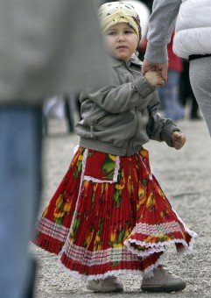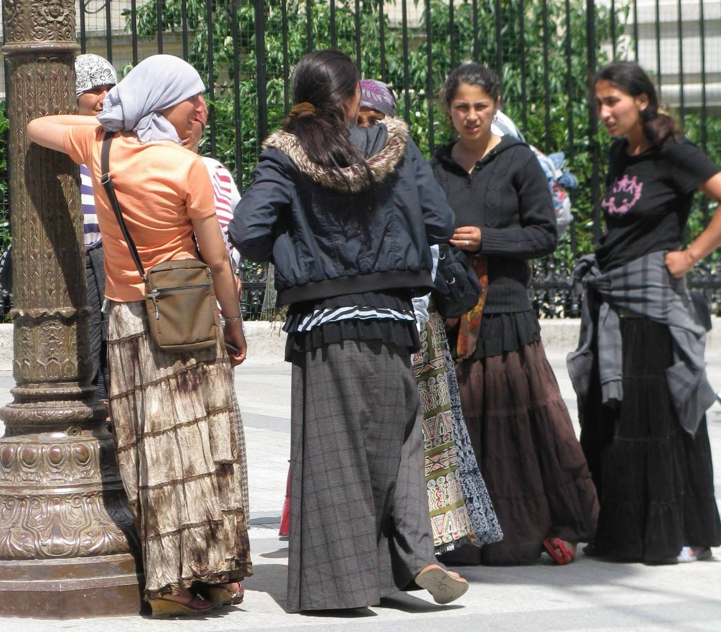
Source: România Liberă Source: Evenimentul zilei
Sometimes, it is not the image which adds meaning to the article, but its title. Two relevant examples are the photos from Adevărul in which a census taker appears speaking with several Roma women and in front of a block of flats, respectively. The snapshots are labeled: “The Roma are hard to census” (Ion October 29, 2011) and “They refuse to receive the census takers” (Petraru October 24, 2011).
Irrelevant mentions of the Roma ethnic origin continue to be a major issue. For instance, the title of an article reads “A family caught after not having paid heating and hot water for 20 years. See what bill awaits them” (Jurnalul Naţional November 17, 2011). The body of the article pinpoints that “…it is a Roma family, comprised of 6 persons”. Other examples are: “France sends other 150 Roma back to Romania” (Evenimentul zilei November 25, 2011) or “Heads of a prostitution network, arrested last night in Timişoara” accompanied by further explanations “Officers from the Organised Crime Squad arrested the heads of the network, all of them of Roma ethnic origin” (Petrovici November 25, 2011).
However, the most relevant article is the one in Adevărul (Bejenariu 25 October 2011), titled: “The massacre from the woods on the banks of Nera river reached the authorities. The first finding: the Roma cut the trees.” The news is about the illegal deforestation in Caraş Severin county and emphasizes that “according to the first statements of the locals, it seems that those who resorted to such method would have been the Roma ethnics living in Socol, Câmpia and not only“. The contrast between the certainty induced by the title and the hesitating tone of the explanations is striking.
Sometimes, the ethnic origin can be inferred on the basis of an intimate, almost exclusivist relationship that the author establishes with his or her readers: “The English were left without their railway too. For the same reason…Daily Mail sounds the alarm: Romanian gangs have ruined our railways. Englishmen write Romanians, but both they and we know who are the specialists in recaptures.” (Barbulescu November 15, 2011).
Other articles set a clear distinction between the majority population and the Roma. For example, an article speaks about Capital Top 300, a magazine which draws an annual hierarchy of the richest Romanians, and also mentions an alternative top of “the richest Gypsies”. The title reads: “Who the richest Gypsies in Romania are” (Evenimentul Zilei November 3, 2011).
It is also worth mentioning how different papers frame the same news especially with the help of the headlines.
For instance, if analyzing the articles about the statements made by the French Minister of the Interior, România Liberă reads: “The French Minister of the Interior criticizes «the delinquency committed by Romanians» in France as «extremely cruel»” (Petrovici October 3, 2011), Jurnalul Naţional highlights: “The French Minister of the Interior attacks Romanians: They use children to make money” (October 3, 2011), Evenimentul Zilei states: “The French Minister of the Interior: the crimes committed by the Roma, extremely cruel” (October 3, 2011).
All the articles mention that the Minister stated he didn’t wish to stigmatize the Roma. However, despite the explicit note made by the French official, the third headline above mentioned changes his statement and writes Roma instead of Romanians. The body of the article, though, provides accurate information about the Minister’s declarations.
Also illustrative of the juggling of headlines and the frames they set are the articles concerning the changes suggested for the word ţigan in the DEX. Even if the articles fall outside the monitoring period (20-21 September 2011), the many debates on and approaches of this topic make a case.
The analysis is based on the review of the first six daily newspapers which mentioned the issue in question (tabloids included).
Table 3. Headlines referring to the changes suggested for the word ţigan in the Explanatory Dictionary of the Romanian Language (DEX)
Newspaper | Headline
Click (20 September 2011) | The words “ţigan” and “jidan” (A/N pejorative of Jew) removed from the DEX. Do you agree?
Libertatea (20 September 2011) | The pejorative definitions of “ţigan” and “jidan”, removed from the new DEX
Adevărul (21 September 2011) | The little Roma crusade (Mica romaniadă)
Evenimentul zilei (21 September 2011) | The Romanian Academy, between ţigani, jidani and DEX
România Liberă (20 September 2011) | The Romanian Academy will modify the words “ţigan”and “jidan” in the DEX
Jurnalul Naţional (21 September 2011) | The words “ţigan” and “jidan” will be modified in the DEX. What about: balaoacheş, balabustă, cioară, cioropină, pharaon?
If taking a glance at each of these headlines, one can notice that: the first one asks for the feedback of its readers (who thus become a sort of jury whose rationale will influence the final sentence), the second strictly announces the removal of the pejorative definitions, the third refers to the claim made by several organizations as to a little rebellion of the Roma, the fourth frames the news as if the Romanian Academy had to choose between ţigan, jidan and the DEX, the fifth strictly informs about the modifications while the sixth announces the change and counterbalances it by invoking different slang words for Roma and Jew that can be found in the dictionary.
When taking a second glance, the reader notices a discrepancy between the titles mentioning the removal of the words from the dictionary and those referring solely to changing the definitions of the words. The contents of the articles shed light on the dilemma as they establish that several organizations suggested a series of modifications for the definitions of the two nouns (mainly consisting of making their pejorative meanings known) and that the Romanian Academy is willing to make all the necessary changes for avoiding any biased interpretations. However, there is no discussion about completely removing the words from the dictionary as two of the titles imply.
The picture is further completed by the online forums where readers agree with the modifications suggested or veto the decision either by arguing that regardless of the noun used, they judge the person by his / her behavior or by saying that Gypsies are just Gypsies and their felonies argue in favor of ţigan rather than Roma.

6. Conclusions
The present chapter gradually traverses literature and statistical evidence in order to draw an outline of the stereotypes, prejudices and discrimination against the Roma in Romania.
The introduction provides an insight into the lexicon associated with this ethnic group and is followed by European and national figures which shed light on the patterns applied to its members.
The EU-MIDIS survey builds a less worrying perspective (unlike in the other countries surveyed), as the Roma in Romania report lower discrimination rates. However, instead of jumping to positive conclusions, the research warns about the considerably higher spatial segregation which is likely to have impacted the results.
National figures (CNCD report) pinpoint that the Roma ethnic origin is the main issue most discrimination cases stem from. Concerns are also echoed by the Barometer of Interethnic Relations which shows that the cleavage between the self- and hetero-image of the Roma is higher than the one experienced by the non-Roma. The main reason for which the two do not overlap are the negative perceptions which others hold about the Roma.
The ‘drawers’ into which the Roma are fitted are also exemplified by a brief analysis of the stories mass media tell. In this regard, both the existing surveys and the review made within the frame of the REDUPRE project emphasize that media portrayals are rather negative and conflict-related. The inventory shows that crimes, illicit fortunes and begging are the tip of the iceberg and that many of the incidents occurred in foreign countries are turned into a stain on Romania’s image abroad.
Another constant finding refers to the ethnic origin mentioned in the articles and broadcasts which negatively portray the Roma. Even if this doesn’t bring additional information, it surely reinforces existent prejudices.
Pity or sympathetic journalism also has its share but it doesn’t overbalance the unfavorable picture. Considering the rather notable confidence in mass media and the greater likelihood to develop biased perceptions if being exposed to negative messages, the analyses sound an alarm.
Findings look even grimmer if taking into account that readers go through newspapers selectively, usually choosing those stories which confirm rather than challenge their beliefs (Morris 2000).
As Ungerleider argues in his 1991 study of Canadian media (Media Awareness Network), the news tell stories which cast people as “heroes, villains and victims”. Given that the Roma are most often chosen to play the villains, the collective imagery assigns a negative frame especially in the case of those to whom “alternative interpretations are not evident”.

Chapter IV: Analysis of the four target localities in Romania

The present chapter introduces the four localities chosen as focal points for the research conducted in Romania, within the REDUPRE project, and also delves into the main arguments which recommend these as edifying case studies in relation to the overall project goal.
For such purpose, the chapter begins by providing a statistical overview of the Roma population in the West and North-West regions of Romania and its distribution pattern across counties and continues by taking a closer look at the four localities proposed.
Further statistical information about the regions addressed is provided by Annex “Statistics concerning the Roma population in the West and North-West Regions of Romania (Timis, Arad, Bihor Counties)”.

According to the 2002 census, in the West region (comprising of four counties – Timiş, Arad, Caraş-Severin, Hunedoara), the two counties situated at the top of the hierarchy, judging by the amplitude of their Roma communities, are Timiş (16,084 Roma, i.e. 2.37% of the county’s population) and Arad (17,664 Roma people, i.e. 3.82% of the county’s population).

Fig. 10. Roma population by county (West region)

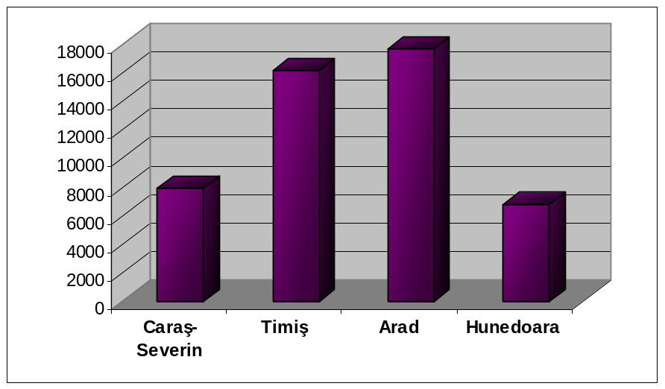

In the North-West region (comprising of six counties – Sălaj, Maramureş, Bihor, Bistriţa-Năsăud, Satu-Mare, Cluj), the county that displays the highest number of Roma is Bihor where these amount to 30,089, representing 5.01% of the county’s population.

Fig. 11. Roma population by county (North-West region)

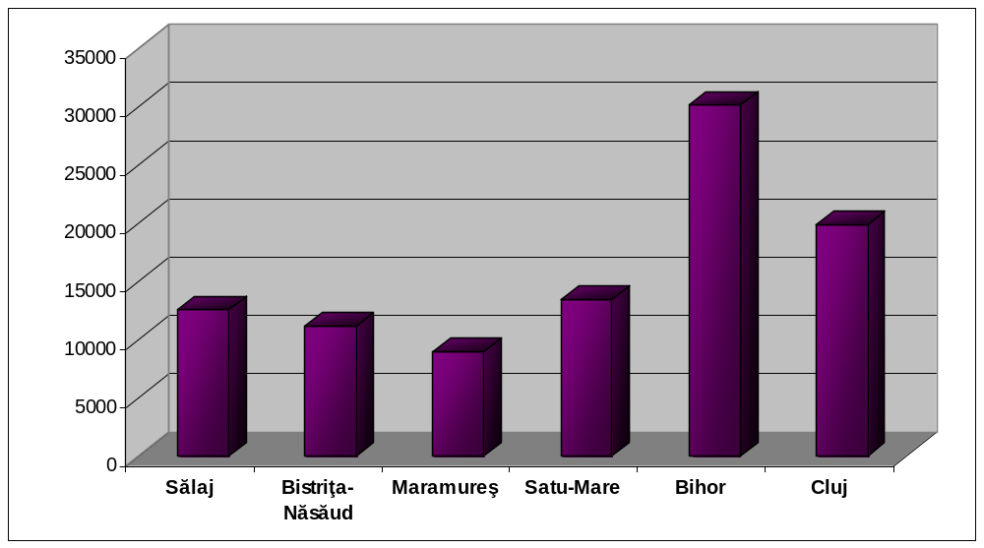

The four localities representing the core of the research to be conducted in Romania are Timişoara, Sânpetru Mare (Timiş County), Sântana (Arad County) and Aleşd (Bihor County). The main reasons for which these are believed to make strong cases in the context of the REDUPRE project are their large Roma communities and the fact they are located in the border region. The latter is a value-added feature which gives the opportunity to analyze the prejudices against the Roma in different ethnic backgrounds, due to the fact that borderlands have always been places of “exchange and enrichment”, where plural identities meet and mingle (Dolff-Bonekämper 2004).
In the case of the three counties chosen, the proximity to Serbia and Hungary is mainly responsible for the multiethnic profile displayed, even though other groups (Germans, Slovaks, Ukrainians etc.) also pay notable contribution to the great cultural diversity of the region. Therefore, in order to have a wider perspective on the perceptual categorization of the Roma, the research (as well as all project activities) addresses different ethnic backgrounds which reveal the relationships between the Roma and the Romanians, but also the relationships between the Roma and other ethnic groups which outnumber them or have similar dimension.
Moreover, communities of different sizes will be considered in order to determine how the quantitative aspect impacts the interactions among their members.
Consequently, the research sets the ball rolling for a comparative analysis of the prejudices and stereotypes which are prone to emerge in both small and large communities and aims to establish a correlation between the nature of the prejudices and the ethnic structure of the communities addressed.

1. Timişoara
Timişoara (Timiş County) is the largest city in the West region and also, according to 2009 statistics, the third largest city in Romania (Agerpres National News Agency 2 February 2010).
It is considered to be one of the country’s most prominent multicultural emblems given the 29 ethnic groups and 17 religions it hosts. The great cultural diversity is also the key lever used for proposing Timişoara as a potential European Capital of Culture in 2020 (The City Hall of Timişoara).
In 2000, after a 5-month monitoring by the United States Agency for International Development (USAID) and the Center for Institutional Reform and Informal Sector (IRIS), Timişoara was awarded the ‘5-star city’ distinction due to its openness to foreign investment. Thus, the city displays a promising economic climate given the impressive investments particularly made by German, Italian, Swiss and USA companies and its low unemployment rate (Magyary-Vincze 2007).
Besides the economic environment, one of the main aspects which appeals to the foreign investors in the region is the distance to border crossings. Timiş County has three border crossings: two with Serbia (Stamora Moraviţa and Jimbolia) and one with Hungary (Cenad). The distance from Timişoara to each of the crossings mentioned is 56, 45 and 75 km, respectively.

According to 2002 official census, the total population of Timiş County amounts to 677,926. The Roma population accounts for 2.37%, ranking third after Romanians and Hungarians.
Timişoara is the largest city in the county, with a total population of 317,660 inhabitants. The city also holds the highest percentage of Roma in the total Roma population of the county – 19%, given its 3050 Roma people recorded in the official census.
When compared to the other ethnic communities in the city, Roma rank fifth after Romanians (85.52%), Hungarians (7.64%), Germans (2.25%) and Serbs (1.98%). However, taking into account that many Roma do not admit to their ethnic origin for fear of discrimination, the real size of this ethnic group is thought to be much higher.

Fig. 12. Population by ethnic group in Timişoara

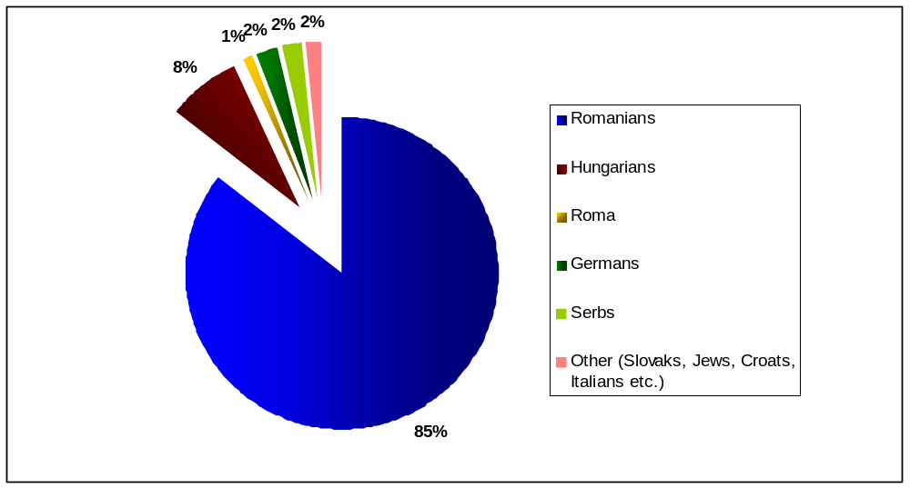

In regard to the population structure by mother tongue, the Romany language is spoken by 10,433 people (1.53% of the county’s population), being third to Romanian and Hungarian.
In Timişoara, the percentage of people having Romany as mother tongue is 0.6%, ranking fifth after Romanian, Hungarian, German and Serbian.

As stated by the research carried out within the frame of the PHARE 2004 programme – “Strengthening the institutional capacity and partnership building in order to improve the Roma living conditions and their image” (Magyari-Vincze 2007), in Timişoara, there are four main Roma categories – băieşi (Boyash - miners), geambaşi (horse dealers), căldărari (coppersmiths), gabori (Roma of Hungarian origin).
The main neighborhoods where these can be found are Colonia Ştrand (East), Fratelia and Ronaţ (North-West), Kuntz (North-East), Plopi (East) and Blascovics (West), all situated on the outskirts of the city.
From a socioeconomic perspective, the Roma in Timişoara fall into two main categories: those who are very rich and have built “their famous palaces” with the money earned abroad (as one representative of the Local Police stated in the research report above cited) and those who are poor and live on the outskirts, in ramshackle cabins. The discrepancy between the two extremes is striking given the low standard of living of the latter and the opulence displayed by the former through the heavily-ornamented architecture of their houses which is usually inconsistent with the architectural style of the areas where they are built (Magyari-Vincze 2007).
On the other hand, the so-called Roma palaces are a constant topic in local mass media. A brief review of the local print media brings into the limelight many disagreements (that have often turned into fights) which have arisen because of the houses bought or built in historical neighborhoods. According to the articles, the Roma use to display banners with messages like “This is a house owned by Roma” and to take various intimidating actions for hindering non-Roma people from buying apartments in the respective buildings. Such behavior is also one of the main issues feeding the stereotypes against the Roma community in the city (Lupulescu 2008).
As mentioned by the research earlier cited (Magyari-Vincze 2007), the problems faced by the Roma are related to four major fields: housing, employment, education and health.
The main issues corresponding to the first field refer to the lack of identity papers which hinders them from obtaining a dwelling, living in state-owned flats or houses and, thus, running the risk of being evacuated, living in ramshackle cabins built in the fields with no current water, electricity or toilet, the fact that public policies do not prioritize Roma along with other unprivileged categories for obtaining social housing.
When it comes to employment, the main problems faced by the Roma revolve around the difficulty to practice traditional crafts (e.g. tinsmithing), the lack of education which reduces the range of options down to black market or unskilled labor, the high percentage of Roma working abroad in the black market which also results in an increase in the number of children having no identity papers, the discrimination against the Roma in the labor market, the non-feasibility of the expert training programmes which haven’t created the necessary opportunities for the employment of those trained.
The main barriers impeding proper access to education are: the lack of identity papers which is a major obstacle to the timely enrollment of children in schools and kindergartens; the low level of income determining a significant dropout rate; the seasonal labor migration of parents who take their children abroad; the discrimination against the Roma children in schools; segregation; the fact that educational facilitators are not well-enough prepared for properly handling such problems.
Healthcare represents another problematic chapter because of the low income, improper nutrition, lack of medical insurance, the discriminatory treatment applied by the medical staff.

2. Sânpetru Mare
Sânpetru Mare is one of the largest communes in Timiş County, comprised of two villages: Sânpetru Mare and Igriş.
The former is located 15 km from Sânnicolau Mare (the closest city), 55.5 km from Timişoara and 50 km from Arad.
The latter is very close to the border with Arad County and also to the town of Sânnicolau Mare.
As far as the distance to the Hungarian border is concerned, the locality is 35 km away from the Cenad border crossing. Given its proximity to Arad County, Igriş village is particularly close to Nădlac crossing (7 km).
The locality dates back to 1333 and is very often mentioned for being home to the first library in Romania.
From an economic point of view, Sânpetru Mare displays a mainly agricultural profile.
Given its geographical position and ethnic structure, the locality is a member of the Limited Liability European Grouping of Territorial Cooperation Banat – Triplex Confinium (The City Hall of Sânpetru Mare).
According to the 2002 census, the population of Sânpetru Mare amounts to 5844, out of which 72.51% are Romanians, 13.15% - Serbs and 12.13% - Roma. Consequently, in 2002, the Serbian and Roma ethnic groups had similar size, being second only to Romanians.
The percentage is said to be higher in Igriş village where Roma accounted for 10% of the population during the same year. However, since 2002, this ethnic group has had a staggering upward trend. According to the monograph written by Florea Jebelean (2009), the Roma people represented 44.4% of the population in 2006, while according to the figures provided by the Timis County Council, the Roma held a share of more than 30% in 2009.

Fig. 13. Population by ethnic group in Sânpetru Mare
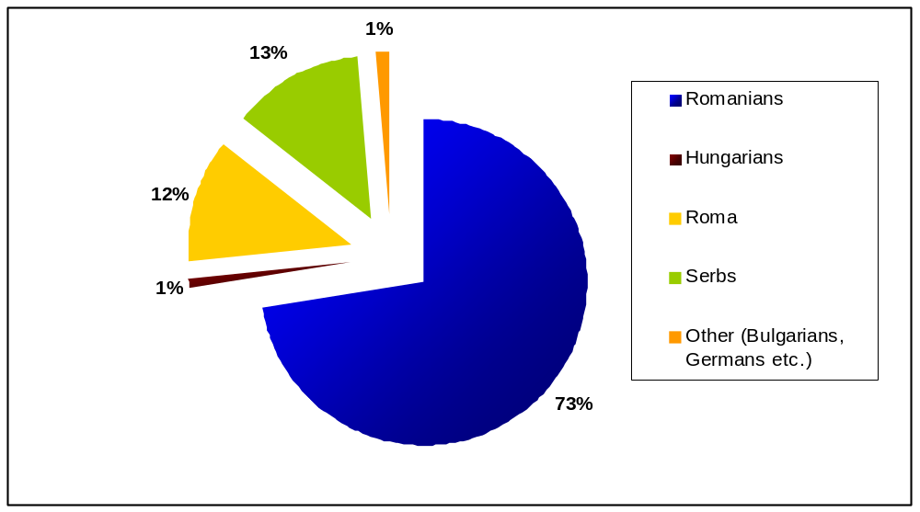
When shifting to the percentage of people having Romany as a mother tongue, the 2002 census reveals that only 0.92% speak this language. Such data places Romany on the third position of the hierarchy, the first two places being held by Romanian (82.98%) and Serbian (13.02%).
On a county level, the Roma population in Sânpetru Mare accounts for nearly 4.5% of the total Roma population in Timiş County, a ratio which places the locality close to the top of the hierarchy.

The main weak points of the Roma community in Sânpetru Mare are education, healthcare and employment.
According to the information provided by the City Hall, the locality has two schools: one in Igriş village and one in Sânpetru Mare village.
In Sânpetru Mare, there are 246 students out of which 179 Romanians, 25 Serbs and 42 Roma.
In Igriş, the number of students amounts to 126, but their ethnic structure is not mentioned. However, considering that Roma hold a significant share in the local population, a significant share is to be found in the educational process also.
The main education-related issues consist of a high dropout rate (having as main reasons the low level of income and the need to work from an early age for ensuring subsistence), the lack of information concerning the importance of education and the facilities Roma children could benefit from in order to complete the educational process, and, last but not least, the uneven treatment which is sometimes applied to Roma children by colleagues or teachers given the negative perception they hold against this ethnic group.
Another field considered to be a major weakness is the local labor market.
On the one hand, Sânpetru Mare is a mainly agricultural area. Therefore, inhabitants look for jobs in nearby localities – Sânnicolau Mare, Periam and even Timişoara – where there is a higher number of entrepreneurs and, consequently, a higher likelihood of job opportunities. However, the lack of education and identity papers doesn’t recommend the Roma as eligible candidates, a thing which results in an increasing tendency to work in the black market.
Moreover, the traditional crafts of the Roma (e.g. blacksmithing, tinsmithing) are no longer in compliance with the nowadays requirements of the labor market. Hence, there is a major cleavage between the labor supply and demand that can’t be bridged given the lack of financial and information resources necessary for retraining.
It is the very same lack of financial and information resources that also triggers the healthcare issues with which Roma are confronted. Mainly, the disease rate is very high because of not complying with basic hygiene and healthy nutrition rules or not going to regular medical check-ups. Moreover, the medical staff operating on the local level is not always prepared to deal with Roma patients. Hence, they sometimes disregard them or do not explain clearly enough the medication prescribed, thus increasing even more the gap between the Roma community and the healthcare institutions.
The problems above emphasized become all the more prominent when analyzing the demographic trend. More precisely, while the overall population of the locality undergoes a downward tendency, the Roma ethnic group has a staggering growth. This implies that the amplitude of the already-existing problems will increase taking into account the boost in the number of Roma people under the circumstances of an equally precarious socioeconomic background (The City Hall of Sânpetru Mare).

3. Sântana
Sântana is a town located in the north-western part of Arad County. The closest cities are Arad (28 km) and Chişineu Criş (22 km), while the closest border crossings with Hungary are Curtici (15 km), Vladimirescu (31 km) and Turnu (45 km). The town originates in an older settlement – Comlăuş (dating back to 1334) which has nowadays become one of its major neighborhoods, and also includes the Caporal Alexa village (The City Hall of Sântana).
Sântana displays a promising economic profile given the means of transport ensuring its interconnection with nearby localities and regions as well as due to the investments that foreign companies (from Austria, Germany, Italy and Hungary) have made in the region since 2008. The investments mainly address the industrial field and are likely to result in higher job opportunities.
This is also one of the reasons for which the local development strategy lays a great emphasis on the estimated growth of the secondary and tertiary sectors despite the town’s current economy which is mainly agricultural. Moreover, specific architecture and historic monuments are considered focal points towards which local tourism development could gravitate provided that these are properly tapped into.
On a larger scale, Sântana is the biggest town of the microregion located in the north-west of Arad County which includes two other cities – Curtici and Pâncota - and 4 villages – Olari, Simand, Zarand, Zimandu Nou.
The entire microregion is part of the Danube-Kris-Mureş-Tisa Euroregion (The City Hall of Sântana).

The population of Arad County amounts to 461,791 inhabitants and has the following ethnic structure: 82.16% - Romanians, 10.67% - Hungarians, 3.82% - Roma, 1.23% - Slovaks, 1.05% - Germans. Consequently, according to the 2002 census, Roma are the third largest ethnic group in the county. However, considering the statement made by Gheorghe Răducanu (Advisor to the Prefect of Arad County on Roma issues in 2005), the number of Roma is estimated to be almost double given that most of them refuse to state their genuine ethnic origin (Buga 2005).
Sântana has nearly 13,000 inhabitants out of which 14.91% are Roma. These figures place the Roma ethnic group on the second position after Romanians who account for 79.08%. Even though the share they hold in the total population is much lower, the Germans (3.49%) and Hungarians (2.19%) are the two other communities which bring their contribution to the town’s multiethnic profile.

Fig. 14. Population by ethnic group in Sântana

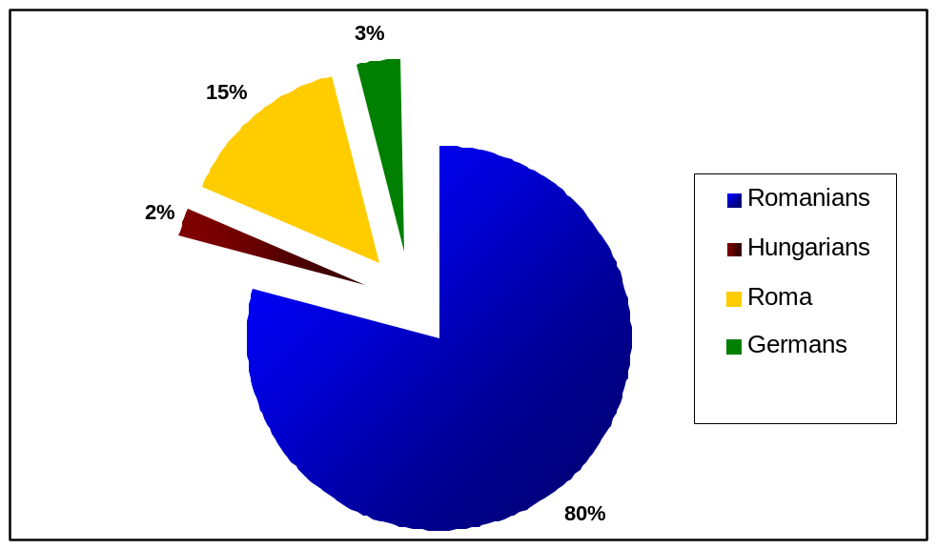

From a town-county ratio perspective, the Roma people in Sântana represent 11% of the Roma population in Arad County (being the second largest Roma community in the county), while from a microregional perspective, Sântana ranks first.
The population structure by mother tongue reveals that Romany language is spoken by 1.94% of the county’s population, ranking third after Romanian (spoken by 84.72%) and Hungarian (10.45%).
In Sântana, the percentage of people having Romany as mother tongue is much higher (10.09%), almost squaring with the number of Roma people mentioned by the official census.

According to local statistics, the main areas inhabited by Roma people are Comlăuş neighborhood (with over 3000 inhabitants) and Caporal Alexa village (Creţu 2008).
The most prominent issues these communities face are related to the inappropriate infrastructure and mainly consist of unpaved roads and poor water supplies. More precisely, the Roma in Comlăuş neighborhood have to walk long distances for ensuring the water they need in their households for drinking, cooking or breeding animals (Creţu 2008).
As mentioned by the local development strategy, in 2005 the City Hall of Sântana submitted the project “Rehabilitating the road infrastructure in the Roma neighborhood” within the frame of the governmental programme “Partnership for Roma support”. Even though the project was approved, the scarce financial resources of the City Hall rendered its implementation impossible.
Aside from the poor road infrastructure, a few hundreds of dwellings inhabited by Roma people in Comlăuş and Caporal Alexa are in an advanced state of decay, undergoing a severe danger of collapse or structural failure. Authorities state that besides not being able to provide adequate shelter, such dwellings are likely to crash in case of prolonged bad weather conditions (Creţu 2008).
The antipode of the shabby houses above described is represented by the so-called palaces that rich Roma afford to build. As stated by the Advisor to the Prefect of Arad County on Roma issues, the impressive size of such buildings is directly linked to the importance that Roma families wish to have in the community. In other words, they are prone to build houses which stand out in order to both flag their social status and make sure there is enough room for all their relatives. Yet, despite the extravagance displayed, most houses are non-functional or only partially used (Buga 2005).
When alternating their significance with the opinions expressed by the architects in Arad, one discovers that most specialists lay emphasis on the contradiction existing between the heavily-ornamented houses and the architectural style in the region. In their opinion, such buildings shouldn’t even be granted a construction permit given the failure to comply with regional and local building codes (Buga 2005).
Another facet of the housing issue is the lack of property deeds. Many Roma people have transferred ownership by signing informal agreements in the presence of witnesses, thus avoiding the authentication procedure executed before a notary public. Consequently, ownership transfer can’t be neither tracked nor proved.
On the other hand, the lack of property deeds is just one aspect of a wider range of legal paper issues also including the lack of identity cards and birth certificates which apply to a considerable number of Roma people (Creţu 2008).
When it comes to employment, the local print media as well as the County Advisor on Roma issues reveal that many Roma families have built their welfare by buying antiques (especially furniture) from the elders in the region and selling them abroad. Also, according to the same sources, there is a significant share of Roma people who earn their living by practicing traditional crafts – i.e. manufacturing brandy boilers and rainwater pipes (Buga 2008). However, the unemployment rate among the Roma people is high given the lack of education and the increasing gap between the existing traditional craft supply and the labor market demand. Such gap is prone to become even wider considering the recent investments which mainly address the industrial field in the region.

4. Aleşd
Aleşd is a city located in Bihor County (North-Western Romania) which comprises of four localities: Aleşd, Pestiş, Tinaud and Pădurea Neagră.
The proximity to Hungary is marked by the relatively short distances to three border crossings in Bihor County: Aleşd Oradea (40 km), Borş (57 km) and Salonta (76 km).
Among the main strengths that the city displays, a great emphasis is put on the natural resources (mineral springs, thermal water), tourist objectives, cultural events representative for the region as well as on hunting and fishing opportunities. The tourism infrastructure is also positively assessed due to the accommodation establishments, restaurants and thermal water pools which tap into the resources of the region (The City Hall of Aleşd).
Despite the impressive tourism potential, the city’s economy has been mainly based on the building materials industry (especially cement, lime and refractory materials) which has undergone a steep decline after 1989. In 1998, Aleşd was declared underprivileged area and a major shift occurred to the light industry where new jobs were created given the foreign investments attracted to the region.
Local statistics pinpoint that the workforce is mainly skilled for the light and building materials industries, but it is not qualified for the tourism sector which is inappropriately harnessed (The City Hall of Aleşd).

Bihor is among the Romanian counties with the largest Roma population. Of the total number of inhabitants which amounts to 600,246, the Roma account for 5.01% (30,089), as stated by the 2002 census. These figures place the Roma ethnic group on the third position after Romanians (67.38%) and Hungarians (25.96%).
In line with county statistics, the Roma in Aleşd amount to 953, representing 9.15% of the city population (10,415 inhabitants). Therefore, the Roma rank third after the Romanians (65.17%) and Hungarians (19.07%) and are followed by the Slovak ethnic group (6.19%).

Fig.15. Population by ethnic group in Aleşd

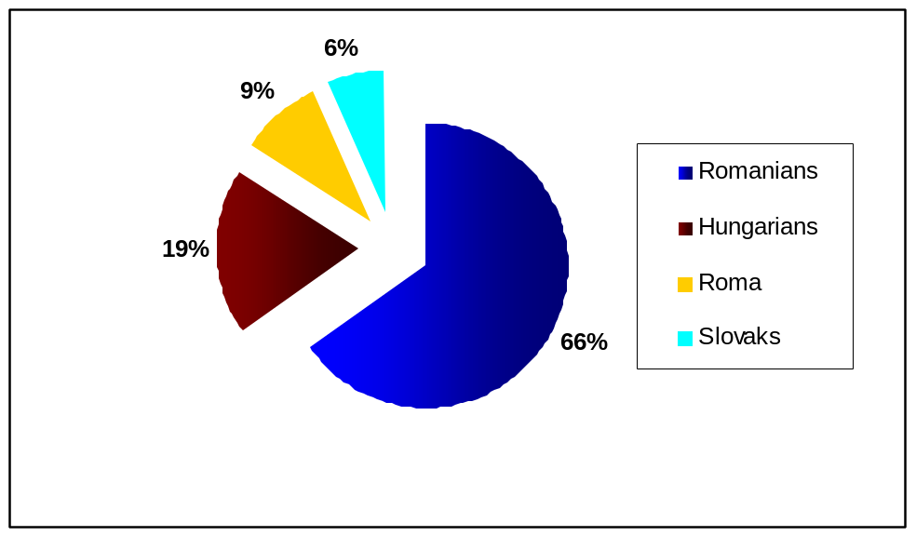

Shifting from ethnic to mother tongue structure, the 2002 census reveals that 3.02% people in Bihor County speak Romany, while in Aleşd the percentage increases to 9.11%, closely following the share held by the Roma community in the city population.
When analyzed through the lens of city-county ratio, the statistics above emphasize that the share held by the Roma from Aleşd in the total Roma population of Bihor county amounts to nearly 3.5%.

Local statistics highlight that the distribution of Roma among the four localities the city comprises favors Aleşd (945 Roma) over Tinaud, Pestiş and Pădurea Neagră. The highest number of Roma can be found in the Obor neighborhood where several projects have been implemented in order to tackle and touch upon the issues this ethnic group is confronted with. However, such projects induced only a slight change and the respective issues continue to be as prominent as they were in the past (The City Hall of Aleşd).
First of all, the poor infrastructure significantly lowers the standard of living. One of the major flaws is the lack of electric power which has been addressed in 2007 within the frame of the project “Strengthening the voice of the Roma”, carried out by Ruhama Foundation (Oradea). The project managed to bring electric power to 10 Roma households, but the rest continue to cope with this major lack (Ruhama Foundation).
Also, given the scarce financial resources of the Roma families, their dwellings can not provide proper shelter given the advanced state of deterioration.
The flaws of the housing sector also refer to the precarious hygiene which proves to be a major obstacle to obtaining a job or going to school. In this regard, the Aleşd Town Hall and Ruhama Foundation have implemented a project whose main result was the Aleşd Multifunctional Center, a social service addressing the Roma, which encompasses a children day care and a public bath (Bursaşiu 2009).
The former targets students aged between 6 and 12 who have low school performances, high dropout rates or major social problems like single-parent families, tense relationships with their parents, parents with disabilities or alcohol problems.
The latter targets both children and adults and aims to ensure a better personal hygiene as a first step to better health, higher school attendance and eligibility to work.
The Center opened in 2010 and is said to be correlated with the health education provided by the facilitators from the County Hospital in Oradea.
Other issues related to the Roma group in Aleşd are similar to those mentioned for the previous three locations that the project targets - namely, the lack of education, the lack of identity papers, the gap between the labor supply and demand.
Additionally, the conflicts between the Roma clans which are a constant subject to mass media and the low to almost non-existent participation in the local decision-making processes are also feeding the prejudices against the Roma community whose vulnerability is listed as a weak point by the SWOT analysis in the local development strategy (The City Hall of Aleşd).

5. Conclusions
Timişoara proves to be a relevant case study from both the size and the multicultural perspective.
On the one hand, it is the largest city in the West region (and one of the largest in the country) which has a considerable Roma ethnic group that can serve as a solid foundation for a thorough and ample research.
On the other hand, the 29 ethnic groups in the city and the successfully maintained ethnic peace which has become a distinctive local emblem broaden the range of study in the context of an increasing Roma community.
Furthermore, the gap between the rich and the poor Roma in the city adds new facets to the research aimed at getting an insight into the perceptual frames applied to the ethnic group in question.
Sânpetru Mare represents a distinct case because of its lower number of inhabitants (5900) and its ethnic structure which places both the Roma and the Serbs second to Romanians.
Thus, unlike the other three localities addressed by the research, Sânpetru Mare allows for a stereotype analysis on a smaller scale, in a cultural background which equally owes its diversity to two ethnic groups – Roma and Serbian.
Sântana has been chosen as a target location of the REDUPRE project given its notable Roma community (representing 15% of the local population) which is second only to the Romanian one.
The German and Hungarian groups hold lower shares (3.5%, 2%, respectively) and, therefore, the town can be considered an illustrative case of the prejudices that arise in the communities where the Roma and the Romanians are the two protagonists of the ethnic background.
The discrepancy between the rich and the poor Roma as well as the economic upward trend and its subsequent impact on the local labor market are two additional aspects which provide the opportunity for a thorough research of the Roma issues in the area.
Aleşd makes a different case because of its Roma community which despite being numerous (9% of the local population) is second to Hungarian (19%) and is closely followed by the Slovak group (6%). Therefore, the town provides the opportunity for analyzing the relationships between the Roma and one other ethnic group which outnumbers them as well as the relationships between the Roma and a smaller ethnic group.
Consequently, the culturally diverse background in Aleşd fosters a broad comparative analysis of the perceptual frames held by several ethnic groups in relation to the same Roma community and brings into the limelight two new entries – the Hungarian and the Slovak communities – which haven’t been protagonists in any of the three other localities addressed by the research.
Bibliography

- Achim, Viorel. 1998. Gypsies in Romanian history. Bucharest: Editura Enciclopedică.
- ActiveWatch - Press Monitoring Agency. 2003. The television and the Gypsies. Press analysis. http://www.activewatch.ro/stiri/Antidiscriminare/Televiziunea-si-tiganii-2003-177.html
- ActiveWatch - Press Monitoring Agency. 2006. The image of minorities in national and local print media. http://www.activewatch.ro/stiri/Antidiscriminare/Imaginea-minoritatilor-in-presa-scrisa-nationala-si-locala-171.html
- Asociaţia Pro Democraţia. 2011. Stereotypes about the Roma. The perception of the Roma ethnicity. The role of the media. Identifying alternatives for improvement. http://www.apd.ro/files/comunicate/Sondaj_APD_romi.pdf
- The Audit Bureau of Circulations in Romania. www.brat.ro
- Avram, Eliza. September 20, 2011. The Romanian Academy will modify the words “ţigan” and “jidan” in the DEX. România Liberă.
http://www.romanialibera.ro/actualitate/eveniment/academia-romana-va-modifica-cuvintele-tigan-si-jidan-in-dex-cuvintele-jignitoare-si-discriminatorii-238249.html
- Bădescu, Gabriel et al. 2007. Roma Inclusion Barometer. Bucharest: Open Society Foundation.
- Bădescu, Gabriel, Kivu, Mircea and Monica Robotin. Eds. 2005. The Barometer of Ethnic Relations 1994-2002. A Perspective on the Interethnic Climate in Romania. Cluj-Napoca: CRDE.
- Bărbulescu, Răzvan. November 15, 2011. The English were left without their railway too. For the same reason. Jurnalul Naţional. http://www.jurnalul.ro/editorial/si-englezii-au-ramas-fara-cale-ferata-din-acelasi-motiv-596573.htm
- BBC News. July 8, 2009. On the road: Centuries of Roma history. http://news.bbc.co.uk/2/hi/europe/8136812.stm
- Bejenariu, Oana. October 25, 2011. The massacre from the woods on the banks of Nera river reached the authorities. The first finding: the Roma cut the trees. Adevărul. http://www.Adevărul.ro/locale/resita/resita-caras_severin-Adevărul-nera-granita-romania-serbia-defrisari-ilegal-ilegale_0_578342735.html
- Bennett, John. 2010. Summary of the IRSDTC National Report for Romania, 2010. http://medlive.hotnews.ro/wp-content/uploads/2010/12/Raportul-Na%C5%A3ional-IRSDTC-pentru-Rom%C3%A2nia_rezumat.pdf
- Boţa, Dragoş. August 20, 2008. How the gypsies get hold of the center of Timişoara. Gândul. http://www.gandul.info/reportaj/cum-pun-mana-tiganii-pe-centrul-timisoarei-2943009
- Buga, Marian. February 22, 2005. The palaces of cold. Bănăţeanul.
http://old.banateanul.ro/articol/ziar/Timişoara/palatele-frigului/4861/0/print/
- Bursaşiu, Veronica. November 3, 2009. Public bath for the Roma. Bihor Online. http://www.bihon.ro/stiri/oradea-bihor/articol/baie-comunala-pentru-romi/cn/news-20091103-02401121
- Cambridge Dictionaries Online. Cambridge Advanced Learner's Dictionary & Thesaurus. http://dictionary.cambridge.org/
- Center for Documentation and Information on the Minorities in Europe – Southeast Europe [CEDIME-SE]. 2001. The minorities in South-East Europe. The Roma in Romania. Cluj-Napoca. Ethnocultural Diversity Resource Center.
http://www.edrc.ro/docs/docs/Romii_din_Romania.pdf
- Chamber of Deputies. The Constitution of Romania.
http://www.cdep.ro/pls/dic/site.page?id=371
- Chamber of Deputies. Law no. 215/2001 – Local Public Administration Law. http://www.cdep.ro/pls/legis/legis_pck.htp_act_text?idt=27123
- Chamber of Deputies. Law no. 324/2006 on amending and supplementing Government Ordinance no. 137/2000 on preventing and punishing all forms of discrimination. http://www.cdep.ro/proiecte/2006/300/00/2/leg_pl302_06.pdf
- Chiriac, Marian et al. 2007. Introduction to Roma culture. Exploring cultural diversity for family doctors. Bucharest: JSI Research and Training Institute, Inc.
- Chiriac, Marian, and Alina Constantinescu. 2007. Is it possible to break the deadlock? Inventory of problems and solutions concerning the situation of the Roma in Romania. Cluj-Napoca: Ethnocultural Diveristy Resource Center.
http://www.edrc.ro/docs/docs/Raport%20Roma%202007.pdf
- The City Hall of Aleşd. www.Aleşd-bihor.ro
- The City Hall of Timişoara. www.primariatm.ro
- The City Hall of Sânpetru Mare. www.primaria-sanpetrumare.ro
- The City Hall of Sântana. http://www.primariaSântana.ro/
- Council of Europe. N.d. Is this a stereotype? A tool for fighting stereotypes towards the Roma. http://www.coe.int/T/DG3/Romatravellers/source/documents/toolstereotypesEN.pdf
- Council of Europe. National Council for Combating Discrimination Romania. http://www.coe.int/t/dghl/monitoring/ecri/good_practices/1-specialised%20bodies/sb_romania_EN.asp
- Creţu, Răzvan. January 4, 2008. The situation of the Roma in Comlăuş, an uncertainty. Arad City. http://www.aradcity.ro/index.php?x=stiri&id_tip=10&id_stire=2020
- Crowe, David. 1996. A History of the Gypsies of Eastern Europe and Russia. New York: St. Martin's Griffin.
- De Laat, Joost, and Christian Bodewig. April 2011. Roma inclusion is smart economics – Illustrations from Bulgaria, Czech Republic, Romania and Serbia. World Bank’s Europe & Central Asia Knowledge Brief 39.
http://siteresources.worldbank.org/INTECALEA/Resources/KB_V39_ROMA_Inclusion.pdf
- Decade of Roma Inclusion 2005-2015. http://www.romadecade.org/about
- Djuvara, Neagu. 2006. Between East and West (4th edition). Bucharest: Humanitas.
- Dolff-Bonekämper, Gabi (Coordinator). 2004. Dividing lines, connecting lines – Europe’s cross-border heritage. Council of Europe.
http://www.coe.int/t/dg4/cultureheritage/heritage/Resources/Publications/ID565Patrimoine_en.pdf
- Dumitrescu, Doru, Căpiţă, Carol, and Mihai Manea. Coords. 2008. The history of the national minorities in Romania. Bucharest: Editura Didactică şi Pedagogică.
- Equinet – European network of equality bodies. http://www.equineteurope.org/315.html
- Ethnocultural Diversity Resource Center. 2002. The ethnic and demographic structure of the population in Romania. http://www.edrc.ro/recensamant.jsp?language=0
- European Commission. Europe 2020. National Reform Programme 2011-2013. http://ec.europa.eu/europe2020/index_en.htm
- European Commision. Romania – Joint report on social protection and inclusion - 2009. http://ec.europa.eu/social/main.jsp?catId=757&langId=en
- European Structural Funds. Sectoral Operational Programme Human Resources Development – POS DRU. http://www.fonduri-structurale-europene.ro/posdru/grupuri-vulnerabile-piata-muncii.html
- European Union. The Charter of Fundamental Rights of the European Union. European Parliament. http://www.europarl.europa.eu/charter/default_en.htm
- European Union. Integrated European Platform for Roma Inclusion Road Map (2010). European Commission. http://ec.europa.eu/social/BlobServlet?docId=5583&langId=en
- European Union Agency for Fundamental Rights. 2009. EU-MIDIS -European Union Minorities and Discrimination Survey. Main results report. http://fra.europa.eu/fraWebsite/attachments/FRA-2011_EU_MIDIS_EN.pdf
- Fleck, Gábor, and Cosima Rughiniş, eds. 2008. Come closer. Inclusion and exclusion of Roma in today’s Romanian society. Bucharest: Human Dynamics.
- Focus Consultancy Ltd. 2005. Assessment of the Roma strategy implementation mechanism. Evaluation Report. The National Agency for Roma.
http://www.anr.gov.ro/docs/rapoarte/Focus_Final_Evaluation_Report_181.pdf
- Fraser, Angus. 1992. The Gypsies (The Peoples of Europe). Oxford: Blackwell Publishing.
- General Secretariat of the Government. Government Decision no. 834/2003 on the establishment of the National Centre for Roma Culture. http://www.sgg.ro/docs/File/UIP/legislatie/hg-834-2003.pdf
- General Secretariat of the Government. Government Decision no. 881/1998 for the proclamation of December 18 National Minorities Day in Romania. www.sgg.ro/docs/File/UIP/legislatie/hg-881-1998.pdf
- General Secretariat of the Government. Law no.612/2002 for formulating a statement on Romania’s recognition of the competence of the Committee on the Elimination of Racial Discrimination, in accordance with Art. 14 of the Convention on the Elimination of All Forms of Racial Discrimination, adopted by the United Nations General Assembly in New York on December 21, 1965. www.sgg.ro/docs/File/UIP/legislatie/lege-612-2002.pdf
- Gilbea Vasile et al. 2008. Human rights observance in Romania: The Roma – citizens of a state governed by the rule of law. Romani CRISS - Roma Center for Social Intervention and Studies. http://www.romanicriss.org/Raport%20DDO_2006-2007.pdf
- Government of Romania. Government Program 2009-2012. Chamber of Deputies. http://www.cdep.ro/pdfs/guv200912/ProgramGuvernare.pdf
- Government of Romania. 2005. National Development Plan 2007-2013. European Social Fund Romania. http://www.fsenordest.ro/BIBLIOTECA/ndp0713_en.pdf
- Government of Romania. 2007. National Strategic Reference Framework 2007-2013. Managing Authority for Sectoral Operational Programme “Increase of Economic Competitiveness “. http://amposcce.minind.ro/fonduri_structurale/CSNR_engleza_261109.pdf
- Government of Romania. The 2001 Regular Report on Romania’s Progress Towards Accession.
http://www.gov.ro/2001-regular-report-on-romania-s-progress-towards-accession__l2a100046.html
- Graham, Efrem. October 29, 2010. Romanian Gypsies' Revival Stirs Hope for Change. CBN News. http://www.youtube.com/watch?v=kDqVvOMk1FA
- Grigore, Delia. 2008. Mutual perceptions in the collective imagery. The Roma. In Dumitrescu, Doru, Căpiţă, Carol, and Mihai Manea, Coords. The history of the national minorities in Romania. Bucharest: Editura Didactică şi Pedagogică.
- Horvath, István, Raţ, Ramona, and Katalin Vitos. 2006. Application of the Romanian law on national minority rights. Language rights in the local public administration. Department for Interethnic Relations of the Romanian Government. http://www.dri.gov.ro/cd-2006/index.htm
- The Human Rights Project. 2007. Summary of the International Convention on the Elimination of All Forms of Racial Discrimination (CERD). www.hrpujc.org/documents/CERD_000.pdf
- Ion, Alin. October 29, 2011. Census problems in Roma communities. Adevărul. http://www.Adevărul.ro/locale/targu-jiu/Targu-Jiu_0_581342038.html
- Ionescu, Livius. September 20, 2011. The words “ţigan” and “jidan” (A/N pejorative of Jew) removed from the DEX. Do you agree? Click. http://www.click.ro/news/national/Cuvintele-Jidan-scoase-DEX-Esti_0_1252674784.html#
- Jebelean, Florea. 2009. Igriş - Monograph. Timişoara: Mirton.
- Liégeois, Jean-Pierre. 1994. Roma, Gypsies, Travellers. Strasbourg: Council of Europe
- Lippmann, Walter. 1997. Public opinion. New York: Free Press Paperbacks. (Original work published 1922).
- Lupulescu, Diana. August 19, 2008. The Prefect threatened by the gypsy mafia in Timişoara! Agenda. http://www.agenda.ro/news/news/10505/prefectul-amenintat-de-mafia-tiganeasca-din-Timişoara.html
- Magyari-Vincze, Enikö. 2007. Research report – The social exclusion of the Roma. Case study – Timişoara. Cluj-Napoca: Babeş-Bolyai University.
http://www.euro.ubbcluj.ro/structura/pers/excl_romi.pdf
- Marascu, Sorin. Aprill 26, 2010. Gypsies (still) make the law in the center of Timişoara. Ziua de Vest.
http://www.ziuadevest.ro/actualitate/9076-iganii-inc-fac-legea-in-centrul-timioarei.html
- Mincan, Mihai. September 21, 2011. The little Roma crusade. Adevărul. http://www.Adevărul.ro/actualitate/social/Mica_romaniada_0_558544690.html
- The Ministry of Education, Research, Youth and Sport (MECTS). Strategic Plan 2007-2009. http://www.edu.ro/index.php/articles/8276
- Morris, Rachel. 2000. Gypsies, travelers and the media: Press regulation and racism in the UK. Media Diversity Institute.
http://www.media-diversity.org/en/additional-files/documents/Z%20Current%20MDI%20Resources/Gypsies,%20Travellers%20and%20the%20media%20-%20press%20regulation%20and%20racism%20in%20the%20UK.pdf
- N.a. November 25, 2011. France sends other 150 Roma back to Romania. Evenimentul zilei. http://www.evz.ro/detalii/stiri/franta-trimite-in-romania-alti-150-de-romi-vezi-cati-bani-primesc-la-intoarcerea-in-tara.html
- N.a. October 3, 2011. The French Minister of the Interior attacks Romanians: They use children to make money. Jurnalul Naţional. http://www.jurnalul.ro/externe/ministrul-francez-de-interne-ii-ataca-pe-romani-se-folosesc-de-copii-ca-sa-faca-bani-592328.htm
- N.a. October 3, 2011. The French Minister of the Interior: the crimes committed by the Roma, extremely cruel. Evenimentul zilei. http://www.evz.ro/detalii/stiri/ministrul-francez-de-interne-delincventa-romaneasca-este-foarte-cruda-948087.html
- N.a. September 20, 2011. The pejorative definitions of “ţigan” and “jidan”, removed from the new DEX. Libertatea. http://www.libertatea.ro/detalii/articol/dex-jidan-tigan-355526.html
- N.a. November 3, 2011. Who the richest Gypsies in Romania are. Evenimentul zilei. http://www.evz.ro/detalii/stiri/cine-sunt-cei-mai-bogati-tigani-din-romania-952484.html
- N.a. September 21, 2011. The words “ţigan” and “jidan” will be modified in the DEX. What about: balaoacheş, balabustă, cioară, cioropină, pharaon?. Jurnalul Naţional. http://www.jurnalul.ro/observator/cuvintele-tigan-si-jidan-vor-fi-modificate-in-noul-dex-ce-facem-cu-balaoaches-balabusta-cioara-cioropina-faraon-591001.htm
- The National Agency for Employment. The 2011 Employment Program for the Socially Marginalized Persons. http://www.anofm.ro/program-ocupare-persoane-marginalizate-social-pentru-anul-2011
- The National Agency for Employment. Employment Programme 2011. http://www.anofm.ro/programul-de-ocupare-al-anofm-pentru-anul-2011
- The National Agency for Employment. Progress in implementing the Employment Programme of the National Agency for Employment, in the first half of 2011. http://www.anofm.ro/stadiul-realiz%C4%83rii-programului-de-ocupare-a-for%C5%A3ei-de-munc%C4%83-a-anofm-pe-primul-semestru-al-anului-201
- The National Agency for Roma. Public policies for Roma in Romania, 2000-2005: legislative framework, institutions, programmes, achievements and expectations.
http://www.anr.gov.ro/docs/statistici/Public_policies_for_Roma_in_Romania_2000_2005_190.pdf
- The National Agency for Roma. Project of the Government Strategy for the Inclusion of the Romanian Citizens belonging to the Roma Minority 2011-2020. http://www.anr.gov.ro/docs/Politici/proiect_strategie.pdf
- The National Center for Roma Culture - Romano Kher. http://www.romanikultura.ro/
- The National Council for Combating Discrimination. Government Ordinance no. 137/2000 on preventing and punishing all forms of discrimination. www.cncd.org.ro/Files/?FileID=83
- National Council for Combating Discrimination. Report on the Implementation of the Race Directive 2003-2010. www.cncd.org.ro/Files/?FileID=370
- National Democratic Institute for International Affairs (NDI). 2009. Assessment of barriers to Roma political participation in Romania.
http://www.ndi.org/files/Assessment%20Report%20Final%20%28complete%29.pdf
- Office of the High Commisioner for the Human Rights (OHCHR). Pamphlet No. 8. The Council of Europe’s Framework Convention for the Protection of National Minorities. http://www.ohchr.org/Documents/Publications/GuideMinorities8en.pdf
- Organization for Security and Co-operation in Europe (OSCE). 2005. Report on Anti-Gypsyism in European Media. http://www.osce.org/cio/15491
- Petraru, Claudia. October 24, 2011. Roma ethnics run off census takers. Adevărul. http://www.Adevărul.ro/locale/tulcea/Etnicii_romi_fug_de_recenzori_0_578342616.html
- Petrovici, Georgeta. November 25, 2011. Heads of a prostitution network, arrested last night in Timişoara. Evenimentul zilei. http://www.evz.ro/detalii/stiri/capii-unei-retele-de-prostitutie-arestati-azi-noapte-in-Timişoara-955309.html
- Petrovici, Ovidiu. October 3, 2011. The French Minister of the Interior criticizes “the delinquency committed by Romanians” in France as “extremely cruel”. România Liberă. http://www.romanialibera.ro/actualitate/europa/ministrul-francez-de-interne-critica-delincventa-comisa-de-romani-in-franta-deosebit-de-cruda-239703.html
- Popescu, Claudia. 2002. The image of the Roma in mass media. Case study. In Poledna, Rudolf, Ruegg, François and Călin Rus. 2002. Interculturalism. Romanian researches and perspectives. Cluj-Napoca: Presa Universitară Clujeană.
- Preoteasa Ana Maria, Cace Sorin, Duminică Gelu. Coords. 2009. The national strategy for improving the condition of the Roma: The voice of communities. Bucharest: Expert http://www.publicinfo.gov.ro/library/10_raport_tipar_p_ro.pdf
- The Research Institute for Quality of Life. 2010. Legal and equal on the labor market for the Roma communities. Bucharest: Expert.
- The Roma Civic Alliance of Romania. Decade Watch Romania Report 2010: Mid Term Evaluation of the Decade of Roma Inclusion (2010). Decade of Roma Inclusion 2005-2015. http://www.romadecade.org/decade_watch_romania_2010
- Romani CRISS- Roma Center for Social Intervention and Studies. March 6, 2011. Press release. Nine out of ten clubs in Romania’s major cities deny access to Roma youth. http://www.romanicriss.org/European%20Testing%20Night%20-%20comunicat%20de%20presa.pdf
- Romania. Wikipedia – The Free Encyclopedia. http://ro.wikipedia.org/wiki/Romania
- Romani people. Wikipedia – The Free Encyclopedia.
http://en.wikipedia.org/wiki/Romani_people
- The Romanian National Institute of Statistics (INSSE). 14 June 2011. Press release – Employment and unemployment in 2010.
http://www.insse.ro/cms/files/statistici/comunicate/com_anuale/ocup-somaj/somaj_2010.pdf
- Romanian National Institute of Statistics (INSSE). 2002. Population and housing census. http://www.insse.ro/cms/files/RPL2002INS/index_rpl2002.htm
- The Ruhama Foundation. www.ruhama.ro
- SALTO Cultural Diversity Resource Centre. Youth in Action and the Roma community. Inclusion of diversity. SALTO Cultural Diversity Resource Centre. http://www.salto-youth.net/downloads/4-17-1799/Booklet%20Youth%20in%20Action%20and%20the%20Roma%20Community.pdf
- Sandu, Mariana. 2005. The Roma population in Romania – Historical landmarks. Bucharest: Vanemonde.
- Surdu, Laura, Vincze, Enikö, and Marius Wamsiedel. 2011. Participation, school non-attendance and the experience of discrimination in the case of the Roma in Romania. Bucharest: Vanemonde.
- Tarnovschi, Daniela. 2002. The Identity of the Roma: A historical and media construct. In Poledna, Rudolf, Ruegg, François and Călin Rus. 2002. Interculturalism. Romanian researches and perspectives. Cluj-Napoca: Presa Universitară Clujeană.
- Timis County Council. http://www.cjtimis.ro/sanpetru_mare/index.php
- Ethnic and Visible Minorities in the News. Media Awareness Network. http://media-awareness.ca/english/issues/stereotyping/ethnics_and_minorities/minorities_news.cfm
- United Nations Information Center in Romania. Millenium Development Goals. http://www.onuinfo.ro/odm/
- United Nations. International Convention on the Elimination of All Forms of Racial Discrimination. United Nations Treaty Collection.
http://treaties.un.org/Pages/ViewDetails.aspx?src=TREATY&mtdsg_no=IV-2&chapter=4&lang=en#EndDec
- United Nations. Universal Declaration of Human Rights.
http://www.un.org/en/documents/udhr/
- The United Nations and Government of Romania. 2010. Millenium Development Goals – Romania 2010. United Nations Development Programme Romania.
http://www.undp.ro/libraries/corporate/MDG/MDG_Romania_Progress_Report_2010.pdf
- U.S. Department of State. 2005 Country Reports on Human Rights Practices. Romania. http://www.state.gov/g/drl/rls/hrrpt/2005/c17094.htm
- Vasilcoiu, Cristian. September 21, 2011. The Romanian Academy, between ţigani, jidani and DEX. Evenimentul zilei. http://www.evz.ro/detalii/stiri/academia-romana-intre-tigani-jidani-si-dex-946411.html
- Wamsiedel, Marius et al. 2009. Health and the Roma community: Analysis of the situation in Romania. Bucharest: Romani CRISS - Roma Center for Social Intervention and Studies.
- The World Bank, The Ministry of Labor, Family and Equal Opportunities, The National Institute of Statistics. November 2007. Romania: Poverty Assessment Report.
http://siteresources.worldbank.org/INTROMANIAINROMANIAN/Resources/PovertyAssessmentReportRom.pdf
- The World Bank. Data – Indicators. http://data.worldbank.org/indicator/SL.TLF.CACT.FE.ZS
- Wamsiedel, Marius et al. 2009. Health and the Roma community: Analysis of the situation in Romania. Romani CRISS - Roma Center for Social Intervention and Studies. http://www.gitanos.org/upload/42/60/Rumania-final-baja2.pdf
Annex
Statistics concerning the Roma population in the West and North-West Regions of Romania
- Timiş, Arad, Bihor Counties –

- The localities with the most numerous Roma communities in the West and North-West Regions of Romania
I. West Region
I.1. Timiş County
I.2. Arad County

II. North-West Region
II.1. Bihor County

- Population by ethnic group and mother tongue in Romania, West and North-West Regions
I. Romania
I.1. Population structure by ethnic group
I.2. Population structure by mother tongue
II. West Region
II.1.1. Population structure by ethnic group
II.1.2. Population structure by mother tongue
II.2.1. Population structure by ethnic group – Timiş County
II.2.2. Population structure by mother tongue – Timiş County
II.3.1. Population structure by ethnic group – Arad County
II.3.2. Population structure by mother tongue – Arad County
III. North-West Region
II.1.1. Population structure by ethnic group
II.1.2. Population structure by mother tongue
II.2.1. Population structure by ethnic group – Bihor County
II.2.2. Population structure by mother tongue – Bihor County

- The localities with the most numerous Roma communities in the West and North-West Regions of Romania (Timiş, Arad, Bihor Counties)

I. West Region
I.1. Timiş County
Table I.1.1. The localities with the most numerous Roma communities
Nr | Locality | Population | Romanians  (%) | Hungarians  (%) | Roma  (%) | Germans  (%) | Serbs  (%) | Slovaks  (%) | Bulgarians  (%) | Ukrainians  (%)
1 | Comloşu  Mare | 4806 | 74,15 | 1,08 | 19,74 | 3,14 | - | - | - | -
2 | Lenauheim | 5676 | 81,34 | 1,74 | 12,8 | 3,4 | - | - | - | -
3 | Sânpetru  Mare | 5844 | 72,51 |  | 12,13 | 0 | 13,2 | - | - | -
4 | Cenei | 4799 | 63,57 | 9,06 | 11,85 | 0 | 12,2 | - | - | -
5 | Chereveşu  Mare | 1910 | 70,31 | 10,83 | 10,99 | 0 | - | 6,96 | - | -
6 | Cenad | 4249 | 66,36 | 15,46 | 8,63 | 0 | 7,53 | - | - | -
7 | Satchinez | 4638 | 88,35 | 1,16 | 7,56 | 1,7 | - | - | - | -
8 | Cărpiniş | 7166 | 86,46 | 3,94 | 7,53 | 1,73 | - | - | - | -
9 | Jimbolia | 11136 | 72,44 | 14,75 | 6,92 | 4,62 | - | - | - | -
10 | Periam | 6626 | 87,56 | 2,02 | 6,7 | 2,61 | - | - | - | -
11 | Jebel | 5350 | 91,28 | 1,23 | 6,42 | - | - | - | - | -
12 | Banloc | 4525 | 75,6 | 5,19 | 6,36 | - | - | - | - | -
13 | Ciacova | 7285 | 80,3 | 8,41 | 5,84 | 2,62 | - | - | - | -
14 | Lovrin | 8932 | 84,6 | 2,89 | 5,26 | 4,98 | - | - | - | -
15 | Sânnicolau  Mare | 12914 | 76,79 | 9,36 | 2,81 | 3,18 | 3,58 | - | 3,62 | 6,98
16 | Lugoj | 44636 | 82,98 | 9,57 | 2,31 | 2,95 | - | - | - | -
17 | Timişoara | 317660 | 85,52 | 7,64 | 0,96 | 2,25 | 1,98 | - | - | -

Fig. I.1.1. The share of Roma in the population of each locality
- Timiş County –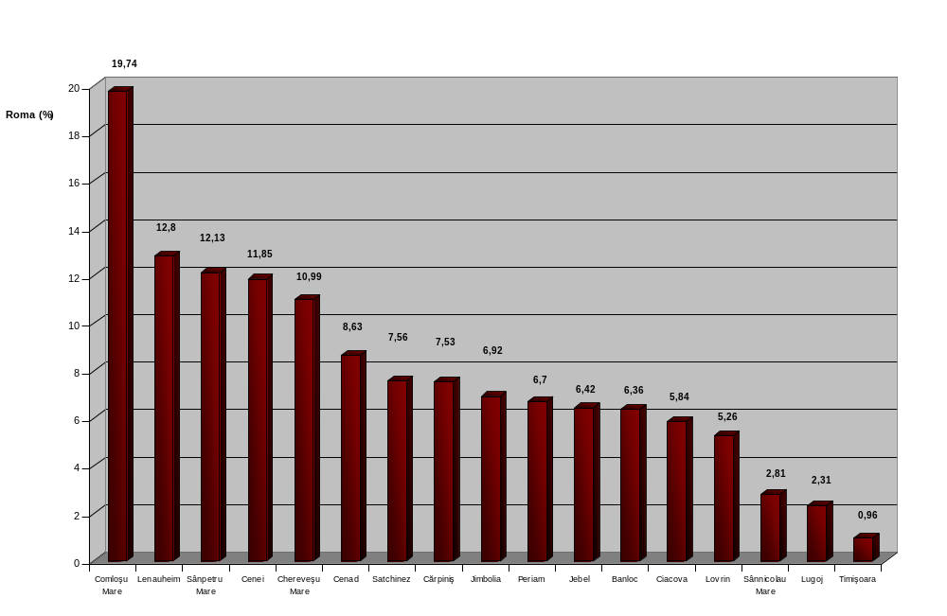
Fig. I.1.2. The share of Roma in the total Roma population of Timiş County

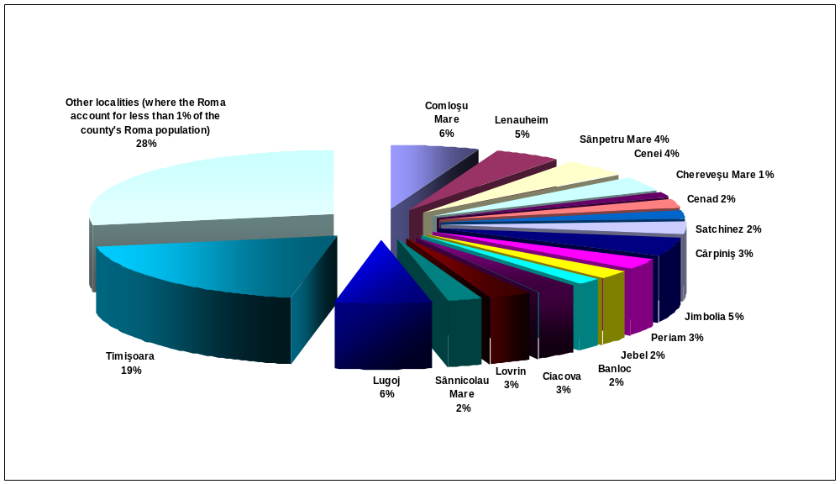
Fig. I.1.3. The localities where the number of inhabitants belonging to the Roma ethnic group is approximately equal to the number of inhabitants belonging to other ethnic groups
- Timiş County –

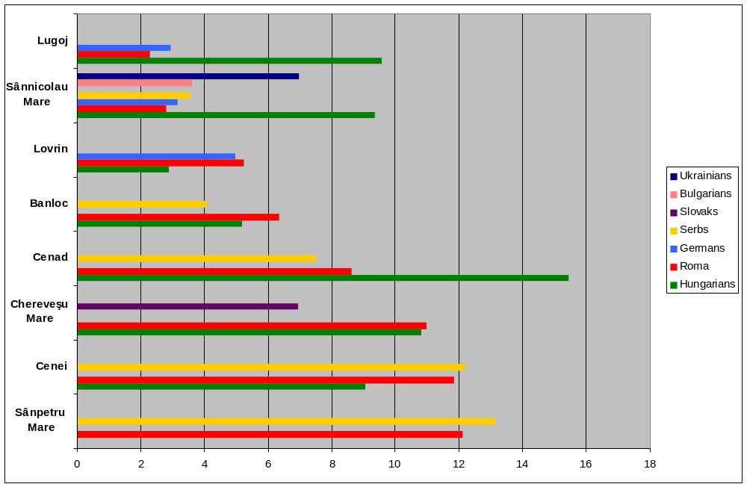

I. West Region
I.2. Arad County

Table I.2.1. The localities with the most numerous Roma communities

Nr. | Locality | Population | Romanians  (%) | Hungarians  (%) | Roma  (%) | Germans  (%) | Serbs  (%) | Slovaks  (%) | Bulgarians  (%)
1 | Covăsinţ | 2659 | 75,66 | 0,56 | 23,5
2 | Mişca | 3546 | 36,97 | 40,49 | 21,71
3 | Sântana | 12936 | 79,08 | 2,19 | 14,91 | 3,49
4 | Şiria | 8140 | 81,26 | 4,42 | 12,02 | 1,8
5 | Birchiş | 2044 | 87,72 | 0,48 | 11,59
6 | Curtici | 9722 | 69,69 | 19,07 | 10,68
7 | Şemlac | 3787 | 80,8 | 3,59 | 9,61 | 3,64
8 | Cărand | 1320 | 89,54 | 0,22 | 9,39
9 | Vinga | 6388 | 53,16 | 24,87 | 8,79 |  |  | 2,42 | 8,01
10 | Pecica | 13024 | 57,05 | 32,57 | 8,38
11 | Macea | 6169 | 85,6 | 3,3 | 8,33 | 2,2
12 | Ineu | 10207 | 85,62 | 8,42 | 5,06
13 | Felnac | 5182 | 87,3 | 1,91 | 5,03 |  | 4,26
14 | Arad | 172827 | 82,72 | 13,01 | 1,73 | 1,3

Fig. I.2.1. The share of Roma in the population of each locality
- Arad County –

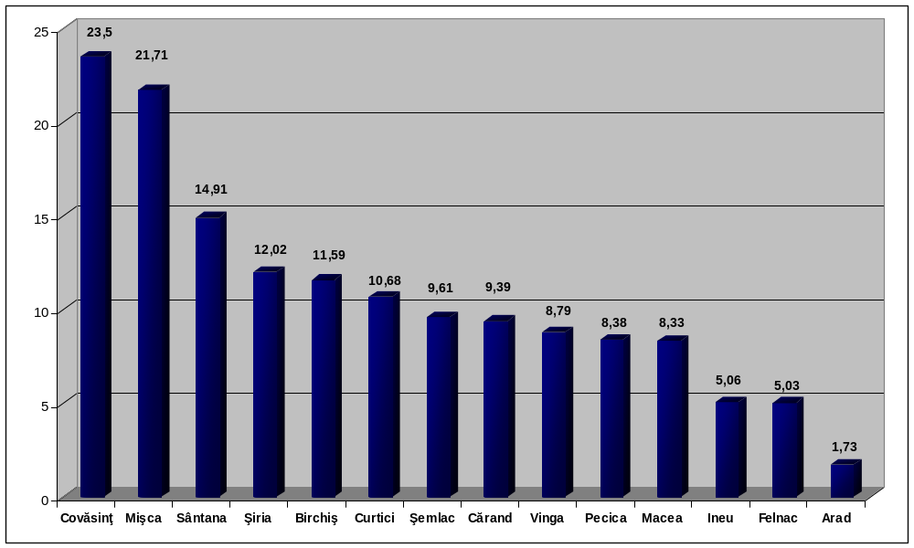

Fig. I.2.2. The share of Roma in the total Roma population of Arad County

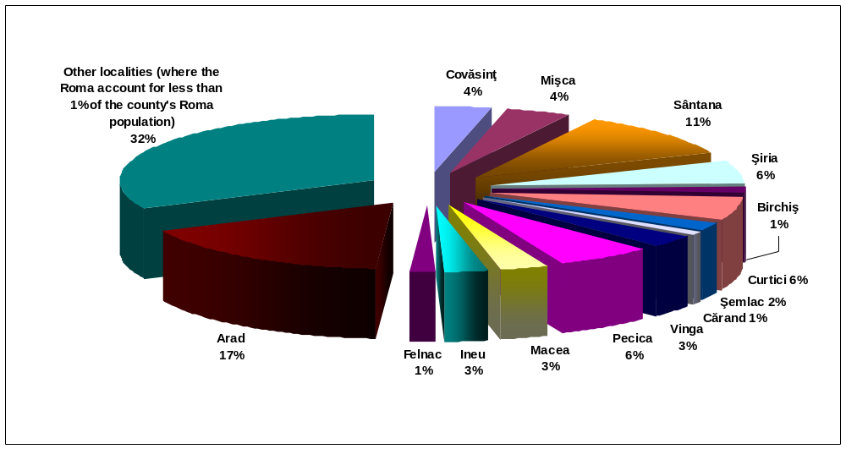

Fig. I.2.3. The localities where the number of inhabitants belonging to the Roma ethnic group is approximately equal to the number of inhabitants belonging to other ethnic groups
- Arad County –

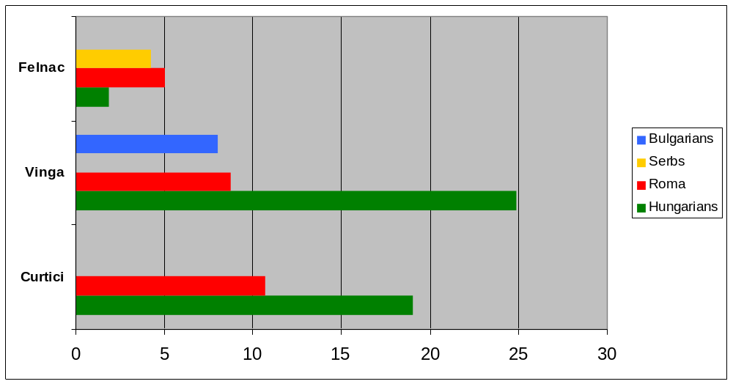

II. North-West Region
II.1. Bihor County
Table II.1.1. The localities with the most numerous Roma communities
Nr. | Locality | Population | Romanians  (%) | Romanians | Hungarians  (%) | Hungarians | Roma  (%) | Roma | Slovaks  (%) | Slovaks
1 | Drăgeşti | 2600 | 74,76 | 1944 | 0 | 0 | 24,96 | 649 |  | 0
2 | Lugaşu de Jos | 3314 | 48,67 | 1613 | 19,31 | 640 | 24,26 | 804 | 7,57 | 251
3 | Batăr | 5222 | 63,04 | 3292 | 15,09 | 788 | 21,79 | 1138 |  | 0
4 | Ineu | 4075 | 68,17 | 2778 | 10,99 | 448 | 20,68 | 843 |  | 0
5 | Ciumeghiu | 4498 | 52,44 | 2359 | 27,9 | 1255 | 18,87 | 849 |  | 0
6 | Abrămuţ | 3020 | 29,73 | 898 | 50,52 | 1526 | 18,8 | 568 |  | 0
7 | Lăzăreni | 3034 | 81,08 | 2460 |  | 0 | 18,72 | 568 |  | 0
8 | Ţeţchea | 3141 | 71,47 | 2245 | 9,13 | 287 | 18,65 | 586 |  | 0
9 | Holod | 3526 | 81,99 | 2891 |  | 0 | 17,81 | 628 |  | 0
10 | Budureasa | 2671 | 82,4 | 2201 | 0,14 | 4 | 17,44 | 466 |  | 0
11 | Husasău de Tinca | 2350 | 81,23 | 1909 |  | 0 | 17,1 | 402 |  | 0
12 | Curtuişeni | 3774 | 25,09 | 947 | 58,45 | 2206 | 16,4 | 619 |  | 0
13 | Cherechiu | 2483 | 1,85 | 46 | 81,95 | 2035 | 16,14 | 401 |  | 0
14 | Şoimi | 3011 | 83,92 | 2527 | 0,23 | 7 | 15,8 | 476 |  | 0
15 | Avram Iancu | 3317 | 74,67 | 2477 | 9,61 | 319 | 15,64 | 519 |  | 0
16 | Tinca | 7446 | 66,42 | 4946 | 17,87 | 1331 | 15,44 | 1150 |  | 0
17 | Săcueni | 11665 | 7,63 | 890 | 77,23 | 9009 | 14,97 | 1746 |  | 0
18 | Tăuteu | 4488 | 55,57 | 2494 | 28,27 | 1269 | 14,52 | 652 |  | 0
19 | Dobreşti | 5659 | 86,95 | 4921 | 0,12 | 7 | 12,72 | 720 |  | 0
20 | Suplacu de Barcău | 4610 | 34,42 | 1587 | 34,42 | 1587 | 10,97 | 506 | 20,26 | 934
21 | Oşorhei | 5887 | 65,78 | 3872 | 22,59 | 1330 | 10,75 | 633 |  | 0
22 | Diosig | 9653 | 32,63 | 3150 | 56,54 | 5458 | 10,7 | 1033 |  | 0
23 | Cefa | 6354 | 81,96 | 5208 | 6,53 | 415 | 10,59 | 673 |  | 0
24 | Şimian | 4045 | 22,49 | 910 | 67,49 | 2730 | 9,39 | 380 |  | 0
25 | Aleşd | 10415 | 65,17 | 6787 | 19,07 | 1986 | 9,15 | 953 | 6,19 | 645
26 | Tileagd | 7142 | 66,97 | 4783 | 23,21 | 1658 | 8,84 | 631 |  | 0
27 | Sânmartin | 7924 | 86,08 | 6821 | 4,73 | 375 | 8,8 | 697 |  | 0
28 | Abram | 3346 | 83,26 | 2786 | 8,27 | 277 | 8,33 | 279 |  | 0
29 | Oradea | 206614 | 70,31 | 145270 | 27,58 | 56984 | 1,18 | 2438 |  | 0
Fig. II.1.1. The share of Roma in the population of each locality
- Bihor County –

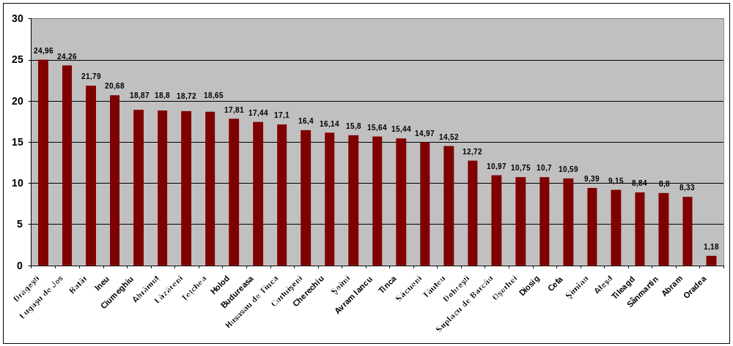

Fig. II.1.2. The share of Roma in the total Roma population of Bihor County

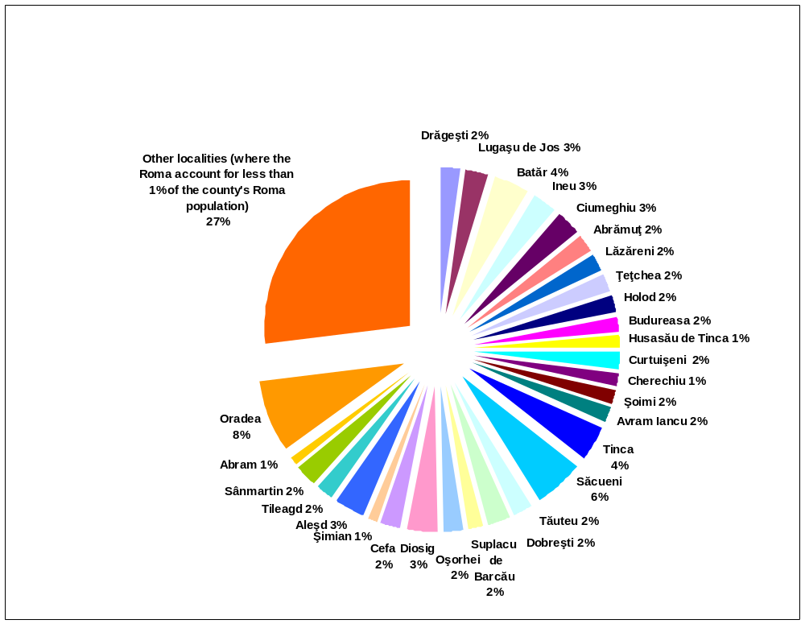

Fig. II.1.3. The localities where the number of inhabitants belonging to the Roma ethnic group is approximately equal to the number of inhabitants belonging to other ethnic groups

- Bihor County –

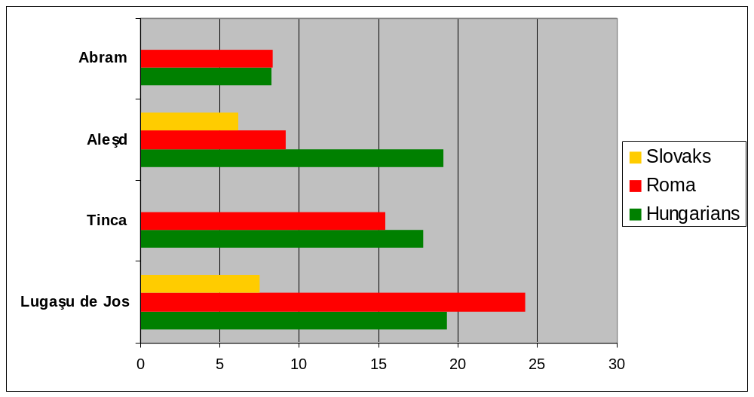
B. Population by ethnic group and mother tongue in Romania, West and North-West Regions

I. Romania
I.1 Population structure by ethnic group
Romanians | 19,399,597 | 89.47 %
Hungarians | 1,431,807 | 6.60 %
Roma | 535,140 | 2.46 %
Ukrainians | 61,098 | 0.28 %
Germans | 59,764 | 0.27 %
Russians - Lipovans | 35,791 | 0.16 %
Turks | 32,098 | 0.14 %
Tatars | 23,935 | 0.11 %
Serbs | 22,561 | 0.10 %
Slovaks | 17,226 | 0.07 %
Bulgarians | 8,025 | 0.03 %
Croats | 6,807 | 0.03 %
Greeks | 6,472 | 0.02 %
Jews | 5,785 | 0.02 %
Czechs | 3,941 | 0.01 %
Polish | 3,559 | 0.01 %
Italians | 3,288 | 0.01 %
Chinese | 2,243 | 0.01 %
Armenians | 1,780 | 0.0 %
Csango | 1,266 | 0.0 %
Other | 16,850 | 0.07 %
Ethnic group not mentioned | 1,941 | 0.0 %

I.2 Population structure by mother tongue
Romanian | 19,736,517 | 91.03 %
Hungarian | 1,443,970 | 6.66 %
Romani | 237,57 | 1.09 %
Ukrainian | 57,407 | 0.26 %
German | 44,888 | 0.20 %
Russian-Lipovan | 29,246 | 0.13 %
Turk | 28,115 | 0.12 %
Tatar | 21,272 | 0.09 %
Serbian | 20,411 | 0.09 %
Slovak | 16,027 | 0.07 %
Bulgarian | 6,735 | 0.03 %
Croatian | 6,355 | 0.02 %
Greek | 4,17 | 0.01 %
Jewish | 951 | 0.0 %
Czech | 3,381 | 0.01 %
Polish | 2,69 | 0.01 %
Italian | 2,531 | 0.01 %
Chinese | 2,266 | 0.01 %
Armenian | 721 | 0.0 %
Other | 13,621 | 0.06 %
Mother tongue not mentioned | 2130 | 0.0 %
Total: 21,680,974

II. West Region (Hunedoara, Timiş, Caraş-Severin Counties)
II.1.1 Population by ethnic group
Romanians | 1,689,443 | 86.25 %
Hungarian | 131,059 | 6.69 %
Roma | 48,485 | 2.47 %
Ukrainians | 12,806 | 0.65 %
Germans | 27,112 | 1.38 %
Russians - Lipovans | 297 | 0.01 %
Turks | 196 | 0.01 %
Tatars | 27 | 0.0 %
Serbs | 20,624 | 1.05 %
Slovaks | 8,043 | 0.41 %
Bulgarians | 6,468 | 0.33 %
Croats | 6,665 | 0.34 %
Greeks | 345 | 0.01 %
Jews | 772 | 0.03 %
Czechs | 2,971 | 0.15 %
Polish | 279 | 0.01 %
Italians | 712 | 0.03 %
Chinese | 51 | 0.0 %
Armenians | 50 | 0.0 %
Csango | 47 | 0.0 %
Other | 1,96 | 0.10 %
Ethnic group not mentioned | 236 | 0.01 %
Total: 1,958,648

II.1.2 Population structure by mother tongue

Romanian | 1,730,832 | 88.36 %
Hungarian | 123,555 | 6.30 %
Romani | 26,065 | 1.33 %
Ukrainian | 11,166 | 0.57 %
German | 22,573 | 1.15 %
Russian-Lipovan | 277 | 0.01 %
Turk | 163 | 0.0 %
Tatar | 23 | 0.0 %
Serbian | 18,733 | 0.95 %
Slovak | 7,367 | 0.37 %
Bulgarian | 5,999 | 0.30 %
Croatian | 6,29 | 0.32 %
Greek | 272 | 0.01 %
Jewish | 88 | 0.0 %
Czech | 2,593 | 0.13 %
Polish | 139 | 0.0 %
Italian | 563 | 0.02 %
Chinese | 56 | 0.0 %
Armenian | 16 | 0.0 %
Other | 1,739 | 0.08 %
Mother tongue not mentioned | 139 | 0.0 %
Total: 1,958,648

II.2.1. Population structure by ethnic group – Timiş County
Romanians | 565,639 | 83.43 %
Hungarians | 50,556 | 7.45 %
Roma | 16,084 | 2.37 %
Ukrainians | 7,321 | 1.07 %
Germans | 14,174 | 2.09 %
Russians - Lipovans | 144 | 0.02 %
Turks | 74 | 0.01 %
Tatars | 8 | 0.0 %
Serbs | 13,273 | 1.95 %
Slovaks | 1,908 | 0.28 %
Bulgarians | 5,562 | 0.82 %
Croats | 371 | 0.05 %
Greeks | 209 | 0.03 %
Jews | 441 | 0.06 %
Czechs | 283 | 0.04 %
Polish | 79 | 0.01 %
Italians | 271 | 0.03 %
Chinese | 18 | 0.0 %
Armenians | 32 | 0.0 %
Csango | 17 | 0.0 %
Other | 1,311 | 0.19 %
Ethnic group not mentioned | 151 | 0.02 %
Total: 677,926

II.2.2 Population structure by mother tongue – Timiş County
Romanian | 579,663 | 85.50 %
Hungarian | 47,707 | 7.03 %
Romani | 10,433 | 1.53 %
Ukrainian | 6,378 | 0.94 %
German | 12,197 | 1.79 %
Russian-Lipovan | 141 | 0.02 %
Turk | 66 | 0.0 %
Tatar | 9 | 0.0 %
Serbian | 12,159 | 1.79 %
Slovak | 1,636 | 0.24 %
Bulgarian | 5,235 | 0.77 %
Croatian | 296 | 0.04 %
Greek | 187 | 0.02 %
Jewish | 54 | 0.0 %
Czech | 173 | 0.02 %
Polish | 50 | 0.0 %
Italian | 239 | 0.03 %
Chinese | 23 | 0.0 %
Armenian | 8 | 0.0 %
Other | 1,173 | 0.17 %
Mother tongue not mentioned | 99 | 0.01 %
Total: 677,926
II.3.1. Population structure by ethnic group – Arad County

Romanians | 379,451 | 82.16 %
Hungarians | 49,291 | 10.67 %
Roma | 17,664 | 3.82 %
Ukrainians | 1,741 | 0.37 %
Germans | 4,852 | 1.05 %
Russians - Lipovans | 59 | 0.01 %
Turks | 60 | 0.01 %
Tatars | 13 | 0.0 %
Serbs | 1,217 | 0.26 %
Slovaks | 5,695 | 1.23 %
Bulgarians | 819 | 0.17 %
Croats | 17 | 0.0 %
Greeks | 25 | 0.0 %
Jews | 178 | 0.03 %
Czechs | 152 | 0.03 %
Polish | 48 | 0.01 %
Italians | 240 | 0.05 %
Chinese | 14 | 0.0 %
Armenians | 6 | 0.0 %
Csango | 13 | 0.0 %
Other | 214 | 0.04 %
Ethnic group not mentioned | 22 | 0.0 %
Total: 461,791

II.3.2 Population structure by mother tongue – Arad County

Romanian | 391,269 | 84.72 %
Hungarian | 48,282 | 10.45 %
Romani | 9,001 | 1.94 %
Ukrainian | 1,375 | 0.29 %
German | 4,053 | 0.87 %
Russian-Lipovan | 49 | 0.01 %
Turk | 52 | 0.01 %
Tatar | 9 | 0.0 %
Serbian | 884 | 0.19 %
Slovak | 5,489 | 1.18 %
Bulgarian | 707 | 0.15 %
Croatian | 7 | 0.0 %
Greek | 12 | 0.0 %
Jewish | 21 | 0.0 %
Czech | 143 | 0.03 %
Polish | 27 | 0.0 %
Italian | 216 | 0.04 %
Chinese | 14 | 0.0 %
Armenian | 5 | 0.0 %
Other | 163 | 0.03 %
Mother tongue not mentioned | 13 | 0.0 %
Total: 461,791

III. North -West Region (Bistriţa Năsăud, Maramureş, Cluj, Satu-Mare, Sălaj, Bihor Counties)
III. 1.1. Population structure by ethnic group
Romanians | 2,054,793 | 74.99 %
Hungarians | 529,204 | 19.31 %
Roma | 96,013 | 3.50 %
Ukrainians | 36,103 | 1.31 %
Germans | 11,299 | 0.41 %
Russians - Lipovans | 229 | 0.0 %
Turks | 112 | 0.0 %
Tatars | 20 | 0.0 %
Serbs | 111 | 0.0 %
Slovaks | 8,982 | 0.32 %
Bulgarians | 67 | 0.0 %
Croats | 9 | 0.0 %
Greeks | 248 | 0.0 %
Jews | 631 | 0.02 %
Czechs | 33 | 0.0 %
Polish | 73 | 0.0 %
Italians | 392 | 0.01 %
Chinese | 41 | 0.0 %
Armenians | 89 | 0.0 %
Csango | 24 | 0.0 %
Other | 1,288 | 0.04 %
Ethnic group not mentioned | 303 | 0.01 %
Total: 2,740,064

III.I.2. Population structure by mother tongue

Romanian | 2,098,639 | 76.59 %
Hungarian | 545,055 | 19.89 %
Romani | 44,984 | 1.64 %
Ukrainian | 35,079 | 1.28 %
German | 5,135 | 0.18 %
Russian-Lipovan | 205 | 0.0 %
Turk | 99 | 0.0 %
Tatar | 15 | 0.0 %
Serbian | 70 | 0.0 %
Slovak | 8,562 | 0.31 %
Bulgarian | 41 | 0.0 %
Croatian | 6 | 0.0 %
Greek | 211 | 0.0 %
Jewish | 96 | 0.0 %
Czech | 17 | 0.0 %
Polish | 45 | 0.0 %
Italian | 364 | 0.01 %
Chinese | 41 | 0.0 %
Armenian | 13 | 0.0 %
Other | 1,1 | 0.04 %
Mother tongue not mentioned | 287 | 0.01 %
Total: 2,740,064

III.2.1 Population structure by ethnic group – Bihor County

Romanians | 404,468 | 67.38 %
Hungarians | 155,829 | 25.96 %
Roma | 30,089 | 5.01 %
Ukrainians | 198 | 0.03 %
Germans | 1,163 | 0.19 %
Russians - Lipovans | 75 | 0.01 %
Turks | 15 | 0.0 %
Tatars | 4 | 0.0 %
Serbs | 35 | 0.0 %
Slovaks | 7,37 | 1.22 %
Bulgarians | 31 | 0.0 %
Croats | 4 | 0.0 %
Greeks | 74 | 0.01 %
Jews | 224 | 0.03 %
Czechs | 15 | 0.0 %
Polish | 22 | 0.0 %
Italians | 155 | 0.02 %
Chinese | 1 | 0.0 %
Armenians | 12 | 0.0 %
Csango | 4 | 0.0 %
Other | 338 | 0.05 %
Ethnic group not mentioned | 120 | 0.01 %
Total: 600,246

III.2.2. Population structure by mother tongue – Bihor County
Romanian | 411,542 | 68.56 %
Hungarian | 161,668 | 26.93 %
Romani | 18,177 | 3.02 %
Ukrainian | 132 | 0.02 %
German | 783 | 0.13 %
Russian-Lipovan | 54 | 0.0 %
Turk | 15 | 0.0 %
Tatar | 5 | 0.0 %
Serbian | 27 | 0.0 %
Slovak | 7,121 | 1.18 %
Bulgarian | 17 | 0.0 %
Croatian | 4 | 0.0 %
Greek | 60 | 0.0 %
Jewish | 25 | 0.0 %
Czech | 8 | 0.0 %
Polish | 18 | 0.0 %
Italian | 140 | 0.02 %
Chinese | 1 | 0.0 %
Armenian | 6 | 0.0 %
Other | 301 | 0.05 %
Mother tongue not mentioned | 142 | 0.02 %
Total: 600,246

The texts reads: For sale: A first “sălaş” (family) of Gypsy slaves. Through an auction at noon at the St. Elias Monastery on 8 May 1852. It comprises of 18 men, 10 boys, 7 women & 3girls. In fine condition
The proportion of the population aged 15 and over that is economically active: all people who supply labor for the production of goods and services during a specified period (according to the International Labour Organization cited on the World Bank web site).
Argot used for designating the Roma
Argot used for designating the Roma
The statistics were provided by the database uploaded on the website of the Ethnocultural Diversity Resource Center (2002) on the basis of the 2002 census.

